Providence Hospital Nurse Scheduling
Richard Greer
4/29/2010

- Introduction
The Neonatal ICU in Providence Alaska Medical Center would like a scheduling system to assign nurses to babies based on numerous constraints. Babies are classified by biomedical risk and psycho social environment. Nurses are assigned preferences based on their schedule, training and location. Nurses can be assigned to 0-3 babies (depending on the biomedical risk of the baby). Several constraints make it difficult for a human to find an optimal solution.
To solve this problem I wrote a program using C# and Microsoft Visual Studio. The plethora of possible solutions that this problem entails led me to implement a genetic algorithm. The genetic algorithm is used to find a schedule that best meets nurse and baby requirements. The program features a graphical user interface that allows a user change nurse assignment rules, open the correct Excel sheet and visualize the progress of the genetic algorithm.
- Project Overview

The client for this project is Providence Alaska Medical Center. The Neonatal ICU in Providence Alaska Medical Center uses Excel sheets to hold data in regards to infants, staff, psycho social classification of infants, and biomedical classification of infants that are used to determine schedules.

Currently, a member of staff has to assign nurse preferences based on a nurse’s training and schedule. Then a staff member pairs babies to each nurse as close as possible to their preferences. However, some babies depending on their biomedical risks may be assigned to one, two, or three nurses. The variation of preferences and the number of babies assigned to a particular nurse presents a problem that is not easy for a human to solve optimally or quickly.

The goal of this project is to create a program that can find an optimal schedule or perhaps not optimal but at least matching the constraints for the nurses in the Neonatal ICU. Since the staff are comfortable and familiar with Excel I created a program that can read values and write values directly from the Excel spreadsheet so that once the program is executed the results will be outputted directly to the spreadsheet.

I implemented an Automation client for Microsoft Excel by using Microsoft Visual C# .NET. Automation allows applications written in C# to programmatically control other applications. Practically any process that can be achieved manually through the user interface in Excel can be achieved programmatically using C#.

The data that is of concern is all contained in one sheet. Below a screen shot of the spreadsheet is shown.
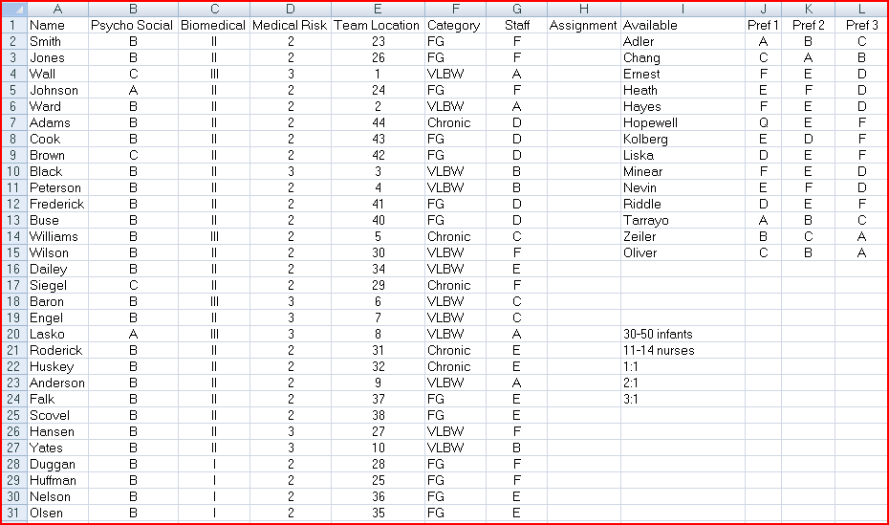

Column D (Medical Risk) is used to determine the limitation of the number of babies that a nurse can be assigned to. Columns J, K, and L show the preferences a particular nurse has. Column H (Assignment) will hold the names of nurses assigned to the babies in the corresponding row.

Default Medical Risk Constraints:
- Medical Risk 1 -> Maximum of 3 assignments
- Medical Risk 2 -> Maximum of 2 assignments
- Medical Risk 3 -> Only one assignment

Although the Medical Risk constraints are hard constraints that cannot be broken I have enabled flexibility for the user to change these constraints if in the future they are changed. Also, there is the possibility that there may not be enough nurses on staff to meet the constraints.

The GUI.
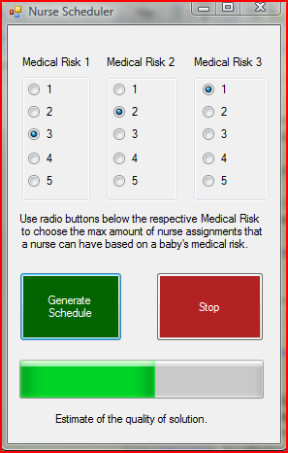

As seen in the image above radio dials allow the user to change the rules for how nurses are assigned to babies based on medical risk.

- Project Requirements
The requirements for this project seem straightforward.
- Read nurse preferences and infant classifications from spreadsheet.
- Find an optimized mapping of nurses to infants.
- Write the assigned nurses back to column “H” of the worksheet.
I have met all of the requirements for this project and have even added more features than intended. A graphical user interface is not needed but I implemented it primarily so the user would be able to see the progress of the genetic algorithm and halt it when they feel fit.
I was not able to meet with client. All of my communication was through my professor. So I made sure that all my code is flexible so that if some of the requirements need to be changed it will not be a hassle.
- System Design

A genetic algorithm is used to create the nurse schedule because there is a vast amount of possible solutions. For example if there are 14 nurses and 14 babies then there will be 14 factorial different combinations = 87,178,291,200 possibilities. This of course is a lot smaller than possibly 40 babies assigned possibly 20 nurses with the possibility of a nurse being assigned to 3 babies.

The program is split into three classes.

- A class for reading in data from the worksheet writing data back to the worksheet and displaying the graphical user interface.
- A class used to access and set nurse information.
- A class for the genetic algorithm.

Form class:

- Allows the user to pick which Excel sheet to read data from.
- Opens Excel, the workbook and the worksheet.
- Reads in nurse and baby data from Excel worksheet
- Displays a progress bar of the genetic algorithm.
- Allows the user to set the Medical Risk constraints.
- Allows the user to start and stop the genetic algorithm.
Nurse class:
- Sets and retrieves a nurse’s max assignments.
- Sets and retrieves nurse preferences 1, 2 & 3.
- Sets and retrieves a nurse’s assignments.

Evolve class:

- Implements the genetic algorithm.
- First a large set of random schedules are created.
- The two best schedules are chosen and then crossed over many times at random points.
- Then a small proportion is change randomly.
- Then the two best schedules are chosen and the process is repeated.

Two important parts of a genetic algorithm are mutation and crossover. Crossover mixes together solutions that have been picked from a population similar to how in evolution genes are mixed between parents to create offspring. Mutation causes random changes to a set of solutions much like how mutation occurs in nature which has a small likelihood of creating a better solution.

The mutation method is shown below:
public List<string[]> mutate(List<string[]> pop)
{
Random random = new Random();
int index;
string[] schedule;
int fitness;

for (int j = 0; j < numOfMutation; j++)
{
index = random.Next(pop.Count);
schedule = new string[pop[index].Length];
fitness= getFitness(schedule);
for (int i = 0; i < pop[index].Length; i++)
{
schedule[i] = pop[index][i];
}

int popIndex;
popIndex = random.Next(pop.Count);

index = random.Next(this.nursesNames.Length);
string gene = this.nursesNames[index];
index = random.Next(schedule.Length);
schedule[index] = gene;
// checks if the schedule is valid
if (this.isValid(schedule)&& (getFitness(schedule)> fitness))
pop[popIndex] = schedule;

}
return pop;
}

The crossover method is shown below:
public void crossOver(string[] p1, string[] p2)
{
int i;
int j;
int length = p1.Length;
string[] schedule1 = new string[length];
string[] schedule2 = new string[length];
string[] beforeMutation1 = new string[length];
string[] beforeMutation2 = new string[length];
Random random = new Random();

for (i = 0; i < p1.Length; i++)
{
schedule1[i] = p1[i];
schedule2[i] = p2[i];
beforeMutation1[i] = p1[i];
beforeMutation2[i] = p2[i];
}
int crossPoint;

while (numOfCrossover > 0)
{
crossPoint = random.Next(length);
int fitness1 = getFitness(schedule1);
int fitness2 = getFitness(schedule2);

schedule1[crossPoint] = beforeMutation2[crossPoint];
schedule2[crossPoint] = beforeMutation1[crossPoint];
if (!isValid(schedule1) || getFitness(schedule1) < fitness1)
schedule1[crossPoint] = beforeMutation1[crossPoint];
if (!isValid(schedule2) || getFitness(schedule2) < fitness2)
schedule2[crossPoint] = beforeMutation2[crossPoint];

numOfCrossover--;
}

setParent1(schedule1);
setParent2(schedule2);
}
Flaws
The only cases where the algorithm can do much better is when there are not enough nurses to meet all of the constraints. The algorithm still works in these cases and assigns a partial schedule. However the partial schedule could be assigned better. The many null values that are present in a partial schedule make it nearly impossible for crossover and mutation to create valid results. This is not an impossible problem and can be fixed by using an alternative algorithm or creating non random schedules that are biased.
- Summary
This project for Providence Alaska Medical Center Neonatal ICU is implemented using a C# application that can read and write values back to an Excel worksheet.
The program is effective at creating schedules that match nurse preferences and baby medical risks. The only cases where the algorithm can do better is when there are not enough nurses to meet all of the constraints. The algorithm still works in these cases and assigns a partial schedule. However the partial schedule could be assigned better by using a different algorithm.
The main challenges of this project are the limited availability of the client to meet for feedback, the obstacle of having to learn the Excel API for C#, and the decision of which type of search algorithm to implement.
Overall I am happy with my program. I am surprised by how fast the genetic algorithm works in many cases. However, I was not able to get a clear set of specifications so it is possible that if this program is to be used it would have to be altered. However I don’t believe that would be too difficult change this program based on a new rule set.

