A New World
CS470 Project Write-up
Jeremiah Lewis
4/29/2010

Table of Contents

Abstract 2
1 Introduction 2
2 Project Overview 2
2.1 Game 3
2.2 Inspiration 3
3 Project Requirements 4
3.1 Features 4
3.2 Interface Mock-Up 5
3.3 System Specifications 6
4 System Design 6
4.1 System Architecture 6
4.2 Data Structures 7
4.3 Algorithms 8
5 Software Development Process 9
6 Results 11
7 Summary and Conclusions 11
8 References 12
Appendix A: User Manual 13

A New World
Jeremiah Lewis

Abstract

Games are a universal constant. They are a means of entertainment, of stress-relief and even of training. For a subset of games, the First-person shooters, this is especially evident. Inside the game, the player is looking out through the eyes of a being in the virtual world, interacting with objects that appear and move like objects in the real world, despite the fact that they are plainly not real. To make the virtual world more like the real world, there needs to be beings that can think and react to the player, much like cats and dogs react to each other and people. Just as evolution has shaped the instincts of the creatures of the real world, cannot the beings in the virtual world have ‘instincts’ shaped similarly?

- Introduction

This project was developed for my final project, my ‘Capstone’ of the structure of knowledge that I had been building in my time here at UAA. It was created with the intents to explore three facets of software design that I had found interesting, namely evolutionary methods to solve problems, artificial intelligence and computer graphics. The graphics projects I had worked on in the past were all simple, single threaded beings, with a steady, step-like approach as my knowledge increased. Artificial intelligence knowledge and projects were also built in small steps, with the final game-playing AI having the rules passed down, set in stone as it were. It could only perform as it was hard-coded to. Evolutionary computing was wholly new to me, but seemed to be an interesting method to solve or nearly-solve problems that would otherwise be impossible. In this case, that would be a form of learning that didn’t have a huge look-up table or take up a monstrous amount of space or computer cycles.

- Project Overview

The client is the player. The play style is First-Person Shooter, Player vs. Monster. If there is time, there is the possibility of making it so Player vs. Player is possible.

One goal of this project is to make a 3D world where the player can move, fight with a sword, cast magic, or place magic symbols on things, such as walls, doors, or their own equipment, like their sword or armor. The opponents would be AI-ran agents or, if enough time at the end of the project, other players. Playing against other players, however, is a low priority.

The other goal of this game is to make an evolving AI, the equivalent of an ‘over-mind’ or ‘general’. What this AI engine will do is spawn randomly generated agents for a given task. How well a given agent does will determine whether it is part of the ‘reproduction pool’ that will be used to create future agents. There will be three types of agent: the Caster, the Trapper and the Enchanter.
  - Game

The game will be a downloadable executable jar file, using Java Web Start to ensure that all the necessary jars, such as the Java 3D jar files, are there and at the current versions needed for the game. Initially, there will be a list to start the game, save a game, load a game and configure the game’s graphics, sound and keyboard layout. Once the player is in the game, it will play like a normal FPS (First-Person Shooter), except with a primitive theme to it such as spells instead of guns and a sword instead of a chainsaw. The basic premise of the game A New World is the character is a prisoner who is given a chance to escape. The game will allow windowing or full-screen play and movement by the directional keyboard or by mouse. The power-ups (new weapons/armor, new spell fragments, etc), keys and special objects will be acquired in the standard FPS-style by ‘running’ over them to pick them up. If there is time, I might finish fleshing out the story and put in an opening FMV (Full Motion Video). Currently, getting the game up, running and playable is the most important goal.

  - Inspiration

Part of the inspiration for this project is the game, Heretic, created by Raven Software using the DOOM engine. Heretic is the first, and one of the few, FPSs that allows the player to have the equivalent of an inventory, letting them store power-ups, such as health potions, for later use. Most other FPSs make the player have to use it when they come across it, or having to run back to where they found it when they need it, often an impossible task.

The inspiration for the magic system comes from The Elder Scrolls III: Morrowind, published by Bethseda Softworks and Ubisoft. The Elder Scrolls series of games are famous for being able to build your spells to meet your needs, but you have to buy them, and cannot change them after you have bought them. Another inspiration for the magic system is the Palladium Fantasy RPG, a pen-and-paper role-playing game published by Palladium Books. One of the types of magic used in their game is called wards, where a player puts wards, or designs, into a pattern resembling a crude sentence. Once placed, the magic just sits there until another being touches it or comes within range of it, whereupon the magic triggers, doing damage or otherwise causing the affect it is designed to do.

For the AI ‘over-mind’, the inspiration is a combination of Dr. Mock’s lecture on genetic algorithms and machine learning and some games that I have seen where the enemies learn the player’s habits and exploit these habits to make them-selves more formidable. Unfortunately, as of the date of this publication, I am unable to accurately remember a single title that uses this approach.

- Project Requirements

The requirements for this project were very general, seeing as how there are no clients until after the project is done. As such, the project is said to be ‘done’ when there are certain features implemented. Due to this fact, there was going to be a large amount of time spent on solidifying what exactly these features are, so there was allotted some extra time at the end of the project for refinement of said features. Unfortunately, with problems that cropped up, the amount of time allotted and what there actually was were two completely different amounts.

  - Features

- The player must be able to move around the world using the keyboard.

- The player must be able to interact with AI agents through combat. There needs to be some way for the player to be able to tell that the other model is damaged. The player needs to see some indication that the ‘enemy’ is being affected when he/she attacks it. An ‘enemy life bar’ in the UI works, but changing the look of the enemy model when damaged is better. Need to have some way of showing that the character or enemy is actually attacking or casting a spell, too.

- The player needs to have basic UI components, including an indicator of the characters health.

- Character needs to be able to cast spells on things such as putting a spell on a wall or on himself. Only one spell on a given object, though.

- Not only do the AI agents need to be able to navigate around the environment, but they also need to be able to do things other than attack. The most basic premise of the game is the character was a prisoner who is escaping. That means that the guards need to be doing something before the alarms go off.

- The agents the AI ‘over-mind’ spawns need to improve. Unlike other games of this type, there are only 3 ‘types’ of agents: One focused on spell casting, one who is a fighter who enchants his equipment, and one who is specializes in placing spell ‘traps’. The agents that are spawned are expected to be at the same approximate ‘level’ as the player, and if they don’t improve, even throwing increasing numbers at the player won’t help much in the way of making the game more challenging.

  - Interface Mock-Up

The interface, as I currently see it, would mostly be the standard for the DOOM-style games.

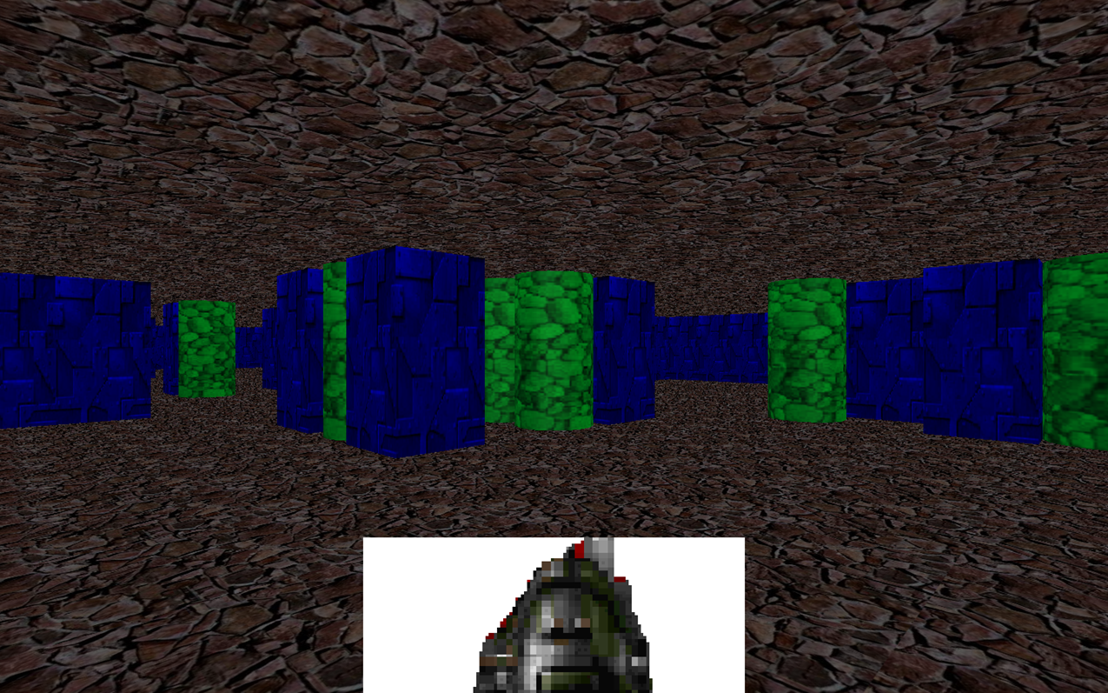
Figure 1. User Interface

As you can see in figure 1, there is really not much to the user interface. While the original idea was good, it was too ambitious. In the final version, the graphic at the bottom of the screen representing the player would change the graphic when the player enchants himself.

The color of the graphic would indicate the state of health of the player. The player would be green for healthy, or over 50% of their life left, yellow for wounded or between 50% and 25% of their life left, or red for mortally wounded, meaning less than 25% of their life left. This works well with the enchanting, since the player is supposed to have a graphic on them when enchanted, and the color of the graphic should change when their color changes.

The opponents are actually the same shape as the player, so their colors and graphics would change similarly.

  - System Specifications

The game is constructed using Java 1.6, Java3D API version 1.5.2 and is coded on Eclipse 3.4. The game is designed to run on computers running at least Windows XP with Service Pack 2, Pentium processer with at least 1.70 GHz clocks and 500 MB of RAM. I am not sure what the minimum requirements are for the video card.

- System Design

Java 3D is a high-level API based off of OpenGL, so as such can only really be used by Java’s AWT (Abstract Windowing Toolkit), which uses a system’s native user interface to create windows and other User Interface objects.

  - System Architecture

The overall system architecture is shown in figure 2.

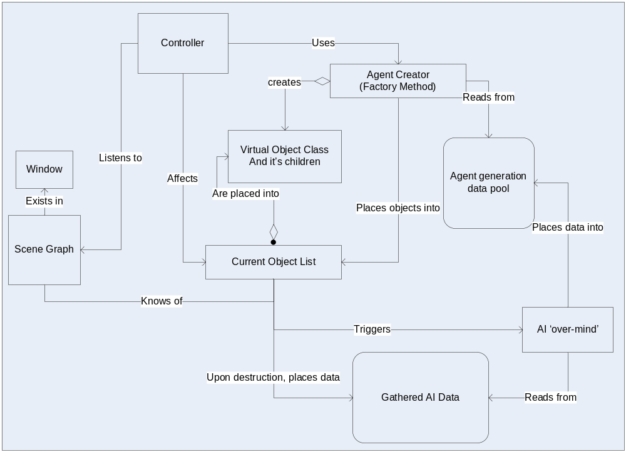
Figure 2. System Architecture
The system architecture will use several design patterns. As can be seen at the top of the diagram, the Controller listens to the Scene Graph, the View in the Model-View-Controller (MVC) pattern, while using the Agent Creator to populate and affect the Current Object List, the Model part of the MVC pattern. There is also the Factory pattern, used to create all the objects, be they objects for the player’s character to acquire and use or the AI Agents that will try to harm the character. The Current Object List is also part of an implementation of the Observer pattern. The Current Object List many objects, some of which are Subjects, notifying their Observer, the AI ’over-mind’, when an Agent object is destroyed. They do this so the AI ‘over-mind’ knows that the data in the Gathered AI Data pool has been updated so it can decide if it needs to generate ‘children’ in the Agent generation data pool. Not shown in the diagram yet still present are the patterns used by the AI Agents, namely the State pattern and the Strategy pattern, used to determine the Agents behavior at any given time.

  - Data Structures

The data structures in this project are quite complex. First, there is the data structure that is the Scene Graph, shown in Figure 3.

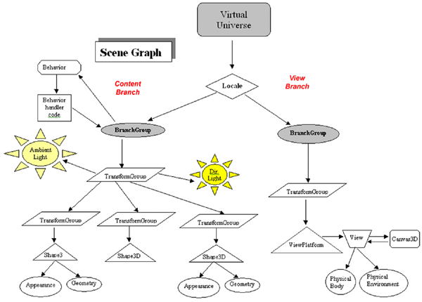
Figure 3. Generic Scene Graph

This is a diagram of the class structure of a standard scene graph. While the Behavior class would fit into the AI category, most of the classes only describe the different virtual objects in the virtual world.

The next data structure type is various instances of the Dynamic Object class and its children. The data structures contain references to the object’s instance of the Shape3D class shown as well as bits of data needed for the computations of game play. An example is an object that represents a bomb holds a reference to the 3D image of the bomb as well as data about the length of time the object exists and what happens when it ‘dies’ or is destroyed, in this case creating an object that represents the explosion. These data structures are in turn contained in a list in the Current Object List.

The final data structure type in the program is the Gathered AI Data pool shown in Figure 2. This table shows the most recent data returned by the various Agents when they ‘died’, such as how long they existed, what their settings were and how much damage they had done to the player’s character and other Agents. The Agent Generation Data pool is similar, except that it contains different permutations of settings, generated by the AI ‘over-mind’ from the data in the Gathered AI Data pool.

  - Algorithms

There are many algorithms used in this project for various reasons. One important algorithm is the generation of new AI Agents. Initially, the Agents will be created with statistics generated by random. Afterwards, new Agents are generated with statistics taken from a pool of previous Agents that has been modified by the evolutionary strategy genetic algorithm.

What this algorithm does is it takes in the potential parents, chooses the best of them, mutates their stats by a small amount, and then uses crossover from at most two of them per child to create a full population, which is the new pool of potential parents. The amount that each stat is mutated by changes according to the learning rate, so they have the potential to change a bit, or not at all. The stats themselves are just percentages, though, so if all of the stats are mutated by a similarly huge amount, that doesn’t necessarily mean that the ratio will change.

Another important algorithm is the ‘brain’ of the Agent. The one used in this program is a finite-state machine. Since the Agents don’t have access to much memory, having to share with all the other objects in the virtual world, the finite state machine was decided to be the best idea, especially since the evolutionary strategy method produces results that are best represented as instincts in this case.

In this case, the finite-state machine starts off when the Agent is generated, looking for the nearest target. If there is none to be found, then it goes to the nearest path, and starts walking it. When the Agent comes across an enemy, be it another Agent or the player, it decides whether to run, fire a ranged attack, or charge. If the Agent decides to run, it then decides whether to drop a trap, in the hopes the enemy will chase it. If charging, it must decide whether to first enchant itself, causing the Agent to do more damage, and protecting it from some damage. The Agent then continues until the opponent is dead or moves out of sight. If out of sight, then the Agent will chase the opponent, and if dead, the Agent will go to the nearest path, following it until it runs across another target.

The final important algorithm is the collision detection. This is performed by both bounding spheres and checking a grid pattern. The bounding spheres are only used to detect collision with a dynamic object, such as a trap or an enemy. The collision in this manner is determined if either object is within the radius of detection of the other one. The grid pattern is used to detect collision with objects that don’t move, such as walls. In this case, the position of the Agent in a grid square is checked to see how close to the edge of the square it is, and if within a certain distance, the next square is checked for obstacles. If there is an obstacle in the next square in that direction, the Agent is stopped. Earlier in the project, there was some experimentation on ‘sliding’ the Agent instead of just stopping it at the boundary, but the computation of the vector needed to perform this ‘sliding’ was too difficult to solve within the time constraints.

- Software Development Process

The best overall methodology for this project is a solo Extreme Programming methodology. There were elements of Prototyping in it, because these types of games are purely GUI-based. Mostly, though, it was working from the middle down, creating and testing each individual section to ensure there were no bugs before linking it to the GUI.

An accurate diagram for the breakdown of my time is the following Gantt chart:
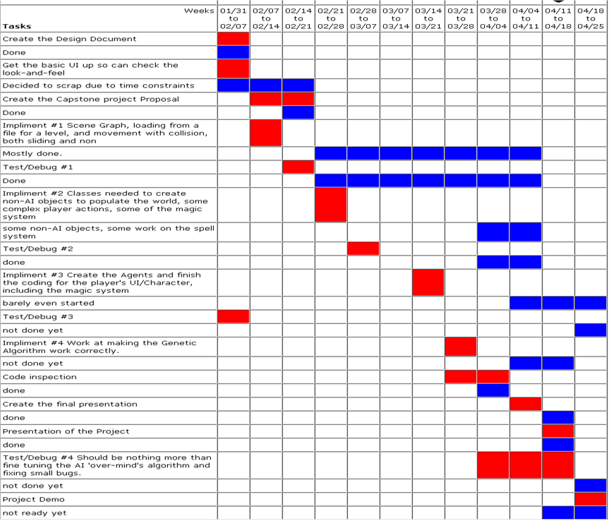
As shown in the Gantt chart, the most of the problems in the project came from building the graphics part of the program. First, the user interface took three times as long as expected, and in the end was lumped together with the 3D graphics portion of the program. Then, the bulk of the time was eaten up by bug after bug in the creation of the 3D world. While the code is there, by the end of the project, I couldn’t even get the Agents placed in the virtual world. For some reason, the factory classes are not even loading the AI class.

- Results

The project is still in a state of only partial completion. The player can move in the world, but it is far from perfect. The collision detection with the non-moving obstacles, like walls, needs to be tweaked some more. The main problem is that there are no Agents in the game. Even the fact that of the three methods of attack, only one is currently working compares to this. Currently, it is an empty world that you can wander around in, shooting at the walls, causing small explosions.

- Summary and Conclusions

I was told that this project was ambitious, and it was. It turned out that it was too much to be done in one semester, without devoting all my time to it. Considering the fact that I had multiple jobs and other classes, which was just not possible. The Java3D API was useful, but I tried to rely on it too much, causing most of my problems.

There was also the problem with trying to find, and later build, a file loader to load 3D objects. In the end, the objects had to be created inside the program, taking up more space. Finally, I got so caught up on one way of doing things, that I didn’t even think about others. With the current implementation of the game, it could have just as easily have been done in 2D, probably causing fewer headaches.

The main goals of this project were the AI and the genetic computation, but I forgot that and became caught up in the graphics. Essentially, I did not plan often enough. I spent too much time pounding out code and testing, that I forgot to take time out to evaluate my current state of progress, or lack thereof. There was a little bit, like dropping the research into model loaders for just hard coding them, but I was stuck on the 3D part, the glitz and glamour, forgetting the purpose of the project. I would have been better served to have to meet with someone occasionally to help pull me out of ‘the coding zone’.

- References

- Introduction to Evolutionary Computing by A.E. Eiben and J.E. Smith; Springer-Verlag Berlin Heidelberg: 2003.

- Developing Games in Java by David Brakeen; New Riders Publishing 2004

- Pro Java 6 3D Game Development by Andrew Davison; Andrew Davison: 2007

- Killer Game Programming In Java by Andrew Davison; O'Reilly: 2005

Appendix A: User Manual

- Install Java 3D 1.5.2 on the computer
- Extract all the files from the JAR, keeping them in the correct file folders and the like.
- Compile and execute in the manner that you commonly use. In the initial case, open Eclipse, import the project from a ZIP or JAR, open Start.java, and run it.
- The program will immediately start running.

Keys:
Up arrow: Moves the character forward
Left arrow: Turn left
Right arrow: Turn right
Down arrow: Move back
Space bar: Fire a ranged magic blast

Ctrl + up arrow: Fly to the ceiling
Ctrl + left arrow: Move to the left (left strafe)
Ctrl + right arrow: Move to the right (right strafe)
Ctrl + down arrow: Fly to the ground
Ctrl + space bar: Drop a Trap spell on the floor (not implemented)
WARNING: Traps currently use up one of your spells permanently
The user starts with 20.

Space + space bar: Cast an Enchant spell on your self (not implemented)

