Piano Chord Builder

Artem Kuligin
CS 470 –Project Write-up

April 30, 2010
Table of Contents

1. Introduction |  | 3
2. Project Overview |  | 4
2.1 - General Source of Data. |  | 4
2.2. Basic idea – Theory |  | 6
2.3. Basic Features of application |  | 7
3. Project Requirements |  | 8
3.1. System Specifications. |  | 8
4. System Design. |  | 9
4.1. User Interface |  | 9
4.2 Data Structures |  | 10
4.3 System Architecture |  | 11
4.4. Algorithms |  | 13
5. Software Development Process |  | 14
5.1 Prototyping Challenges |  | 15
6. Schedule |  | 16
7. Results |  | 16
8. References |  | 17
9. Program interface and features. User’s Manual |  | 18
Appendix A: Code Listing |  | 20
Piano Chord Builder
Artem Kuligin

- Introduction

This application has been developed as testing template project for further development using different hardware platforms and operating systems.

There are many similar products on the market designed to help train people to learn music basics. Especially there are dominant quantities of applications for kids.

But, according to my research, one of the reasons that we have such diversity of similar programs. Is the way how programs being designed to present a music theory. Some application are giving us a specifics of some certain rule, without providing any kind general info , as an example a musical chord structure and it’s origin. So, my idea was to design an application that will provide a basic help for beginners to learn music theory, without going deep into specifics.

The project was carried out with a help of professional pianist - Lubov Mikhailova. From whom I have received a lots of clues and ideas how to design my application, since at very beginning I did not have any knowledge about music theory.

- Project Overview

Many people taking piano lessons. And they find it very interesting. But playing piano is not just following the sequence of musical notes. It is also ability to know the general principles of music construction. This is a way to understand why music some progressions sound ear friendly to us, and why others don’t. To produce a melodic or harmonic sequence we have to understand how music is made.
In music, a chord is any set of harmonically-related notes that is heard as if sounding simultaneously (a "harmonic simultaneity"). The most frequently encountered chords in theory and music are triads: major and minor and then the augmented and diminished triads. The descriptions "major", "minor", "augmented" and "diminished" are referred to collectively as chordal "quality".

2.1 - General Source of Data.
Generally all pro piano players use musical chords. That’s why same song could be played with different tonality set of notes, therefore creating a different mood. All chords are based on Solfege note building principles.

- Solfege is a technique for ear training. It is a method of assigning a syllable to every pitch / degree of a scale. Instead of singing the actual names of the notes in the scale (eg. c d e f g a b) we use the syllables instead (Do Re Mi Fa Sol La Ti).

All chords are formed by combining certain scale tones according to definitive rule (“Circle of fifths”).

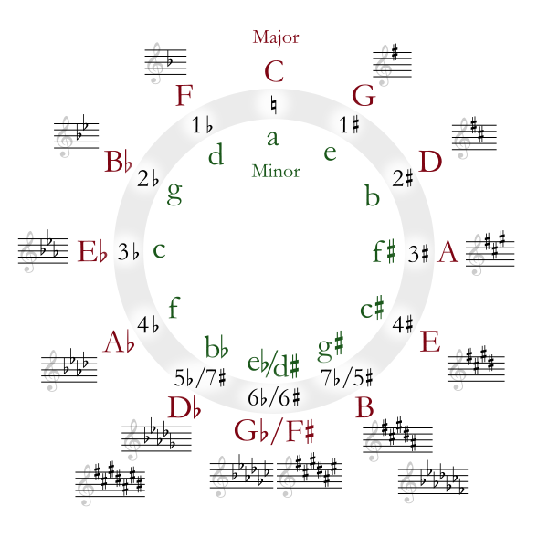
Figure 2-1.

The place where music theory and more specifically knowledge of the Circle of Fifths (Fig. 2-1) can help user when he needs to write a song or to figure a song out by ear. The Circle of Fifths can help user easily construct hundreds of Chord Progressions, Lead Lines, Harmonies, and just about anything else once user get the hang of it.

Generally there are 25 of the most-used types of Chord Progressions. There are several other variations, but these chord types mostly used in modern music. Each chord can be inverted, turned upside down by the number of notes in the chord. For example, a 3 note chord has 3 positions, root position, first inversion, and second inversion. A 4 note chord has 4 positions, a five note chord has 5 positions, and so on. But of course we can build chords not just on one note, but on 12as well: C, Db or C#,D, D# or Eb, E, F, F# or Gb, G, G# or Ab, A, A# or Bb and B . So 12 times the possible 100 or so chords per octave give us a rough total of 1200 possible chords. That is quite a lot of combination to memorize.
My application will help beginners to understand and memorize musical chords for self reference. It will be a sort of musical dictionary for music players. In the beginning, I will implement it as PC application, but later, I’m planning to move into portable devices.

2.2. Basic idea – Theory
Music chords are constructed from musical intervals. Each chord has:
1) A Root note
2) A note a Major third (M3) or minor third (m3) above the Root
3) A note a Perfect fifth (P5), Augmented fifth (A5), or diminished fifth above the Root
If we choose a C - Major chord (Fig. 2-2-I) for example we begin by picking a Root note. We could pick any of the 12 notes but in this case we will choose C. The next note we need is a Major third (M3) above the Root, which in this case would be the note E. The final note we need is a Perfect fifth above the root, which in this case would be the note G. Now we have all three notes of our Major chord: C, E, and G.
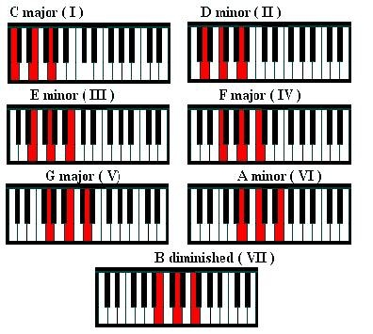
Figure 2-2.

The same Chord Progression can be indicated on the Circle of fifths. (Fig. 2-3)

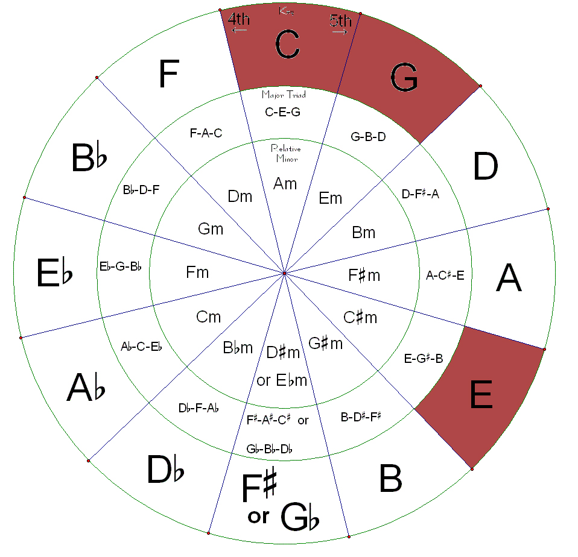
Figure 2-3.

2.3. Basic Features of application
Before starting this project, I was collecting a general data of what we have so far at this moment. I did a research over internet, and I found that most of the programs do not have a good user intuitive interface. To be more specific, I would say that almost all applications either text based or written for professional musicians. If user has no background knowledge about music construction, it was always difficult to trigger a right application feature to get a simple Chord Progression output.

So my goal was to deliver an application that will help beginning piano players to learn and use musical construction rules. To be able to utilize a modern music devices to produce a practice musical Chord Progressions.
To have a good foundation for further development (Portable Devices, Embedded Software and etc…). To get a good practical skills, while working with musical hardware and software communication.
- Project Requirements

Generally my program should have a user friendly interface to help user to understand principles of construction of Chord Progressions. As I mentioned before, I received an objective support from my friend who happed to be a pro pianist.
So, after we have composed a general idea of how we can deliver a useful information to the user. I have composed necessary features of my application.

- To be able to read a musical chord from a screen, using standard musical notation alphabet.
- The program should have a valid input for musical data.
- The program should have a virtual musical input device to enter or modify notes in musical progression. In general it should be done in a form of virtual piano keyboard.
- The UI for circle of fifths should be provided to visualize a Chord progression.
- A valid sound input and output devices should be used to play a Chord Progression.
- External hardware support. MIDI devices in particular.
- The program should not take a significant Big(O) time for some certain operations. Since it might affect a synchronization performance with user input.

  - System Specifications.
The application shall be implemented via C# programming language on Visual studio 2005. Also I will utilize a open source Microsoft Windows API to connect to MIDI input/output devices. The minimum system specifications are:
- Windows 2000 or XP/Vista
- 512 Mb of memory, 450Mhz or higher
- External MIDI device (optional)
- 1024 by 768 pixel monitor resolution
- Sound Card with Microsoft GS Wavetable General Midi support
- System Design.

4.1. User Interface

Generally during I was trying to keep every thing on the screen. All controls had been placed on the form, so that user would not have to use a computer input devices all the time. Since the program has a MIDI input support.

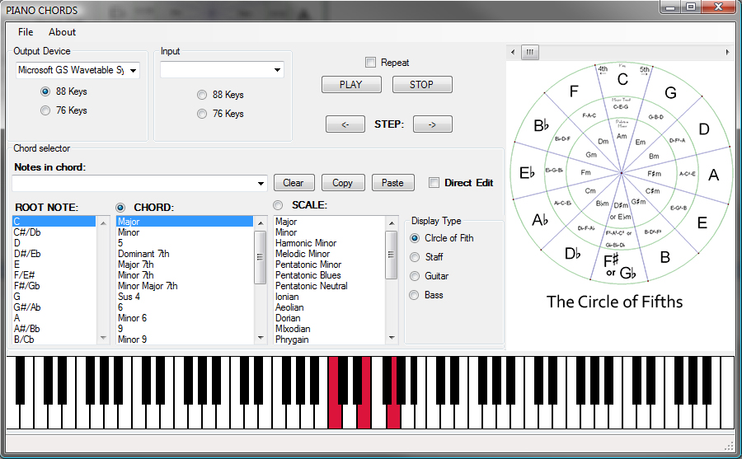

Figure 4-1.

The main form (Figure 4-1) of application has a combined set of controls required to perform a Chord Progression modulation and edition.
- MIDI output device: To select a MIDI sound device to be used for audio output
- MIDI input device: To select a MIDI input device to be used for note input
- “Chord Selector” group.
  - “Notes in chord”: An editable text box Indicate note structure of a chord
  - “ROOT NOTE”: A selectable list for chord root note.
  - “CHORD”: A selectable list of Chord Progression based on selected Root Note.
  - “SCALE”: A list of keyboard major scales available in program DB.
  - “Display Type”: A group of controls, to select the way that notes in a chord shall be visualized.
  - Button Controls – “Copy”, “Paste”, “Clear”: A basic Windows Clipboard control buttons for “Notes in chord” text filed.
- FULL Scale 88 key piano keyboard: An advanced input and output control presented as a virtual piano keyboard.
- Circle of Fifths: Visual presentation of music note used in Chord progression.

The controls that are not being listed, used for development purposes.

Under the menu options are:
- File Exit : to exit the application
- About: brings application info dialog.

4.2 Data Structures

There are not too many places in application where I used any advanced data structures. Since the application is modular (Sound input and output, Keyboard controls, Chord Recognition), I tried not too overcomplicating things, since this is a template project for a bigger final product. The main data structure for used, was a modified Binary Tree to Data tree – too organize a Chord Progressions stored in a program by default, and its'.
To store a Chord Progressions the basic binary tree was really helpful. All data shall be imported using a text file stored in program folder.
During importing this text file, the nodes of a data trees being constructed.
Text file entries and tree node example:
C-Major,C,E,G
C
C-Minor 7 Th, C, D# / Eb, G, A# / Bb
E
D# / Eb

G, C-Major
G

A# / Bb, C-Minor 7 Th
Figure 4-2-1. The simple presentation of binary tree nodes to store Chord Progressions. In this example two Chord Progressions (C-Major and C-Minor 7Th) had been stored in a binary tree node.

The data tree mostly been utilized to generate and search Chord Progressions.

4.3 System Architecture

THE MAIN FORM
SOUND INPUT AND OUTPUT
Compose and Send MIDI message to device

(Key touch event)
Chord Progressions input and output
(Key touch event)
(Key touch midi message decoder)

Read User input
Virtual Piano key board input and output
Highlight piano key
Read a mouse pointer position and generate key touch event
The “Circle of Fifths” visual applet

Figure 4-3-1 System Architecture

At every launch of application the chord data file being imported and organized in a data tree. It’s being used later to recognize all music chord that user generates via external keyboard input. One of the application features to automatically recognize chords if any being produced by user. For example we would like to use a standard chord as a starting point, to produce our own chord. So instead of searching through data base, we could just use an external keyboard to generate chord and then edit it later. The program is continuously listening for any MIDI message to come in through MIDI input device. And the if the user want to capture any keys that being pressed, all that is required is to enable capture feature of external input device.

Also there are 3 alternative note input modes available:
- Using a text editor – User directly modifies a chord formula text field to see the layout on the screen
- Virtual piano input - User directly press a virtual piano key to add note to the chord field to see the layout on the screen
- External Piano - User directly press a piano key to add note to the chord field to see the layout on the screen .

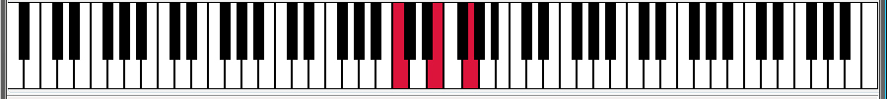
Virtual piano keyboard – An event driven user control that enable user to utilize a features of real piano keyboard, without having one. Each individual key is a separate sub user control that carries it unique properties: Key Name, Tone, Position and color. When user presses a virtual piano key, a system event is being raised, that affect a behavior of virtual piano key and system note recognizer.

External Piano keyboard – A real hardware device that is attached to the computer to produce note phrases using a piano keyboard. When user presses a piano key, a system event is being raised, that affect a behavior of virtual piano key and system note recognizer. The keyboard is being attached to system via Microsoft standard open source libraries and system files included in Window OS.

4-3-2. UML Diagram of Input and output device classes.

4.4. Algorithms

There several general algorithms being used in this project.

1) To organize all systems events those are coming from or to audio devices. In the beginning of the project, I have faced a problem of non logical sorting of simultaneously raised events from input devices such as external or internal virtual keyboard. It was not a big issue for external keyboard, since the program does not control the process of how key press messages had been organized, because it’s a job of external keyboard CPU. But, it was an issue with internal virtual piano user control. Yes there are some methods to control it. Like assigning a sequence value to each key press event, bit it was not applicable, since it could rise and additional problems with application performance. So I decided to do a basic event sorting via .NET Class System.Threading.SynchronizationContext. Which is little bit better that standard System.Threading Abstract Class whick is normally derived by User Control Objects.

2) Chord Progression Organizer – A modified version standard binary tree algorithm that is designed to organize and import general piano chords in a tree.

3) Virtual Piano keyboard animation event – To implement this user control, I used standard graphic function of C#. Basically each time then we press and release a piano key there two messages being raised. Press Piano Key - indicates that we could press a piano key a hold a finger on the key. Release Piano Key –indicates the we removed a finger from piano key. To do a proper highlighting a have developed a simple logic and algorithms to maintain a proper animation.

5. Software Development Process

During a period of development I have switched to several approaches how to organize my program logic that will be flexible enough to add or remove unnecessary feature. There still some features that need to be implemented but this goes beyond time limit that I had for development.

There several major fields that I had to study before starting this project. Initially I had no info and no experience in music theory. For example, in order to understand how the piano keyboard been organized, I moved myself from a field of computer science to the world of music science. Also I had no experience working with external devices such as MIDI keyboard. The MIDI as a technology in a protocol that enables musical devices to pass a musical data between each other. MIDI – Contrary to other audio formats, MIDI does not transmit the actual audio signal or waveform to be played. Instead, it simply transmit a series of event messages such as "press a 'C' key and release it when I tell you”. If you play back the recording of a real piano performance, it will sound very similar on all players, and differences in sound will only depend on the quality of the playback system and the speakers. So the challenge was to create a class to receive MIDI messages from input MIDI devices and send it back. And instead of reinventing a wheel. I used a Microsoft open source code to connect and pass messages to General MIDI audio device.

There major steps that I had to go over during development of this application:
- Music theory research – The major part of entire project. I spent a majority of my time cover this field and I’m glad that I got such a good opportunity to be familiar with music construction principles.
- MIDI Technology – This part is closely related to computer science but still requires knowing basic principles of music instruments, like piano.

As a protocol, it is not complicated at all. But requires a huge time investment into research. In my case, it was the problem of understanding external keyboard messages using a standard techniques. As we all know there are dozens of digital piano keyboard manufactures. Each keyboard of some brand produces a set of messages that is slightly different from others. For example Yamaha keyboard produce message format like: Key, Velocity and Weight. And Casio keyboards produce Key, Velocity and Average hammer travel time. In both cases Velocity value is not in the same range. Yamaha’s range is from 1 to 160, Casio’s is 1-100. So it was really had to tell how we should process these type of commands. After all I found easy solution for both cases. All I had to do, is to disable advanced keyboard features like hammer touch and after sensor. But these is a very important system requirement, that is MIDI device must support General MIDI protocol.
- Development Steps:
    - User controls aka virtual piano keyboard.
    - Music Note processing. To or from Output audio device.

3) Chord Formula Builder

4) Visualization of presented chord.

5) Output to audio MIDI enabled device.

  - Prototyping Challenges

As I mentioned before my project was carried out with assistance of professional pianist . So I was guided by her to come up with a good design and all necessary tools required to utilize program as something that is going to help piano players to learn Chords Progressions faster. But the most and biggest challenge that I faced right at the end of the project is the way user press a piano keys and its timeframes used.

My implementation of chord recognition is based on fixed time frames. But I reality all piano players use their own developed system to insert spaces between notes. And it was very confusing how we should distinguish one chord from another.

As of right now the application still uses a standard approach. To handle keyboard key input. But since this part being important for all musicians, I wish to spend more time and redesign this part.

Also there are several issues that faced during development . I wish to list most critical:
- MIDI format for different brands. Interesting fact, that there is no universal software on the market that knows everything about keyboards.
- The visual presentation of “The Circle of Fifths” has been suspended. Since C#. NET does not support graphic files with pixel transparent data.

6. Schedule

WEEK.

1-6: Music theory research. General idea development. Requirements and Input data generalization. Documentation.

6-7: XML Engine implementation. Hardware research. MIDI Protocol.

8-9: UI. Final Specification Review.

10-12: Hardware testing.

13-14: Documentation. Final Debugging.

15: Demonstration. And Final write-up

7. Results

My goal was to demonstrate that music production software is one of the most interesting fields. This project pushed me a lot farther in this area than I expected.
The program is still under development but it is in a good stage when I can tell that it has potential and may be a good place in a software market.
My personal idea is to deliver a good product that will help beginning piano players to learn and use musical construction rules. To have a good foundation for further development (Portable Devices, Embedded Software and etc…)
To get a good practical skills, while working with musical hardware and software communication

8. References

1) C# for programmers Second Edition 2006, Harvey M. Deitel 2006

2) Desktop Audio Technology: Digital audio and MIDI principles (Music Technology), Francis Rumsey, Focal Press; 2003

3) Music Theory: A Practical Guide for All Musicians, Hal Leonard 2006

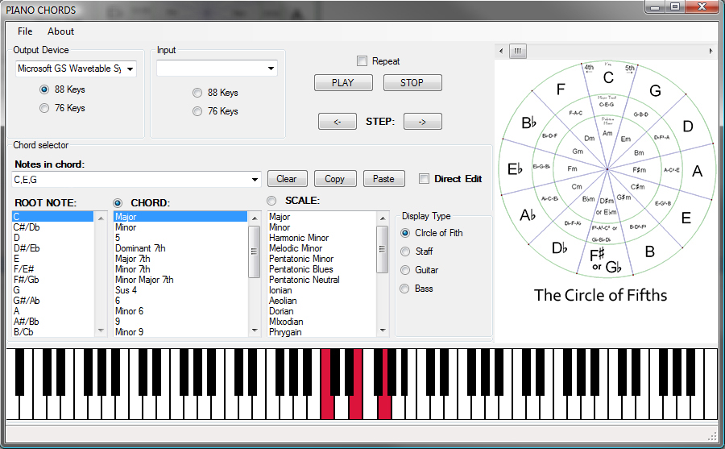
9. Program interface and features. User’s Manual

The main application window has all combined controls in one place.

Fig: 8 -1 .The Main Window

- Virtual keyboard - To play music notes on virtual keyboard. Just use your mouse and clicks keyboard key to activate it.

2) Chord Base selector – There are set of Chord Progressions preprogrammed in the application. Just select a root note and Chord based on your root note.

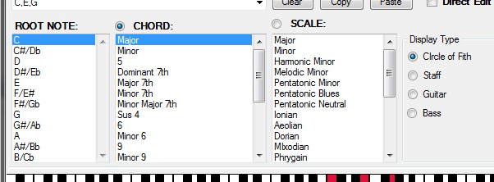

3) To use your external input device in a program. Connect your keyboard before launching the application. And make sure that all drivers had been installed properly. If the device successfully recognized by application it will automatically added to the list of available input devices.

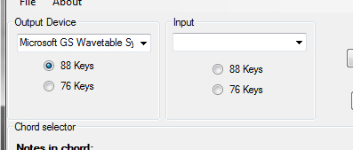

4) To use chord recognition system, try to play any general chord on your external keyboard. If Chord progression identified it will be displayed in console window.

5) When you would like to exit the application, choose F)ile, E)xit or click the X in the upper right corner.

Appendix A: Code Listing

