SNA_PID_SQL

Heath Kimball
CS 470 - Project Write-up

April 27, 2007

Table of Contents

Abstract……………………………………………………………………………………3
- Introduction……………………………………………………………………………3
- Project Overview……………………………………………………………………...3
2.1 Data Files………………………………………………………………………….3
2.2 Previous system…………………………………………………………………...4
3. Project Requirements………………………………………………………………….5
3.1 Functional Specifications………………………………………………………….5
3.2 System Specifications……………………………………………………………..5
4. System Design………………………………………………………………………...6
4.1 Data Structures…………………………………………………………………….6
4.2 System Architecture……………………………………………………………….6
4.3 Algorithms ………………………………………………………………………..6
4.4 User Interface Design …………………………………………………………….7
5. Software Development Process……………………………………………………….8
5.1 Testing and Debugging……………………………………………………………8
5.2 Work Breakdown………………………………………………………………….8
6. Results…………………………………………………………………………………9
6.1 Final Program……………………………………………………………………..9
6.2 Future Enhancements……………………………………………………………...9
7. Summary and Conclusions…………………………………………………………..10
8. References……………………………………………………………………………10
Appendix A: User Manual……………………………………………………………….11
Appendix B: Code Listing……………………………………………………………….16

Social Network Analysis for Person ID
SNA_PID_SQL
Heath Kimball

Abstract

Record management system (RMS) data is used by law enforcement agencies to manage incident data. An incident can be a call to service, an arrest, a complaint, or anything that requires documentation of an incident and the individuals involved. RMS data is a dataset and consists of an incident ID and a series of person IDs. RMS data works well for examining information related to an incident (who, what, where, when) but does not work well for analyzing patterns across incidents. There is a program called UCINET that is used by system analysts. UCINET is a graph network analysis program that uses node data. SNA_PID_SQL was created to convert RMS data into node data.

1. Introduction

This project was developed for Alan McKelvie who is a systems analyst for the University of Alaska Anchorage. The current application that Mr. McKelvie is using is inadequate in that it is not fully automated and requires manually entering data into MS Access tables. It also lacks the ability to create new data descriptor files.

2. Project Overview

The goal of this project is to develop a system that can access and convert RMS data that lies in relational databases, into node data. RMS data is used by law enforcement agencies to manage their incident data. The node format of data is specifically designed to analyze patterns across incidents.

2.1 Data Files

RMS data is stored in relational databases and needs to be extracted and converted into node data. To connect to these databases the system must search the local directories for data descriptor files such as uniform data locator (.udl) files and data source naming (.dsn) files. These data descriptor files contain information about accessible databases and how to connect to them. These files will be used by SNA_PID_SQL to connect to those databases. These databases include but are not restricted to Oracle, Microsoft Access, and SQL Server. The contents of a uniform data locator file are shown in figure 1. The contents of a data source naming file are shown in figure 2.

[oledb]
; Everything after this line is an OLE DB initstring
Provider=SQLOLEDB.1;Integrated Security=SSPI;Persist Security Info=False;Initial Catalog=tst4;Data Source=just-anarm\SQLExpress

Figure 1. Contents of .udl file.
[ODBC]
DRIVER=Microsoft Access Driver (*.mdb)
UID=admin
UserCommitSync=Yes
Threads=3
SafeTransactions=0
PageTimeout=5
MaxScanRows=8
MaxBufferSize=2048
FIL=MS Access
DriverId=25
DefaultDir=E:\AJSAC\prjs\IDMatch\Data
DBQ=E:\AJSAC\prjs\IDMatch\Data\Northwind.mdb

Figure 2. Contents of .dsn file.

After the connection is made to the desired database the tables and views in that database are listed along with the associated values within the tables and views. The desired values to be queried are chosen and a new table containing those values is created and stored in the client’s chosen database. That same queried data is also saved to a .txt file to be later used by UCINET. The contents of the .txt file are shown in figure 3.

DL n = 27 format=nodelist1
labels embedded
data:
1 1 2 3 4 5 6 6
10 10 8 9
11 11
12 12 13 14
13 13 12 14
14 14 12 13
15 15 6 16 17 18
16 16 6 15 17 18
17 17 6 15 16 18
18 18 6 15 16 17 19 20 21
18 18 6 15 16 17 19 20 21
19 19 18 20 21
2 2 1 3 4 5 6 6
20 20 18 19 21
21 21 18 19 20
3 3 1 2 4 5 6 6
4 4 1 2 3 5 6 6
5 5 1 2 3 4 6 6 6 7 8
5 5 1 2 3 4 6 6 6 7 8
6 6 1 2 3 4 5 5 7 8 15 16 17 18
6 6 1 2 3 4 5 5 7 8 15 16 17 18
6 6 1 2 3 4 5 5 7 8 15 16 17 18
6 6 1 2 3 4 5 5 7 8 15 16 17 18
7 7 5 6 8
8 8 5 6 7 9 10
8 8 5 6 7 9 10
9 9 8 10

Figure 3. Contents of output .txt file.

2.2 Previous System

The current system being used, SNA_PID, cannot search local networks for accessible databases and is based off of Microsoft Access. It also lacks the ability to create new data descriptor files and has problems extracting data when not in a specific format.

3. Project Requirements

The requirements suggested by Mr. McKelvie were clear and left open for future add-ons. He provided a list of them along with their priority.

3.1 Functional Specifications

1. The system needs to be able to access and query Oracle, Microsoft Access and SQL Server databases using SQL. Priority = High

2. The systems must provide a way to browse the local directories for data descriptor files such as UDL and DSN files. Different default paths will be provided for both the UDL and DSN files. Priority = High.

3. The system needs to be able to use the data descriptor files to connect to the associated database. Priority = High.

4. Once connected to the database, the system must provide a drop down list of available tables and views in that database. Priority = High.

5. Once the desired table is chosen the system must provide a drop down list of the columns in those tables. Priority = High.

6. Once the user selects the desired columns for the query, the system must create a select statement to query that information. Priority = High.

7. The system needs to be able to save the node data, the queried data, to a text file in the proper format. Priority = High.

5. The system must be able to browse the network for database servers and allow the user to create and save data descriptor files for any discovered databases. Priority = Low.

6. The system must be web based. Priority = Low

3.2 System Specifications

The system was constructed using Visual Basic .Net running Windows XP. The end user system must have a connection to any database that the user may want to access. The system should have a minimum of 256 mb of memory and run at a speed of 700 MHz or higher.
4. System Design

The system is going to be designed with an object oriented approach which is allowed with Visual Basic .Net.

  - Data Structures

The queried data is stored into a dataset which contains data tables. The information in the dataset is sorted, filtered and placed into a data table which is accessed to create the text file.

  - System Architecture

With the current requirements of the system, the functionality of the system can be contained in one module. Several forms for the GUI will need to be created. There will be a main form that elicits information through the use of other forms. A UML diagram of the system is shown in figure 4.

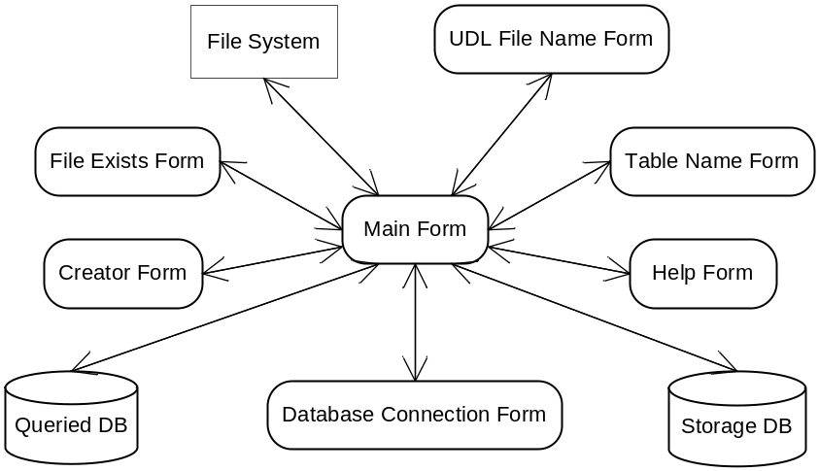

Figure 4. Architecture of SNA_PID_SQL.

  - Algorithms

The algorithm used in SNA_PID_SQL is used to sort and filter the queried data into the desired UCINET node format. The algorithm steps through the dataset placing the appropriate associates with the current PID and removes duplicate associates.

There are several queries used. One gets the largest number of associations that a PID has. This number is used to create the columns that are going to be in the new table. The second query orders and filters information from the database into a format that helps reduce the amount of front end filtering and sorting.

  - User Interface Design

The majority of the work centers on a single form, MainForm. The form is based off of the client’s current system. An image of MainForm is shown below in figure 5. The controls on the form are for:

- Make Table: To browse for DSN or UDL files.
- Save File: Saves the UCINET text file with duplicates.
- Save File Individual: Saves the UCINET text file without duplicates.
- Table: To choose which table to access.
- Person ID: To choose which value the user wants to represent the person ID.
- Event ID: To choose which value the user wants to represent the event ID.
- File
  - New UDL: To create a new UDL file.
  - New DSN: To create a new DSN file.
  - Exit: To end the program.
- Help
  - Help: To provide instructions on how to use SNA_PID_SQL.
  - Created By: To provide information on the creator of SNA_PID_SQL.
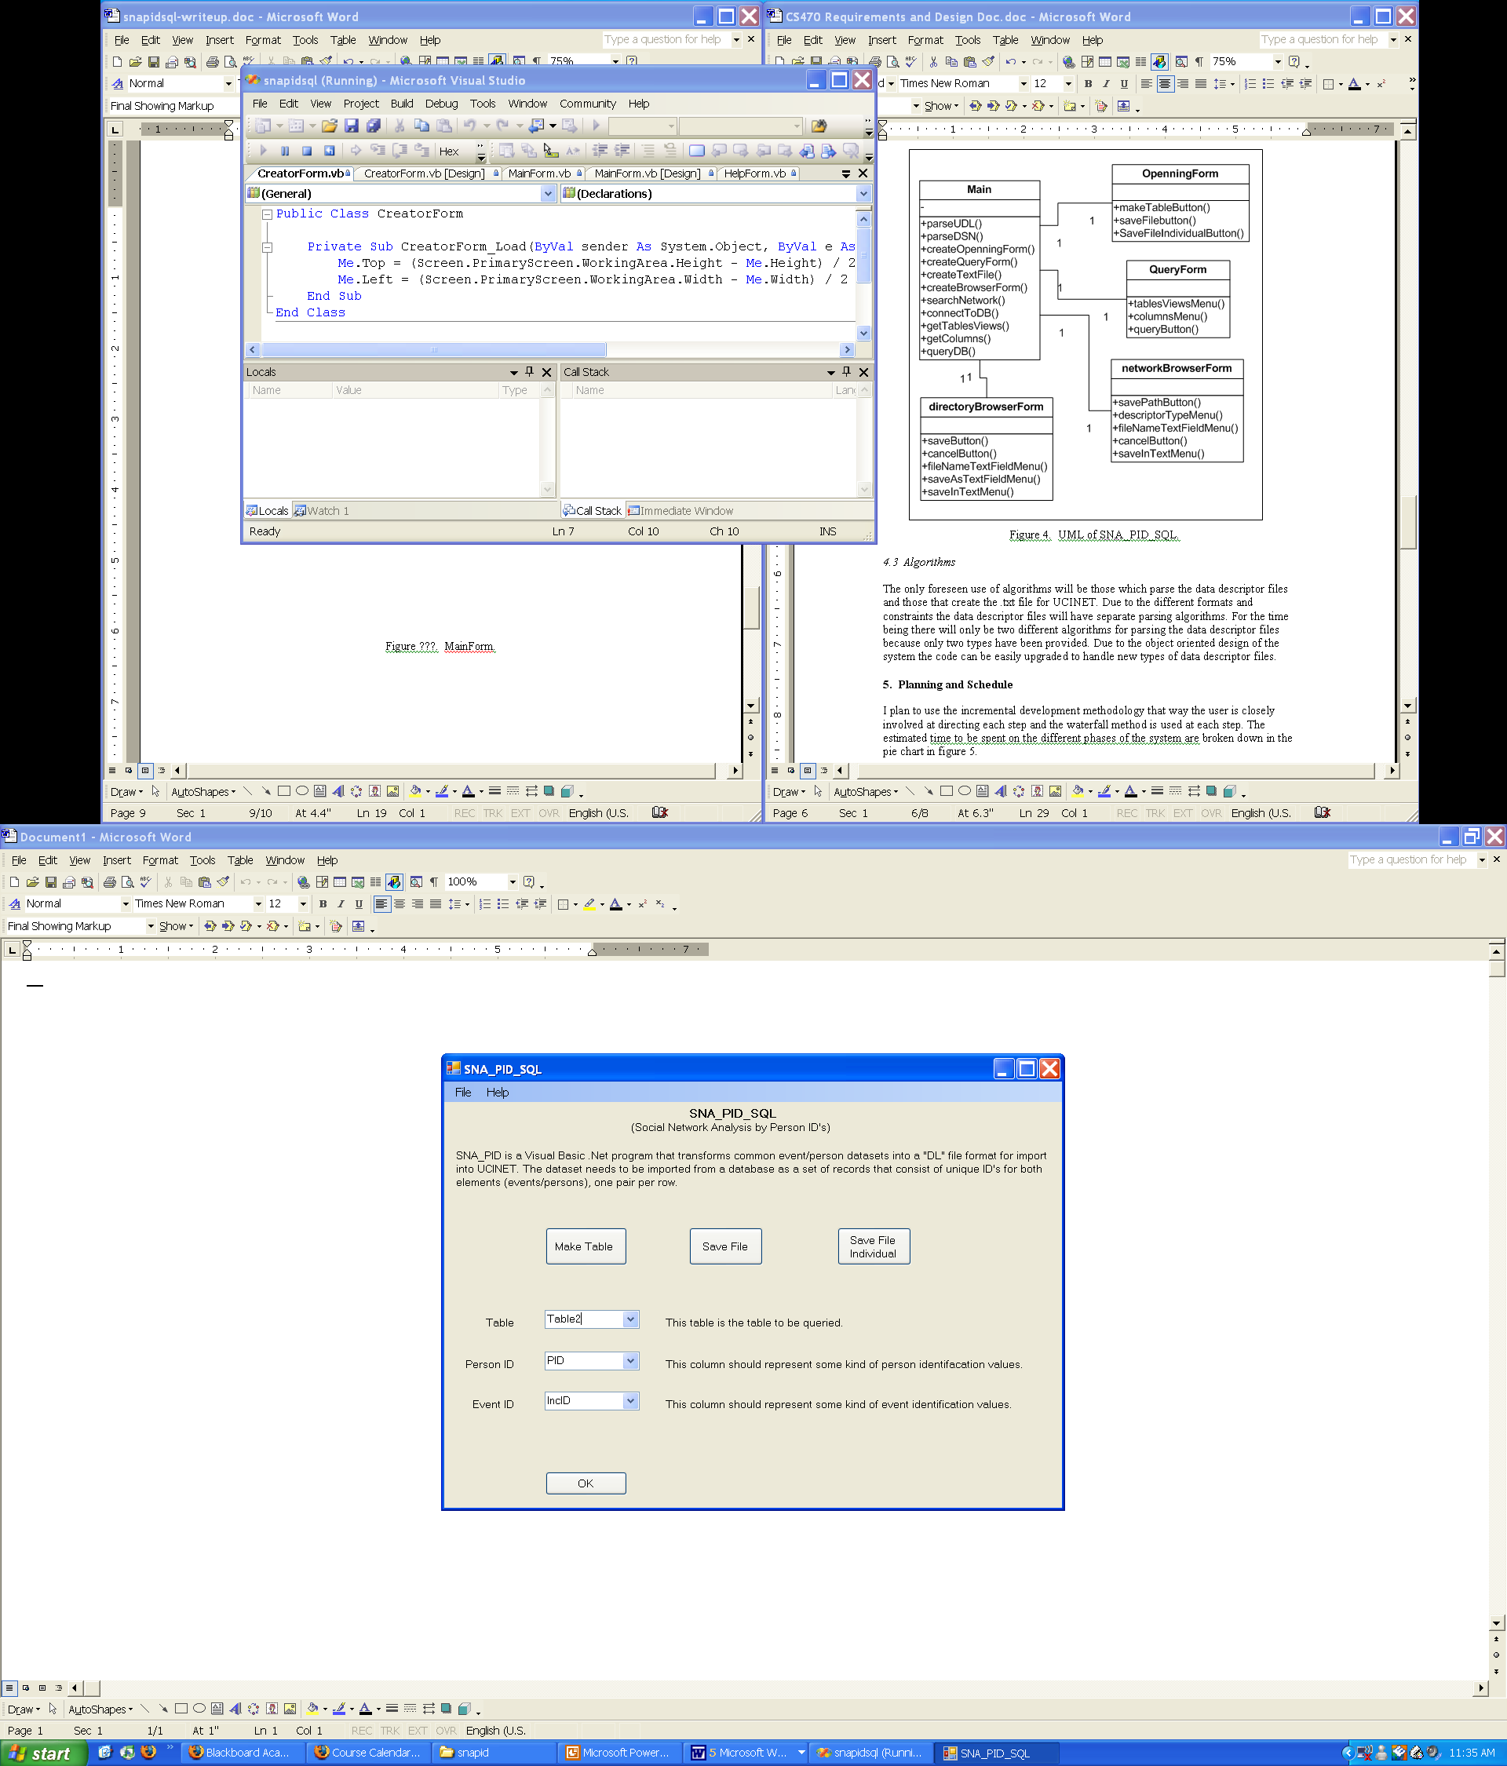

Figure 5. MainForm.

5. Software Development Process

I used the incremental development methodology and the waterfall method to keep the client closely involved at directing each step. As I added new functionality to the program it was thoroughly tested before more functionality was added.

5.1 Testing and Debugging

I spent a lot of time testing, debugging, and ensuring robustness. There were several bugs that took hours to remedy. One was using the fill method for a data adapter, which was supposed to simplify transferring altered data into a data table. I tried several different overloaded ways to use this fill method but was unsuccessful. I proceeded to use another way to fill my data table. I created a dynamic insert statement that was changed for each row in the table. I had one problem with this statement which was an error about the statement not having enough values for the table. I discovered that another dynamic statement, the one that created the table, had one row too many. I fixed the create statement which caused the insert statement work correctly.

5.2 Work Breakdown

The Ghantt chart below, figure 6, shows the estimated and actual work schedule. The values in red represent the estimated time per task determined during the planning and design stage of the project. The values in blue represent the actual time taken per task. Many tasks took much less time than expected but a few took more.

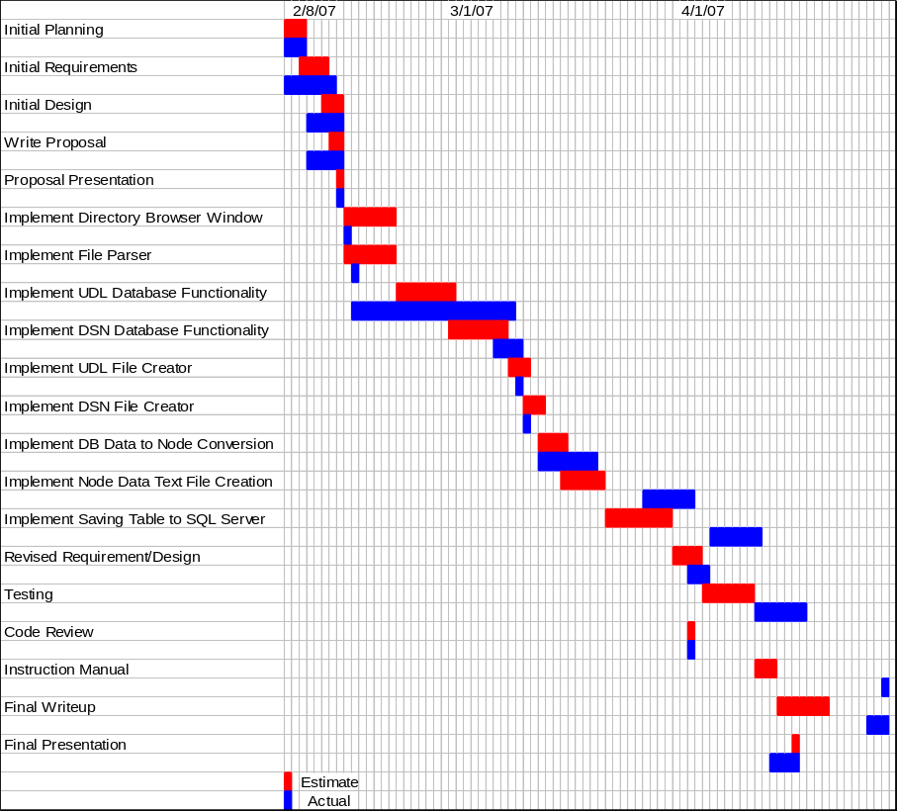

Figure 6. Ghantt Chart

6. Results

The SNA_PID_SQL application was completed on time. The application successfully transforms RMS data into node data, saves the node data to text files, to a database, and creates UDL and DSN files. All of the requested requirements were met to the satisfaction of the client.

6.1 Final Program

For a thorough description of the interface, please refer to the user manual in Appendix A.

6.2 Future Enhancements

A possible enhancement would be to make the application more universal in terms of accessing databases. I would like to give the application the ability to query information from multiple tables as well as from a single table. Currently it can only run against a single table.

Another enhancement would be to create the second text file that UCINET needs to utilize the text file with duplicates. With this file UCINET can create more complex and informative graph networks.

Before you can run SNA_PID_SQL you must go into the code and hardcode the connection string for the database that you want the new table to be saved to. I would like to set it up so a form is called and gives you and option to use a UDL or DSN file. This way the user doesn’t have to get into the code to set the connection string.

Making the application web based would be another excellent enhancement.

7. Summary and Conclusions

This system was developed in Visual Basic .Net for Alan R. McKelvie and the University of Alaska Anchorage. The goal of the system is to convert RMS data into the node format so the data can be analyzed for patterns across independent incidents. This was a very interesting project. I learned a new programming language and gained more experience with the .Net framework.

8. References

[1] www.msdn.com.

[2] www.wikipedia.org.

[3] www.devx.com.

[4] www.codeguru.com.

[5] www.dotnet247.com.

Appendix A: User Manual

Minimum System Requirements

Windows 2000 or XP
.Net 2.0 or newer
256 Mb of memory
700 Mhz CPU

Installation

Copy the SNA_PID_SQL folder to the desired directory.

Go to the saveDataTable() method and set the connection string to the desired database. This will be the database where the table will be saved.

Running the Application

Run the program by clicking on snapidsql.exe icon.

To create a new table, click on the Make Table button.

Now you can choose to use a Data Source Name (DSN) file or Uniform Data Link (UDL) to connect to the database.
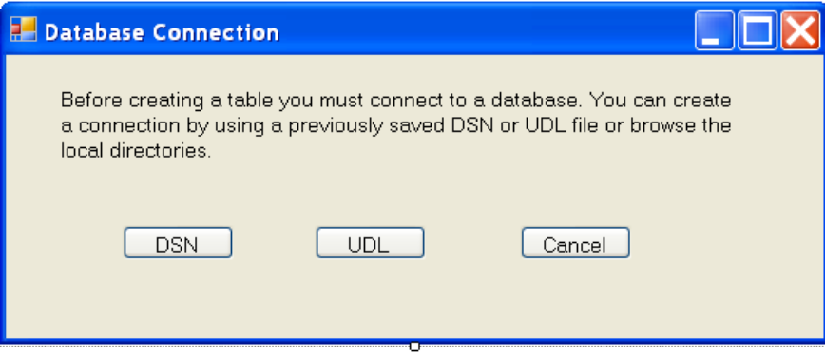

Once you click the DSN or UDL button you are presented with a file directory window that is in the default directory of the chosen file type, either DSN or UDL. If the files are not in the default directory you can browse.

Note:

The default directory for DSN files is:
C:\Program Files\Common Files\ODBC\Data Sources
The default directory for UDL files is:
C:\Program Files\Common Files\UDL\Data Sources
If either of these directories are not present on the end user system be sure to add them before running SNA_PID_SQL.

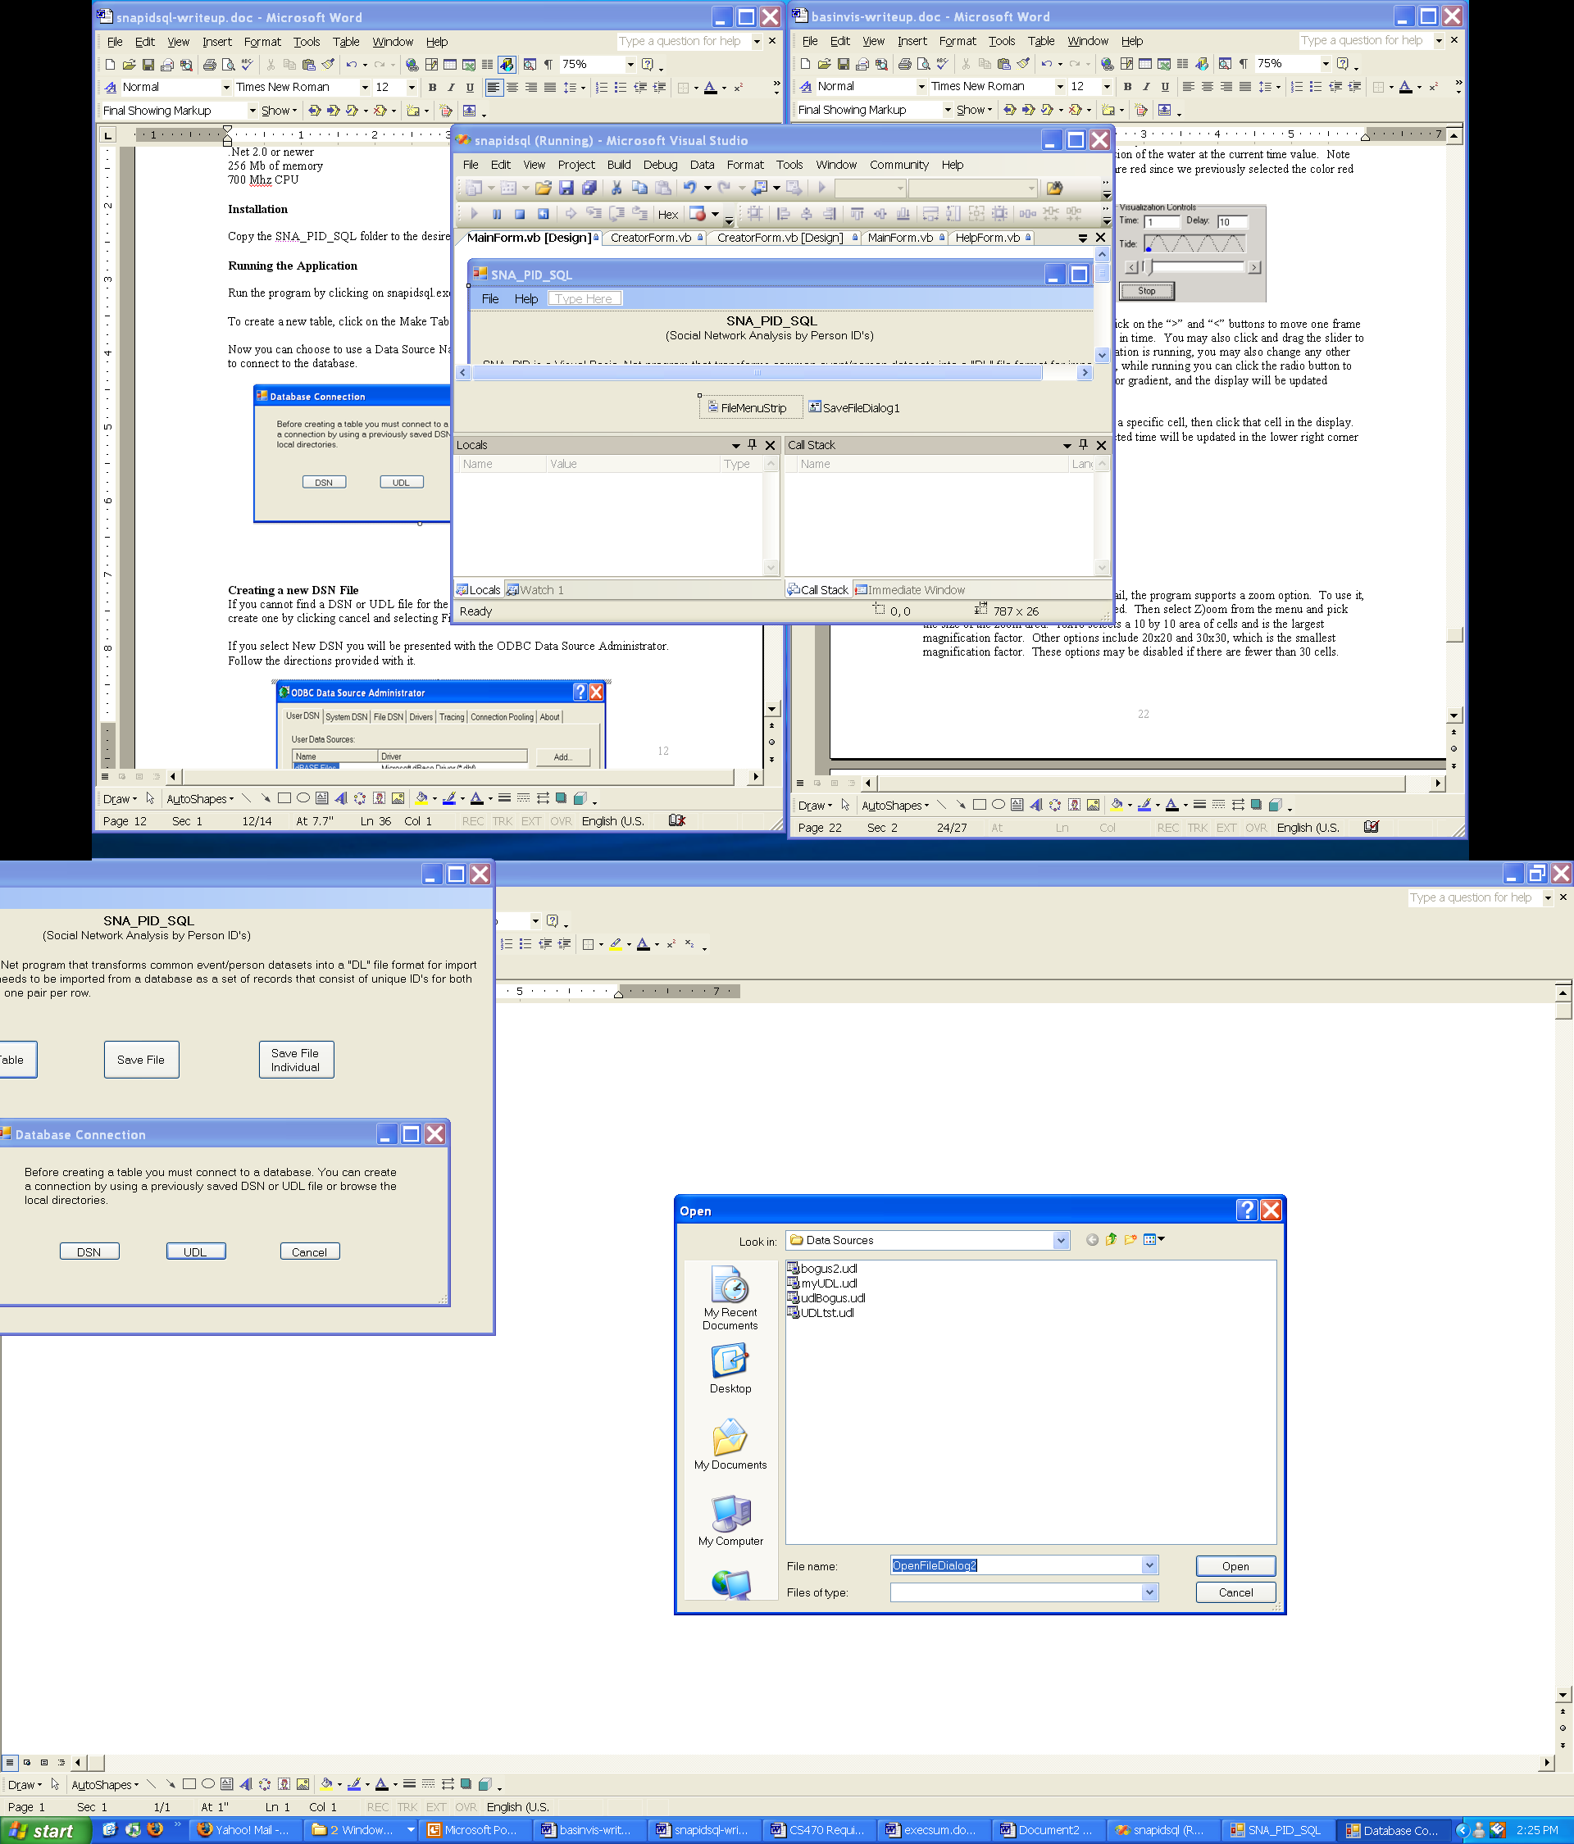

Once a DSN or UDL file is selected, choose a table from the Table drop down menu.

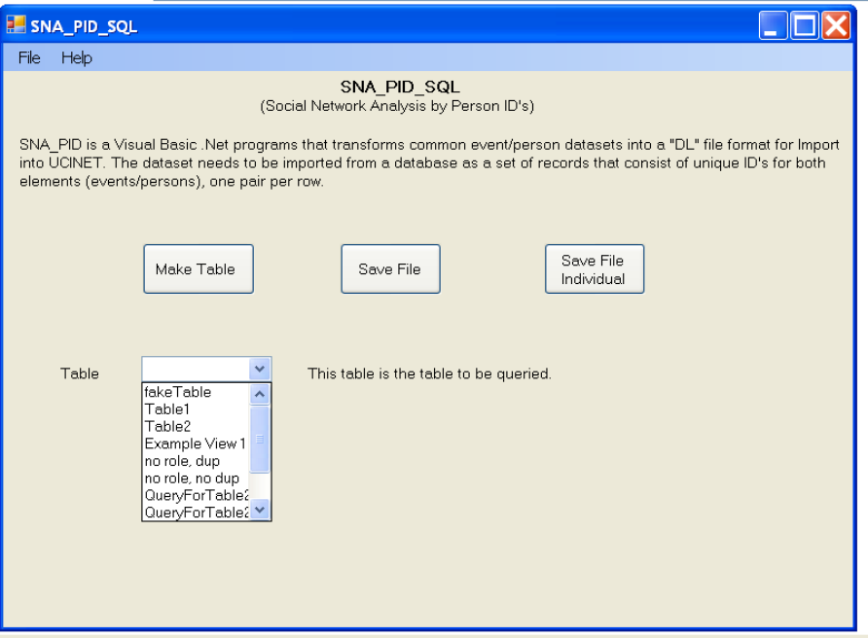

Now choose a value from the Person ID and Event ID drop down menus. The item selected for the Person ID should be a value that represents some kind of person identification value. The item selected for the Event ID should be a value that represents some kind of event identification value. Click OK.

After clicking OK a new table is created with the information from the query.

If you wish to save the data to a text file, select Save Table or Save File Individual. Save File saves the data with duplicates and Save File Individual saves the data without duplicates.

If you want to make another table with data from the current database, select a new table from the Table drop down menu.

If you want to create a new table from another database click the Make Table button.

Creating a DSN File

Select File, New DSN

The ODBC Data Source Administrator form should appear. Follow the directions provided with it.

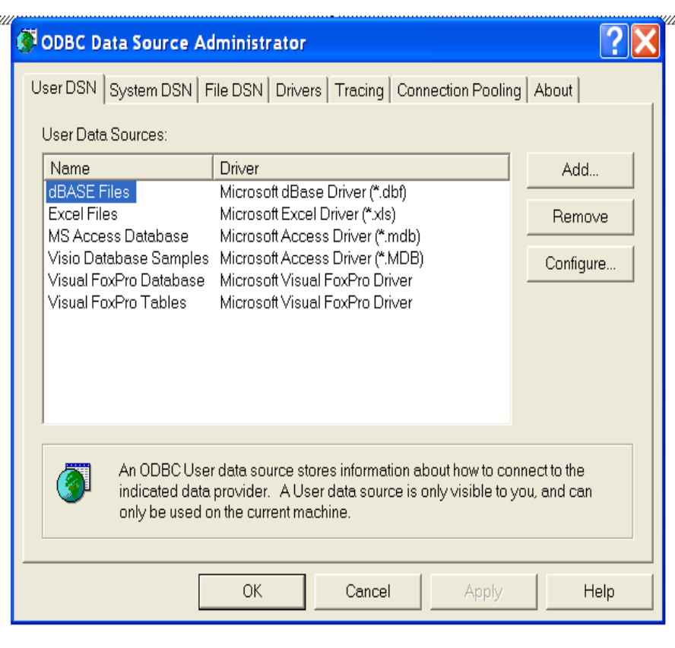

Creating a new UDL File

Select File, New UDL. The UDL file name form should appear.

Enter the name of the UDL file and click OK.

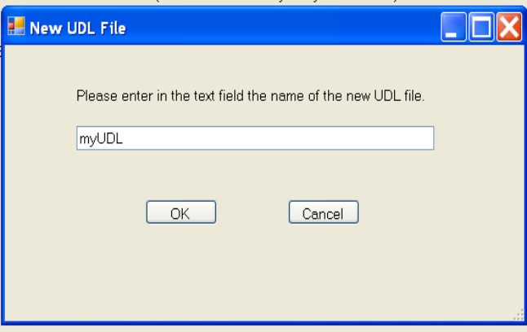

You will then be presented with the Data Link Properties editor. Follow the directions provided with it.

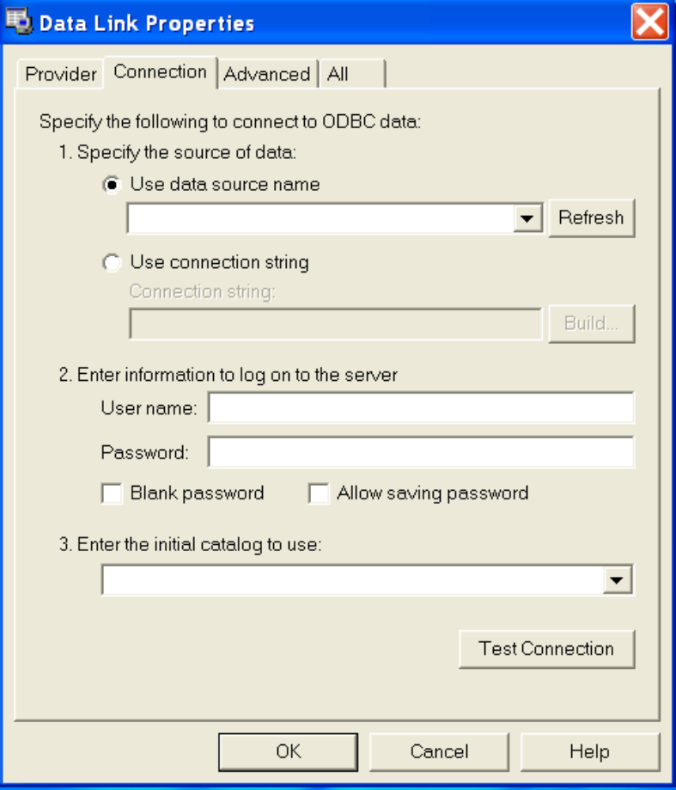

Exiting the Application

Select File, Exit.

Appendix B: Code Listing

