CS 470 Project Report:
Implementation of a
”Broadband Fish Tracker”

While Employed At
Scientific Fishery Systems, Inc.



(5.15.2002 – 11.1.2002)

Table of Contents

Table of Contents ii
A Brief Preface 1
0.1 The Report 1
Chapter 1: Background 2
1.1 The Topic 2
1.2 Background 2
1.3 Current Methods 3
1.3.1 Tagging 3
1.3.2 Narrowband Sonar 3
1.4 A Solution: Build a Broadband Fish Tracking Sonar 6
1.4.1 More Certain Detection 6
1.4.2 Improved Identification 6
1.4.3 The Best Foundation for a Fish Tracker 7
Chapter 2: Design 8
2.1 Analysis 8
2.2.1 Necessary Tasks 8
2.2.2 Structure of the SciFish 2000’s Software 9
2.3 Initial Design Goals 10
2.3.1 Reproducibility 10
2.3.2 Compatibility and Modularity 11
2.3.3 Performance 11
2.3.4 Adaptability 11
2.4 The Integration Plan 12
2.4.1 Tracker Dataflow, Original Concept 12
2.4.2 Tracker Dataflow, Revised Concept 13
Chapter 3: Implementation 14
3.1 The User Interface 14
3.1.1 The Collection Form 14
3.1.2 Track Display Settings Form 15
3.1.3 Tracker Parameter Form 16
3.1.4 Track Export 17
3.1.5 Database Modifications 18
3.2 Tracking Implementation 18
3.2.1 Implementation Challenges 18
3.3.1 The Echogram Displays: LRP and HRP 22
3.3.2 Distribution Pane: DP 23
3.4 Storing And Replaying Tracks 23
3.4.1 Storing Tracks 24
3.4.2 Replaying Tracks 24
Chapter 4: Revision 25
4.1 Informal Revision Process 25
4.2 Formal Revision Process 25
Chapter 5: Error Handling 26
5.1 VB 6.0 Error Handling Syntax 26
5.2 Error Handling Philosophy 27
5.3 Error Handling Implementation 27
Chapter 6: Conclusion 28
6.1 Achievements 28
6.2 Skills Gained 28
Appendix A: Integration Plan 29
A.1 Integration Plan 29
A.2 Review Meeting Minutes 29
Appendix B: Code Samples 30
B.1 Sonar OCX 30
B.2 The User Interface: Forms and Displays 31
B.2.1 Forms 31
B.2.2 Classes 31
B.2.3 Modules 32
B.2.4 Amount of Code Written 32
Glossary of Terms 33
Background Documents 35
7.1 Authorship 35
7.2 List of Documents 35
7.3 Video Demos 35
Bibliographic Sources 36

_____________________________

A Brief Preface
_____________________________

I would like to acknowledge that the path that has lead to this report is one that I haven’t had to walk alone. I’ll begin by thanking my employer, Pat K. Simpson, and my direct supervisor, Jennifer Gunderson, for their encouragement and criticism while working on this project. I’d also like to thank current and past UAA faculty for their dedication. In particular, I would like to single out Professor Mock’s CS 411, Professor Scott’s CS 360 and former Adjunct Professor Billing’s CS 207 as being particularly valuable.

0.1 The Report
This report is laid out in a linear fashion and divided into chapters. Additional supporting documents have been included as appendices. These appendices include: original design documents, source code samples, background documents, short video clips of the software running, and my CS 470 presentation. These appendices can be accessed via hyperlink.

___________________________________________

Chapter 1: Background
___________________________________________

This chapter discusses the background and motivation behind my CS470 topic. It frames the topic’s relationship to an SBIR project funded by the NSF. It explains how the SBIR project is motivated by difficulties faced by riverine resources managers. These difficulties are caused by the limitations of current fish counting and tracking methods. I will briefly explain why tracking is required for accurate fish counts. Finally, I will present the advantages that broadband sonar technology could offer when applied to fish tracking and show how my topic contributes to the overall project and ultimately the fisheries management community.

1.1 The Topic
The NSF has recognized the need for a broadband fish tracking sonar. Scientific Fishery Systems has completed a Phase I SBIR grant to study the feasibility and advantages of a broadband tracker. Recently an additional Phase II SBIR grant was awarded for the construction of a prototype. Work on Phase II began in May of 2002. This prototype will include split-beam technology, tracking, and display functionality. Raw ping data as well as system settings will be stored to ensure a legal recording capability.

My CS470 topic is a subset of this larger, and still continuing, broadband tracker project. I was assigned to modify the software of an existing sonar system, the SciFish 2000, so that it could by used for fish tracking. This report documents how this task was completed.

1.2 Background
Riverine fish populations are under increasing pressure from development and over-utilization. Current methods for assessing fish numbers are labor intensive, imprecise, and often subjective. Without effective tools for measuring fish populations and run escapements, it is difficult for resource managers to make sound decisions. Since the survival of significant animal and human communities is dependent on these fisheries resources, the tangible and intangible costs of poor decisions can be large.

1.3 Current Methods
Current Methods for counting fish include visual counting, fish tagging, and sonar assays.
Visual counting is limited to shallow, clear waterways, leaving tagging and sonar as the most generally applicable methods.

1.3.1 Tagging
Fish tagging can provide a good estimate of fish numbers in addition to behavioral data. Tagging is done by capturing specimens, and then clipping or tagging a fin or implanting a transmitter. Fish with tagged fins must then be recaptured. Fish with implanted transmitters can be actively followed using an appropriate receiver technology.

Unfortunately, tagging has downsides. A large number of specimens must be captured. Capturing and tagging a large number of fish is laborious, and if poorly done, can result in injury to the specimens. Additionally, if transmitters are used, the cost of the transmitters can be prohibitive.

1.3.2 Narrowband Sonar
Narrowband sonar is predominantly used to assess fish quantity and behavior at key points along a river. Fish are distinguished from noise and background echoes by setting a high target strength threshold. The sonar's ping rate is usually set very high providing several dozen echoes for each fish. These echoes are used to produce tracks that document each fish’s movement through the sonar beam.

There are three problems with this methodology. Fish identification is based on target strength, alone which can cause detection problems. Narrowband sonar has difficulty counting and tracking densely schooling fish because it is sensitive to acoustic shadowing. With most narrowband sonar systems, track assignment must be done manually.

1.3.2.1 Riverine Narrowband Detection Problems
Because narrowband sonar only operates at a single frequency, the operator only knows the range and strength of a target’s echo. Target identification with narrowband sonar can be difficult and error prone. In general, the target strength of an echo is a function of target size, type, orientation angle, reverberation effects, size-dependant resonances, and completeness of ensonification.

Unfortunately, when using narrowband sonar, echo target strength thresholds often have to be set quite high, because otherwise the sonar would detect too many false positives. Because thresholds are set high, fish will often disappear and then reappear as they move through the sonar beam. Differentiation between a single track with a gap and two individual tracks is largely subjective and, therefore, difficult to automate.

Examination of typical narrowband riverine data (see the following figure) exemplifies the problem faced. Tracks are clearly visible, but it isn’t clear to an untrained eye how to handle gaps in tracks. How many tracks are present? A trained human can, with difficulty, generate consistent fish counts from such data, but these counts are inherently subjective.
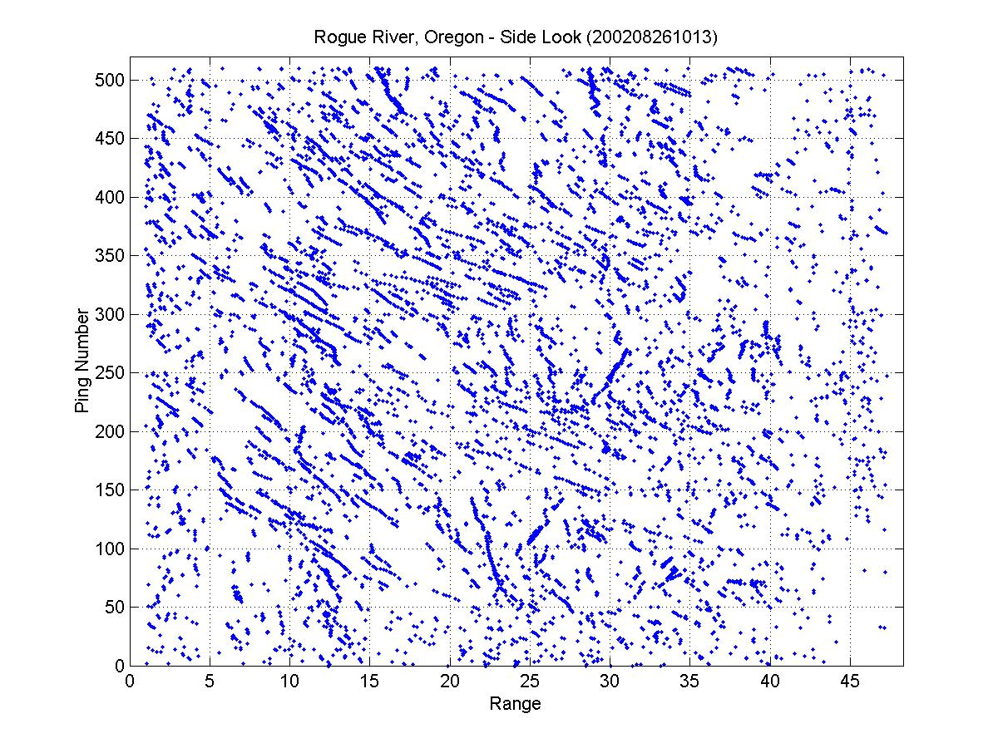

1.3.2.2 Acoustic Shadowing, Cause and Effect
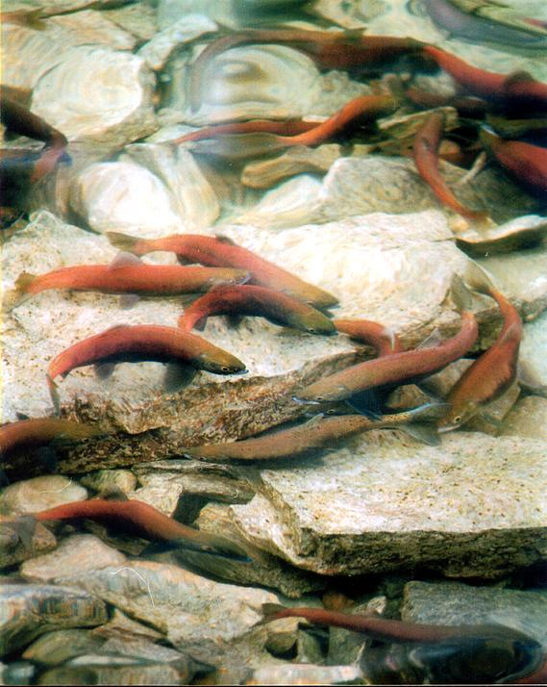
Many economically and environmentally interesting riverine environments have denser fish concentrations than in the sample data from the previous section. When fish are densely schooled, narrowband sonar systematically undercounts fish numbers. Acoustic shadowing causes this systematic error. Acoustic shadowing can compound and be compounded by narrowband sonar’s detection and identification problems.

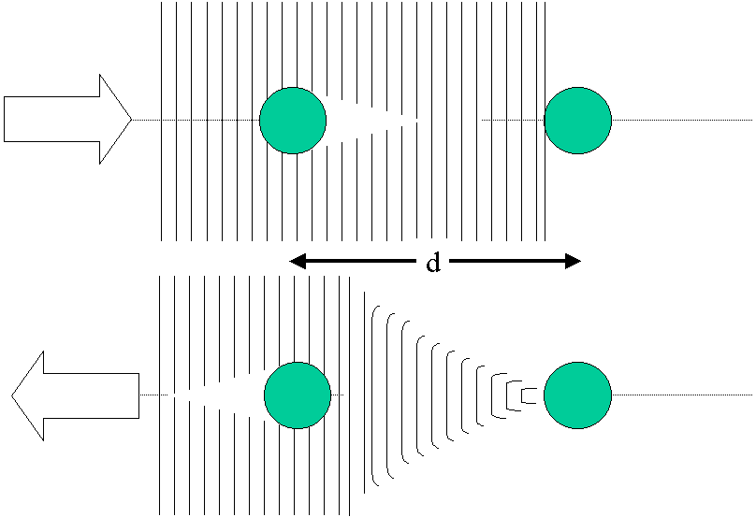The effect is depicted in the figure on the right. Shadowing reduces the target strength of the more distant target. If the targets are sufficiently close to each other, it may be impossible to resolve the two targets as independent echoes. Both effects can, cause highly variable undercounts.

Because narrowband sonar systems generally use high target strength thresholds to separate fish from other echoes, and because they have poor range resolution, acoustical shadowing can seriously effect fish counts. Generally, as fish flow rates increase, narrow band sonar become highly undependable. The effects of fish flow rate on the accuracy of acoustic fish counts is depicted in the next figure.

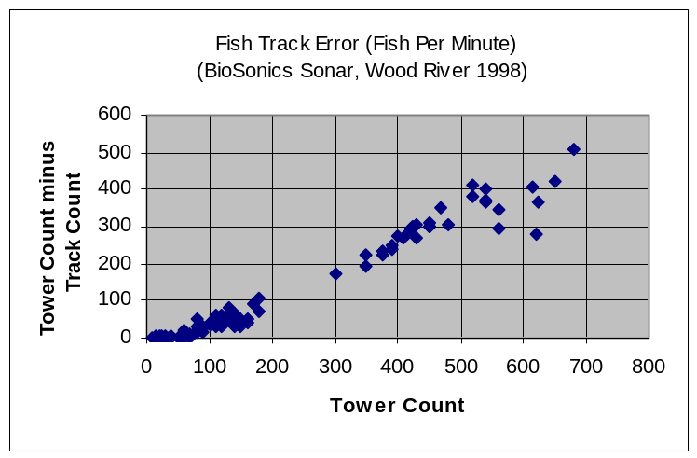The figure on the right shows how narrowband sonar data becomes increasing unreliable as fish numbers increase. Narrowband sonar performs well as long as fewer than 100 fish per minute are being counted. As the rate of fish flow increases, there is a systematic undercount caused by acoustic shadowing effects.

Systematic undercounts are often dealt with by scaling the observed fish counts using the “Bendix” method. This method estimate fish passage rates from echo data multiplied by a user generated scaling factor.

1.3.2.3 The Need for Automated Tracking
As fish swim through the sonar beam, they have to be tracked to ensure that each fish is counted exactly once. Thus, according to current methods, fish-counts are based on the assignment of tracks.

With most existing, narrowband sonar systems, tracking and track assignment is a manual process. Because of gaps in tracks and the effects of shadowing this work is difficult, laborious, and subjective. Resource managers are currently very interested in purchasing systems that can automate tracking.

1.4 A Solution: Build a Broadband Fish Tracking Sonar
Development of a broadband sonar system with automated fish tracking would greatly improve riverine fish passage data. The advantages of a broadband, tracking sonar over current narrowband sonar systems lie in three areas:
- Broadband sonar provides better and more certain detections.
- Broadband sonar provides improved fish identification.
- Broadband sonar provides a superior platform upon which to build a fish tracker.

1.4.1 More Certain Detection
Broadband offers superior detection and 10x better target range resolution. Because identifications are based on target spectra, target strength thresholds and related detection problems are not significant. Superior range resolution means that broadband sonar systems also have fewer detection problems resulting from acoustic shadowing.

1.4.2 Improved Identification
Consider the spectrum of fish identification capabilities:
- Narrowband sonar systems are not strictly capable of fish identification.
Fish Identification Capability
100%
0%
Narrowband
(Conventional)
Broadband
SciFish 2000
Broadband Tracker
(w/ Echo Averaging)
- Scientific Fishery Systems’ current broadband sonar system, the SciFish 2000, identifies fish based on single echoes. Fish species assignment is 80-90% correct.
- A broadband tracker can be setup to apply the SciFish 2000’s fish identification technology to the echoes along a track. According to Alexander Kulinchenko, echo averaging should improve identification rates from 80-90% to 98-99%.

1.4.3 The Best Foundation for a Fish Tracker
There are three reasons that the SciFish 2000 is the best existing foundation upon which to build a broadband fish tracking sonar:
- Broadband sonar offers better detection and identification.
- The SciFish 2000 is the only commercial broadband fisheries sonar.
- The SciFish 2000 already has significant computer hardware resources

__________________________________

Chapter 2: Design
__________________________________

During the design phase, initial design goals were identified, the relationships between the design goals and the existing SciFish 2000 software were analyzed, and an integration plan detailing how these goals could be achieved was developed. This design plan was formally reviewed in a meeting, changes were made, and the design document was accepted.

2.1 Analysis
The existing code base for the SciFish 2000 was analyzed as to how the desired functionality could be implemented.

2.2.1 Necessary Tasks
With regards to the tracker and new functionality, one can distill the problem down into four basic task areas:

- The tracking algorithm and displays accept parameters and settings from the user.
- Echo data is processed into tracks.
- The results of tracking (tracks) are displayed.
- Storage of results.

2.2.2 Structure of the SciFish 2000’s Software
Since any new functionality had to be designed and built with the existing architecture in mind, developing a design required first examining how the three major parts of the application fit together.
The entire SciFish 2000 application is built using Microsoft’s tools. The user interface, including displays, is written in VB 6.0. Most signal processing is done in an OCX written in VC++ 6.0. Data is stored in three Access databases:
- The parameter database:
This database is used for storing persistent setting and configuration information.
- The development database:
This database is used during the extraction and editing of echoes for use in training and testing new neural network based classifiers.
- The ping databases (experimental data):
Each set of raw data is stored in a ping database along with configuration information required for playback.
The figure below illustrates how the UI (user interface) sends parameter and commands to the OCX where signal processing is done. Results from the OCX flow into the databases and are then displayed on the UI’s displays. The various databases supply the UI and OCX with stored data and settings profiles.
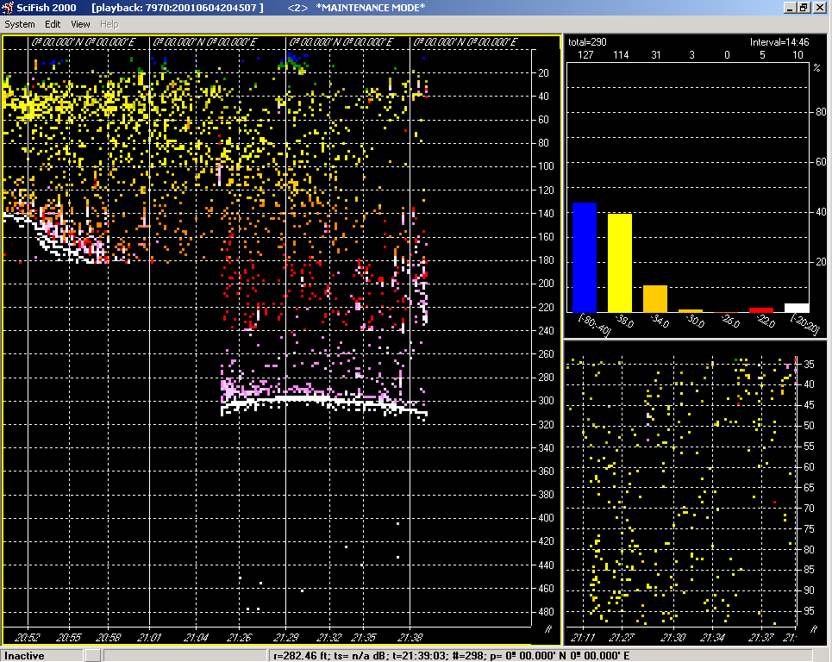
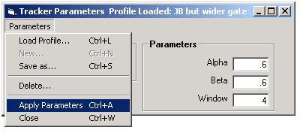
SonarOCX
Databases
User Interface
The Trinity: OCX, UI, and DB

2.3 Initial Design Goals
In the beginning there was an SBIR proposal. This proposal roughly defined the tracker’s minimum capabilities. Based on the SBIR proposal, some initial system specification, and project team discussions, the following initial design goals were developed:

- Reproducibility:
Users should be able to playback data with complete fidelity. From a user’s standpoint, it shouldn’t matter if the raw ping data was from live or recorded measurements.
- Compatibility and Modularity:
New code and functionality shouldn’t conflict with older functionality. Raw data should be transferable between systems with tracking and systems without tracking. The UI and database should remain consistent with the SciFish 2000.
- Performance and Speed:
Any new functionality shouldn’t significantly burden the system data collection and playback. The system should be able to track flow rate of up to 1,000 fish per hour.
- Adaptability:
Since the system is expected to be modified before, during and after field-testing, a flexible implementation was considered important.

2.3.1 Reproducibility
Since the market for the tracker is fisheries managers and scientists, exact reproducibility was defined as a primary goal. The SciFish 2000 already stores complete ping data and sonar configuration during data collection. Reproducibility could be assured by placing the settings used by the tracking algorithm in the database with the ping data. Since a single ping series can be played using multiple different tracker settings, this actually entails adding two tables to the database. (See Below.)
Ping_Series
Sonar Data

Tracking:
Software Version
Ping SeriesID
Tracker SettingsID
Etc.
Tracker Setting:
Settings
Existing “Ping” Database
These new tables are required for reproducibility

2.3.2 Compatibility and Modularity
Cross platform compatibility between the broadband tracker and the original SciFish 2000 sonar system was considered very important. Maintaining database interoperability would allow selected data from the SciFish 2000 pool tests to be used for testing the tracker. Keeping changes to the user interface modular, and logically consistent with the SciFish 2000, would simplify testing, code maintenance, and user training.

For the database, maintaining compatibility meant that none of the pre-existing database tables could be modified. It also meant that the tracker software had to be able to create missing tables “on the fly” when using legacy data. Finally, since the existing databases are in MS Access, the limitations and peculiarities associated with Access also had to be kept in mind.

For forms and their menus, maintaining compatibility meant that, unless tracking was turned on, the software should look, feel, and work like the original SciFish 2000. It also meant that even when tracking was turned on, the differences should be held to a minimum. It was felt that this would simplify cross training for users and would allow the creation of common user documentation for both systems.

For the displays, maintaining compatibility meant that there was a need to compromise between displaying tracks as clearly as possible and maintaining the look and feel of the SciFish 2000’s rather austere displays. Again, it was felt that this would simplify cross training and code maintenance.

2.3.3 Performance
A rapid ping repetition rate is important for good tracking performance. Since no solid data had been collected on how quickly the SciFish 2000 could process a ping, it was arbitrarily decided that anything that was likely to increase the ping processing time by more that 100 milliseconds should be considered for optimization.

2.3.4 Adaptability
Because it is anticipated that different customers may desire to use new or different tracking algorithms, design emphasis was placed on making the infrastructure supporting the tracking algorithm very flexible.

- New algorithms can be added to the settings form by adding additional case statements to a handful of functions in the “Tracker Parameter” form.
- Storage of algorithm parameters is implemented through a “General Configuration” class that can be used for almost any type of configuration.
- Track and echo caching was implemented so that almost any sort of algorithm could be used for associating echoes with tracks.

2.4 The Integration Plan
A fifteen-page integration plan was developed for use as a technical specification. (The integration plan has been appended to this report.) The plan specifies signal processing data flow, tracks should be displayed, and modifications to menus, forms, and databases. The first page of the plan is shown below, with the diagram of the originally proposed dataflow shown expanded.

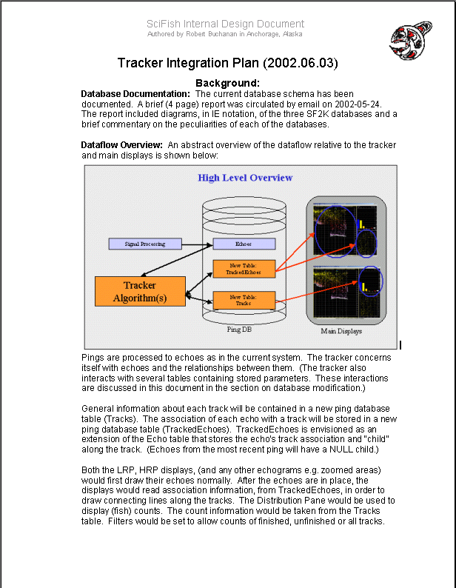
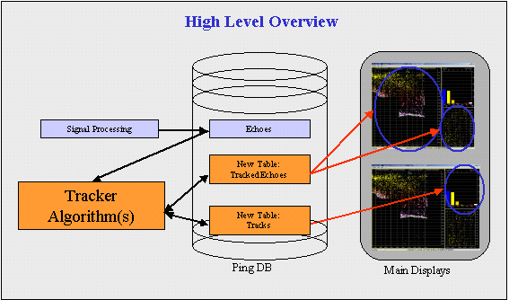

2.4.1 Tracker Dataflow, Original Concept
The diagram above shows the originally conceived dataflow for the tracking functionality. As in the SciFish 2000, echoes are extracted in from the raw ping data and stored in the Ping Database. It was then envisioned that the tracker would read the processed echoes from the database and the track associations in “TrackedEchoes” table with track information being stored in a “Tracks” table. This information would then be read from the database and displayed on the echograms and distribution displays.

2.4.2 Tracker Dataflow, Revised Concept
During formal discussion and review of the original dataflow concept (previous section), concerns were raised regarding performance losses due to excessive database traffic. Simple, timed performance tests were done and they indicated that the problem could be significant. To avoid accessing the database during track creation and display, it was decided to cache echo and track data. The resulting modified dataflow is shown below.
User Interface
Tracker Settings
New Table:
TrackedEchoes
Databases
Echo Cache and Tracker Algorithm(s)
Main Displays
New Table:
Tracks
Data Flow - High Level Overview
Signal Processing
(Echo Extraction)
Sonar Pings
Reports / Counts
_________________________________________________

Chapter 3: Implementation
_________________________________________________

Implementation followed the integration plan developed during the design phase. Feature interdependencies dictated that the feature implementation order roughly followed the task breakdown given in section 2.2.1 of this report:

- The first task was development of menus and forms for the user interface.
- The second task was creation of the tracking “infrastructure” and integration of the tracking algorithm.
- The third task was adaptation of the existing SciFish 2000 displays so that they could display track information.
- The final task was implementation of a way to save tracking results for playback.

3.1 The User Interface
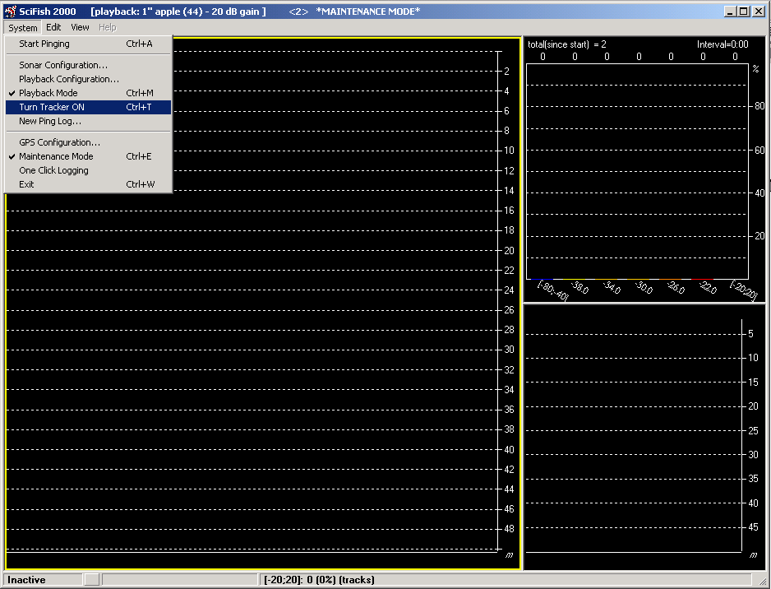The concept of operation called for the tracking functionality to be unobtrusive until activated by the user. The user needed a way to activate tracking and then access forms to enter tracker settings. The forms that would be accessed needed to be created. Finally, the database schema needed to be expanded to store the new, tracker settings.

3.1.1 The Collection Form
It was decided allow the user to activate tracking through the “Collection” form’s system menu. The collection form is the application’s most central form. It is always open and contains the main displays and top-level menus. A screenshot of the Collection form is shown on the right.

The “System | Turn Tracker ON” item was added to the system menu. Toggling this item allows the user to toggle the activation of the tracking functionality. With tracking enabled, a new “Tracker” menu becomes visible. It also allows the user to access new functionality in the Playback Parameters form.
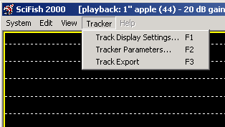
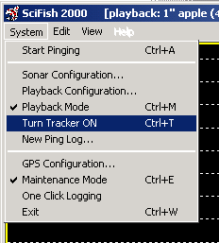

Each item in the Tracker menu leads to a new form. Forms were created to allow the user to adjust track displays and tracker parameters: “Track Display Settings”, and “Tracker Parameters”. A third form, “Track Export”, was created for use as a debugging tool.

3.1.2 Track Display Settings Form
Using the “Track Display Settings” form the system operator sets tracker display options. The user can decide whether track lines should be drawn on the LRP and HRP echograms. The user can also decide whether the DP’s histogram should show echo counts or track counts. The diagram below shows the form on the right with circles and arrows indicating which parts of the settings form effect which displays.

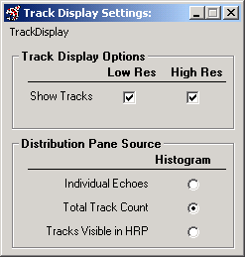
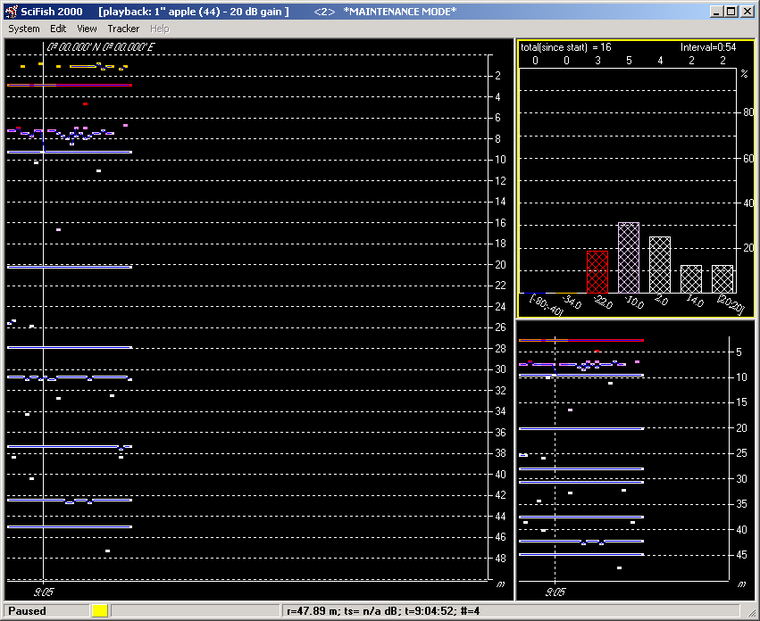

3.1.3 Tracker Parameter Form
Using the Tracker Parameter form, the system’s operator can set the algorithm by choosing from the combo box on the left side of the form. When a new algorithm is chosen, the number and labeling of the parameters automatically readjusts. The screenshot below on the right shows the form, as it would appear after the Alpha Beta tracking algorithm had been chosen. The screenshot on the left shows the form after the JPDA algorithm has been chosen.

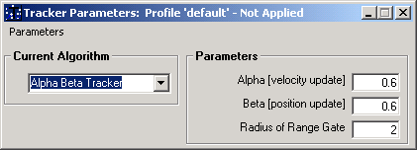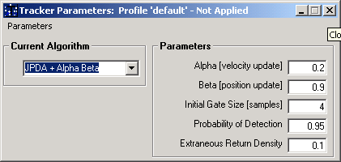

The form’s menu is shown below. This menu allows the operator to load, save, rename, delete and apply a group of settings. The name of the profile displayed by the form, and whether it has been applied, is shown in the form’s caption. Because the currently loaded “default” profile is read only, the ReName menu item has been disabled. If the settings had already been applied, the Apply Parameters item would also be disabled.

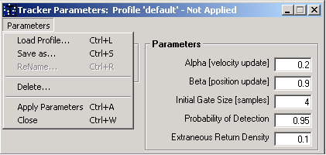

The settings profile is held in an instance of the “General Configuration” class. I created this class so that I could reuse code for creating and managing settings profiles. The class handles all common functionality. The only functionality that the form still has to implement is input validation and control properties.

3.1.4 Track Export
The ‘Track Export’ form, despite its name, is actually a debugging tool. It allows the tester or developer to conveniently view all tracker related parameters, start tests, and tracking results. The Track Export form isn’t intended to be part of the final product. This form will be transformed into a report generation utility after field-testing is completed. The screenshot shown immediately below shows the form:

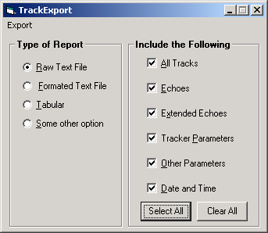

Using the Export menu, the information gathered by the form can be saved to a text file or displayed in a non-modal form consisting of a large textbox. The two screenshots below illustrate the use of this debugging tool to independently verify the applied tracker parameter settings.
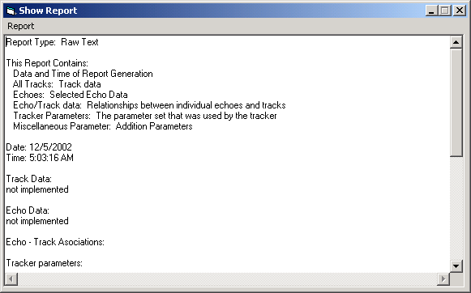
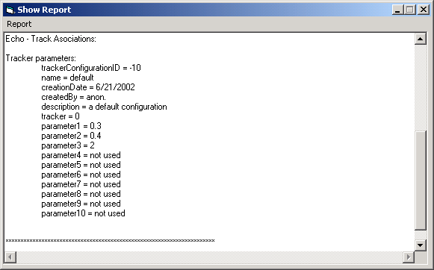

3.1.5 Database Modifications
Additions were made to the parameter database. The new entries in the property list allow the application to default at startup to the last used track display and tracker algorithm settings:

- A table was added to store profiles from the “Track Display Settings” form.
- New entries (additional properties) were added to an existing “PropertyList” table.

3.2 Tracking Implementation
Design goals called for the tracking algorithm to be fast, adaptable, and modular. For the SciFish 2000, nearly all of the heavy data processing is done in the “SonarControl.OCX”. This OCX is a control written in C⁺⁺. Since many tracking algorithms are known to be computationally intensive, it was decided from the start that the tracking algorithms would be implemented as part of the OCX. When the decision was made to cache echo and track data, this also was designed into the OCX.

3.2.1 Implementation Challenges
To successfully implement tracking, four challenges had to be overcome: An interface between the OCX and UI had to be defined and built. Infrastructure for caching echo and track data had to be developed. Existing prototypes of tracking algorithm had to be modified before they could be integrated into the system. Finally, all of this needed to be thoroughly tested, even though there initially was no way to efficiently display track data.

3.2.1.1 Interfacing With The OCX
Creation of an interface between the OCX and the UI’s tracker functionality required the creation of infrastructures on both sides for the OCX /UI boundary. To create an interface that the UI could access, the sonar OCX’s interface was expanded. .

This was accomplished through the creation of public access methods in the sonar class and through creation of a “Tracker” class. An instance of this Tracker class was added as a public member to the Sonar class. The Tracker class serves three needs. It acts as a wrapper for the Sonar class methods that access the OCX’s tracking functionality. It initializes the tracker. Finally, it does “cleanup” when tracking stops.

The diagram on the following page shows the flow of information through the OCX, across the OCX/UI interface. In this diagram the databases and settings forms are the providers of parameters, requests, and raw data. (The connection between the OCX and the sonar hardware during live data acquisition is omitted.) Processed data (echoes and tracks) are stored in the databases and shown on the displays.
Boxes shown in orange stand for modules that were modified or created “de novo” as part of the tracker’s implementation. The UI (written in VB) is shown in the box with the light purple striped background near the top of the diagram. The databases are represented the by purple box in the upper right corner. The green box filling the bottom of the diagram shows the OCX (written in C⁺⁺).

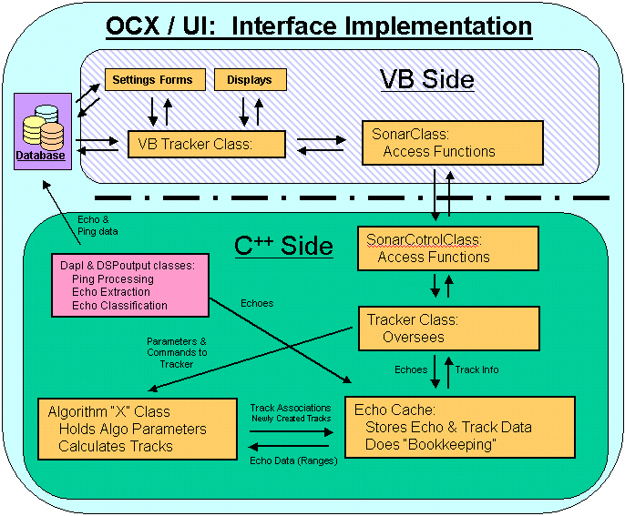

3.2.1.2 Echo-Caching Implementation
To investigate the pros and cons of caching, I created a limited prototype that stored echo and track data in statically allocated arrays. Initial ad hoc performance testing gave positive results and generated interest in ultimately using the cache for more than just tracking.

While I was working on other aspects of the project, a senior developer, Jennifer Gunderson, revised the initial prototype so that it used dynamic memory allocation and a circular buffer. I have recently tested and debugged the revised cache. The concept seems to be working very well.

3.2.1.3 Algorithm Integration
Background research, algorithm analysis, and basic algorithm development were done by Dr. Jae-Byung Jung. My task was to create a wrapper so that current and future algorithms developed by Dr. Jung could be integrated into the software.

Dr. Jung used Matlab and C to explore and define two algorithms. The “Alphabeta” algorithm predicted the position of the object being tracked based on its current location and speed. The JPDA algorithm applied a more global approach basing its predictions on track history statistics. Both algorithms used a nearest neighbor approach to assess goodness of fit.
A Lesson Learned:
I received both algorithms defined in well-commented C. A better medium for defining the algorithms would have been English-like pseudocode. Why? Unfortunately C, (particularly when written by non-programmers), is difficult to read.
When it became necessary to adjust the implementation of the algorithms prior to integration, the algorithms had to be reverse engineered into pseudocode and then re-implemented.

Implementation and integration of the Alphabeta algorithm is complete. Ad hoc performance tests indicate that the current implementation of this algorithm is sufficiently fast. If performance needs to be improved, the slowest step in the algorithm (echo-track association) can be optimized so that it scales at O(n(log(n)) by presorting the list of unfinished tracks.

Implementation of the JPDA algorithm is not yet complete because there are concerns about the amount of memory that the algorithm requires. As currently implemented, Dr. Jung’s implementation can require O(n(n!)) memory space to solve conflicting assignments between ‘n’ tracks in a cluster of fish.

Would memory requirements cause problems for the current implementation of the JPDA algorithm? It can reasonably be assumed that a cross-section of a school of fish could contain about a dozen fish. If these fish are closing bunched then could cause conflicts. The relative memory requirements for two to twelve conflicts are shown below.
Table 1: Memory requirements for O(f(x)) for f = n, n(log(n)), n!, and n(n!).
n | n(log n) | n! | n(n!)
2 | 0.30103 | 2 | 4
3 | 0.477121 | 6 | 18
4 | 0.60206 | 24 | 96
5 | 0.69897 | 120 | 600
6 | 0.778151 | 720 | 4320
7 | 0.845098 | 5040 | 35280
8 | 0.90309 | 40320 | 322560
9 | 0.954243 | 362880 | 3265920
10 | 1 | 3628800 | 36288000
11 | 1.041393 | 39916800 | 4.39E+08
12 | 1.079181 | 4.79E+08 | 5.75E+09

(Implementation of the JPDA algorithm is currently stalled awaiting modification of the algorithm.)

3.2.1.4 OCX Unit Testing
Unit testing and debugging each part of the tracker and its infrastructure (caches, access methods, etc.) presented a challenge. The amount of data that had to be verified was staggering. Most of the testing had to be done prior to the development of the software displays. (This meant that there was a circular dependency with regard to implementation and testing.)

I dealt with these problems by inserting scaffolding into critical sections of the tracking algorithm. This scaffolding captured a snapshot of the trackers state, and sent this information to tab delimited text files. The advantage of using these text files was that I could directly open them using MS Excel.

Since the SciFish 2000 temporarily stores echoes in its databases and nothing related to the tracker interacted with the original signal-processing pathway, I could use echo data from the database as a “gold standard” for comparisons. This echo data was extracted using SQL queries and then exported to Excel.

With test data from the tracker and control data from the databases both in Excel, verification was straight forward. Direct comparison of values was sometimes done. When working with large amounts of data (e.g. several thousand echoes), comparisons were mostly visual using scatter plots. Until the tracker’s displays were complete Excel’s chart making utility was used as a substitute.
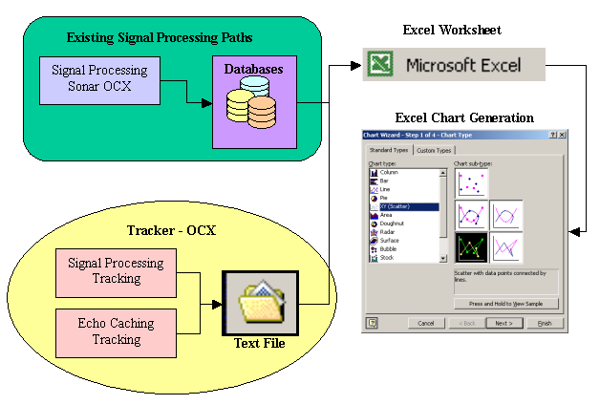

3.3 The Displays
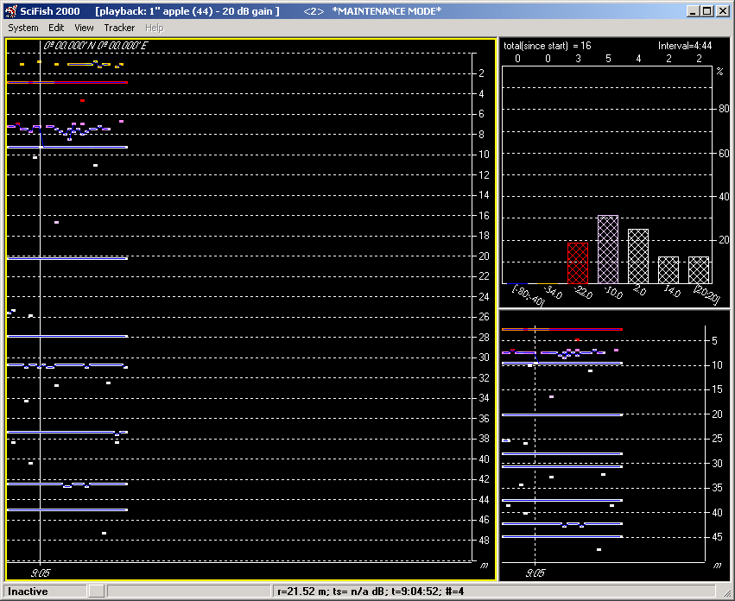
It was decided to keep the tracker’s displays as close to the Scifish 2000’s displays as possible. Both tracker and SciFish 2000 have a main display consisting of three parts. Echoes (and tracks) are displayed in the echogram displays: LRP (Low Res Pane) and HRP (High Res Pane). Counts of echoes (and tracks) are displayed by a histogram showing in the DP (Distribution Pane). The LRP and HRP are located on the left side and lower right corner respectively. The DP is located in the upper right corner.
LRP:
Low Res Pane
HRP:
High Res
Pane
DP:
Distribution Pane

3.3.1 The Echogram Displays: LRP and HRP
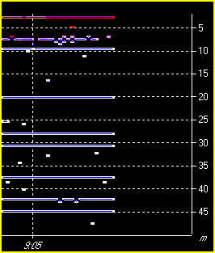
For the base SciFish 2000, both LRP and HRP are implemented as instances of the “EchoGram” class. After every ping is processed, the new echoes are plotted as a time vs. range plot. Point coloration depends on either the echo’s classification (e.g. fish species) or target strength. The user can toggle the choice between target strength and classification. Point sizes (horizontal and vertical) and coloring schemes are also user definable.
HRP:
High Res
Pane

For the tracker, track association is displayed by simply connecting echoes along a path with a thin track line. To ensure that the tracks don’t completely overwrite the echoes, a minimum point size for the echo is defined. If the display’s point size is set too small, it is automatically increased to 3 by 3.

In the current version of the software, all track lines are colored “vbBlue”. Additionally, all track lines are one pixel wide. Experiments with a range of point sizes, track coloration schemes, and track line width showed that these choices created the most legible displays possible without sacrificing visual consistency with the SciFish 2000.

3.3.1.1 Experiments With Multicolored Tracks
Usability experiments with a number of coloration schemas where tracks were colored by average target strength, track classification, or as a hash of the track’s ID were all disappointing. In particular, coloring the tracks by average target strength or classification tended to make the tracks difficult to read. Confusion tended to occur whenever track and echo colors were similar.

3.3.2 Distribution Pane: DP
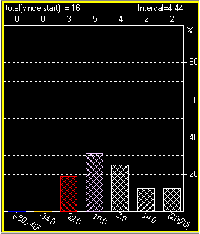
For the SciFish 2000 the DP (histogram display) is implemented as an instance of the “DistributionPlot” class. The DP shows the distribution of echoes by target strength or classification of all for all echoes displayed in the HRP (the echogram below the DP). When the DP displays counts by echo classification, the number of bars is equal to the number of classes being in the classifier. When the DP displays counts by target strength, the user sets the number of target strength bins.
DP: Distribution Pane

With tracking activated, the user can also choose to have the DP display a count of all tracks or just those tracks that start inside the boundaries of the HRP. The DP can be set to display track counts by classification or average target strength. Because the calculation of track classifications and average track targets strengths is resource intensive, these tasks are done in C⁺⁺ as part of the OCX’s Tracker class.

To indicate to the user when the DP is displaying track counts, the bars of the histogram’s display are solid when displaying echoes and crosshatched when displaying track counts. The total sum in the top right of the display indicates whether the track counts are from the start of the series of pings, or if the display only shows track counts based on tracks visible in the HRP. (In the example above, the average target strength distribution of all tracks since the beginning of the ping series is being displayed.)

3.4 Storing And Replaying Tracks
Complete storage of echoes and tracks would require significant amounts of storage space. Instead of saving large volumes of derived data, the software saves raw data and precise tracker and sonar settings so that the tracks can be exactly reproduced. The record associating a series of raw data (i.e. ping series) with a settings profile is stored as a “Track Series” record. Whenever the operator finishes playing tracks, independent of whether live or recorded raw data is being used, there is an opportunity for him to create a Track Series record.

3.4.1 Storing Tracks
When an operator running with tracking engaged, stops playing ping data, he is asked:

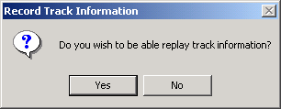

If the operator clicks yes, he is asked for the name of the new “Track Series”. The Track Series is a record containing all of the parameters and profile required in order to replay the tracking result that the user has just viewed. If the name is the same as an existing record, the name that the operator entered has a version number appended to it.

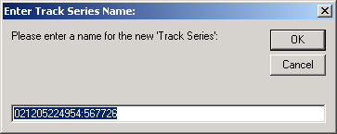

After entering a new name for the Track Series, the operator’s name is requested.

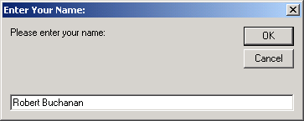

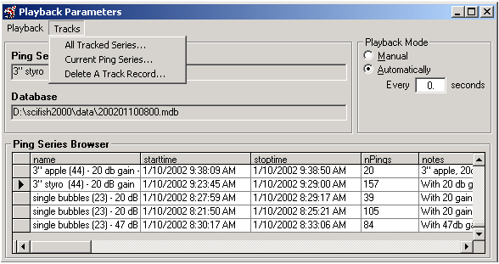If the operator has clicked affirmatively for all three boxes, the tracking event can be replayed later exactly as recorded.

3.4.2 Replaying Tracks
Unless tracking is enabled, the Playback Parameters form only allows the operator to playback a ping series. Once tracking is enabled, the tracks menu becomes visible. The user can use the Track menu to select a track series from all tracks series in the database or from track series using the currently loaded ping series. The last item on the Tracks menu allow the user to delete a track series.
_____________________________________

Chapter 4: Revision
_____________________________________

Review and revision were a result of both ad hoc and formal processes. Both types of processes were useful because they were effective at different project levels.

4.1 Informal Revision Process
Most small revisions to the design and implementation of the software were done in an ad hoc manner. Most small revisions tended to be the result of bugs and / or muddled design implementation. Since the number of these errors was large but their complexity was generally low, they were fixed as they were brought to my attention.

4.2 Formal Revision Process
Most large revisions were a result of the formal review process. Generally these fundamental design problems were unanticipated. Some required partial redesign. Without a formal process of review, the need for these revisions would not have been uncovered until later in the development cycle.

The tracking software has been subjected to several formal cycles on review. The first cycle followed the development of an integration plan. The second cycle followed the implementation of a prototype of the echo cache.

A third cycle of revision will take place after the end of the CS470 project. It consists of pool tests planned for the weekend of 12/14/02 and 12/15/02, followed by a formal code review at the beginning of 2003. If the code review goes well, the current code will be base lined.
________________________________________________

Chapter 5: Error Handling
________________________________________________

Inconsistent error handling is one of the weak points of the SciFish2000’s software. Implementation of a systematic handling system is planned, but not scheduled. During the course of implementing tracking, a policy was accepted that all tracker modules would include error handling. Since the code that I had written for the tracker was largely self-contained, it was viewed as a good test case for implementing consistent error handling.

5.1 VB 6.0 Error Handling Syntax
VB 6.0’s error handling uses “On Error GoTo LABEL” syntax instead of the more conventional “try-catch” syntax used in C++, JAVA, and VB.NET. Because the “On Error GoTo LABEL” is basically a “GoTo” statement, writing well-structured VB error handlers can be difficult.

A literature search of the web, the MSDN library, and advanced tests on VB programming yield a large body of common goals when implementing VB error handling, but little consistency in actually implementing complex application level error handling.

5.2 Error Handling Philosophy
The primary goal for my error handler implementation is to ensure that the software runs correctly, collects data, and does not crash. The following rules of thumb were applied:
- To ensure that the error handler can respond sensibly, the error handler’s first action is to ensure that VB’s “Err” object is saved.
- Errors that can be anticipated are handled with a coded response.
- Unanticipated errors are handled by attempting to roll the software back to a correct state. (All database modifications are done through transactions.)
- Depending on the location and type of error, the operator may be informed.
- All unanticipated errors trip an assertion when running in the IDE.
(Unanticipated errors should be made obvious to the developer and tester.)

5.3 Error Handling Implementation
Initial examination of the application for code reuse candidates was of limited success. A method had been written to store errors, but unfortunately it didn’t work. Two different types of error boxes had already been implemented, but neither was useful. The first error box was too complicated and difficult to use. The “second error” box was too limited.

I attacked these shortcomings by creating the MyErrorObject class. Class methods included a method to store errors that actually worked and an error box method that was compatible with the simpler of the legacy error box methods, but was more useful.

To prevent crashes every routine that I had added or significantly modified during the tracker development, was equipped with an error handler. Where possible the handler was designed to silently correct any errors. If the error occurred during the collection of raw data, the handler disabled tracking, to ensure that tracker error could not affect the data collection process.

_________________________________________

Chapter 6: Conclusion
_________________________________________

I consider my CS470 project to have been successful based on my achievements and the skills gained.

6.1 Achievements
A short list of my achievements includes:
- I succeeded in designing, implementing and integrating fish tracking software.
- The system is ready to be tested under live conditions:
  - Pool tests are scheduled for December 14-15, 2002.
  - On site field-testing is scheduled for summer 2003 on the Copper River.
- I made significant progress toward implementing systematic error handling.
Because the tracker shares a number of modules with other products, complete implementation, once completed will be reusable for a number of similar products.

6.2 Skills Gained
While working on this project, I gained skills and experience:
- I gained extensive knowledge of the Visual Basic language.
- I was introduced to multi-language software development. (C⁺⁺ and VB 6.0)
- I was introduced to, and spent close to a hundred hours working with, error-handling concepts, and practice.
- I experienced the dynamics of product design, including the element of cooperative teamwork, competition, and other intangible interpersonal skills.
______________________________________________________

Appendix A: Integration Plan
______________________________________________________

From 6/21/2002 to 6/4/2002 a plan for integrating tracking into the existing SciFish 2000 software was developed. This Integration Plan has been included with this report, and can be considered part of the report.

A.1 Integration Plan
The Integration Plan is located in the “Report\Appendices\Appendix A” folder. This planning document includes the general approach to the integration problem, task breakdown, examples of pseudocode, and general implementation details. This document was fairly closely followed during the implementation phase.

To view the Integration Plan click here.

A.2 Review Meeting Minutes
The Integration Plan was formally reviewed in a meeting on 6/7/2002. Minutes from the meeting were created and circulated.

To read the minutes from the design review meeting click here.

___________________________________________________

Appendix B: Code Samples
___________________________________________________

I am providing samples of source code that I wrote while working on my topic. All of the source code provided is, and remains. property of Scientific Fishery Systems, Inc. These samples are written in C⁺⁺ and VB 6.0. This source code is not a complete listing of every line written, but is largely a sampling of code taken from the most recent latest software version.

Code samples are located in folder (“\Report\Appendices\Appendix B\User Interface VB6-Code\New”), and can also be reached from this document via hyperlink. For modules that are not new, but have been expanded, a folder (“\Old”) containing the original pre-tracker versions has also been provided for comparison.

B.1 Sonar OCX
Although I am responsible for the early tracker algorithm coding, most of this code has been extensively rewritten by my colleague and supervisor Jennifer Gunderson, and then debugged and revised by myself. In the current version of the tracker algorithm, the only contiguous section of code that I can claim nearly sole responsibility for is the implementation of the Alphabeta class: (Path: \Appendix B\Sonar OCX C-Code\AlphaBeta Algorithm)
- Alphabeta.h
- Alphabeta.cpp
The following source code listings are an example of the earlier version of the tracking algorithm. This code was used as a prototype, but has since been largely revised:
(Path: \Appendix B\Sonar OCX C-Code\Early Tracker Prototype)
- tracker.h
- tracker.cpp
- TRACK_FOR_TRACKER.h
- TRACK_FOR_TRACKER.cpp

B.2 The User Interface: Forms and Displays
Most of my code was written in MS Visual Basic 6.0. Four new forms were created and two existing form were significantly expanded upon. Three new classes were created, and three existing classes were expanded upon. Two modules were somewhat expanded. (Click on hyperlinks to view samples.)

B.2.1 Forms
Of the four new forms, showReport.frm and TrackExport.frm, are only being used as debugging tools during development, and will not be part of the commercial product.
- showReport.frm
- trackDisplaySettings.frm
- trackParameters.frm
- TrackExport.frm

The following preexisting forms were significantly expanded upon:
- frmCollection.frm (Original Version) vs. (New Version)
- playbackParameters.frm (Original Version) vs. (New Version)

B.2.2 Classes
The MyErrorObject class is not fully complete. Possible additional features are stubbed out and await time and resource for completion. The other two classes are finished.
- generalConfigurationClass.cls
- myErrorObjectClass.cls
- tracker.cls
The following preexisting classes were significantly expanded upon. The Echogram and DistributionPlot classes are used for displays. The sonar class had to be expanded to give the UI access to the OCX’s new tracking functionality:
- echogram.cls (Original Version) vs. (New Version)
- distributionPlot .cls (Original Version) vs. (New Version)
- sonar.cls (Original Version) vs. (New Version)

B.2.3 Modules
The modGeneral module serves as the entry point for the application and had to be slightly modified. The modUtil module contains utility functions. Several new utility functions were added and others modified.
- General.bas (Original Version) vs. (New Version)
- Util.bas (Original Version) vs. (New Version)

B.2.4 Amount of Code Written
During the course of the project most of the modules were extensively and repeatedly revised. In the curse of coding and revision approximately 4,000-5,000 lines of VB code and 1,500 lines of C++ were written. Although much of this code was tossed out during revision, the total amount of code added to the project exceeded 100 pages. Approximately, 75% of this material was include as code samples for this report. This leads to two conclusions:
- Since much of the code that was written ended up be revised or edited away, carefully writing durable code is fast than a quick and dirty approach.
- Electronic submission of project reports lifts a weighty burden from students’ and instructors’ shoulders.
_________________________________

Glossary of Terms
_________________________________

Acoustic Shadowing Partial or complete blocking of one sonar target by another. The effect can cause systematic undercounts of passing fish.
Bendix Method A process that combines an echo counting algorithm with input from the user. The method counts all echoes in user-selected range bins, and then scales the overall count by the number of echoes per track from respective bins, as observed on the oscilloscope. For this reason this method of counting is also sometimes referred to as “Scaled Echo Counts.”
Broadband Sonar Sonar utilizing a broad swathe of the acoustic spectrum.
Classifier Classifiers are used in connection with Neural Nets by the SciFish 2000 to identify targets. Creation of classifiers requires example of the object to be identified.
Database,
Development Database used by the SciFish 2000 and Broadband Tracker for the development of classifiers.
Parameter Database used for the storage of persistent settings, configurations, and parameters.
Ping Database used for the storage of sonar data. Also contains related sonar configuration profiles.
Displays,
DP See section 3.3.2
HRP See section 3.3.1
LRP See section 3.3.1
Echo Reflected signal from a sonar target.
Echogram A range vs. time display showing echoes. See section 3.3.1 for examples.
Ensonification Illumination of a target by sound waves from an active sonar.
Narrowband Sonar Sonar utilizing a narrow range of the acoustic spectrum.
NSF U.S. National Science Foundation
Ping Acoustic signal sent out by an active sonar system.
Ping Series A regularly repeating series of pings making up a continuous data set.
Riverine Pertaining to rivers
SBIR Small Business Research Innovation grants are available through a number of U.S. federal agencies and are intended to promote new technology, research, growth.
SciFish 2000 broadband sonar built by Scientific Fishery Systems, Inc. My 470 topic uses this system as the base system upon which the tracker is built.
SonarOCX OCX component of the SciFish 2000’s software. Responsible for most of the data and signal processing. The tracking algorithms are integrated into the SonarOCX.
Tagging Marking or attaching a tag to a fish.
Track The path, consisting of connected observations, as a target moves through a sensor’s field of view.
Track Series The combination of a ping series along with all tracker setting reproducibility of derived tracking results.
Target Strength The strength of a returning sonar echo.

___________________________________________

Background Documents
___________________________________________

I have attached a number of background documents. The documents can be reached via hyperlink. All documents provided are the property of Scientific Fishery Systems and are provided solely for use as background information.

7.1 Authorship
The SBIR report was authored by Pat Simpson and has been included to provide background information. The SciFish 2000 UI Class Hierarchy was created by Jennifer Gunderson using Rational Rose’s reversing engineering capabilities. Although I created the CS470 presentation and the three short demonstration videos, they contain intellectual property belonging to Scientific Fishery Systems.

7.2 List of Documents
The attached documents are:
- Phase I SBIR Report (MS Word 2000)
- SciFish 2000 UI Class Hierarchy (PDF Reader)
- CS470 Presentation (Power Point 2000)

7.3 Video Demos
Three short video demos were created using HyperCam capture software. The files are standard AVI and should be viewable using the Windows Media Player.
- Playback
- Playback and UI
- Playback with only the HRP showing tracks
________________________________________

Bibliographic Sources
________________________________________

- Balena, F. (1999). Programming Microsoft Visual Basic 6.0, Redmond. WA.
Microsoft Press
- Combs, T. & Campbell, J. (1998). 1001 Visual Basic Programmer’s Tips 2nd ed., Albany, NY. Onward Press
- Deitel, H.M., Deitel P.J., Nieto, T.R. (1999). Visual Basic 6: How To Program, Upper Saddle River, NJ. Prentice-Hall Publishing.
- Ezzel, B. (1998). Developing Windows Error Messages, Sebastopol, CA.
O’Reilly Press.
- Eddon, G., Eddon, H. (1998). Programming Components with Microsoft Visual Basic 6.0 2nd ed., Redmond. WA. Microsoft Press
- Gill, T. (2000). Visual Basic 6: Error Coding & Layering, Upper Saddle River, NJ. Prentice-Hall Publishing.
- Patton, R. (2000). Software Testing, Indianapolis, IN, Sams Publishing.
- Holzner, S.. (1998). Visual Basic 6 Black Book, Scottsdale, AR., Coriolis Press.

Design and Analysis of Algorithms
Database Systems
The C Programming Language
SBIR (Small Business Innovation Research) awards are granted by various U.S. federal agencies for the development of innovative new technologies.
NSF (U.S.) National Science Foundation.
Simpson, P. (2000). Broadband Fish Tracker, Report No. SFS-99-09, Phase I SBIR Final Report, Award Number 9961318, U.S. National Science Foundation
According to a SciFish presentation (Simpson, P.) some of the tags used to investigate king salmon along the Copper River cost $150.00 per tag, July 2002.
Target strength is the strength of the returning echo.
The target strength threshold acts as a filter. Echoes falling outside the threshold are ignored.
Denny, G. (2002), private communication, July
Simpson, P. (2000). Broadband Fish Tracker, Report No. SFS-99-09, Phase I SBIR Final Report, Award Number 9961318, U.S. National Science Foundation, pp
The figure was derived from unpublished sonar data gathered on the Rogue River (Ore.) on August 26, 2002. Data and diagram are courtesy of G. Denny and Dr. Jae-Byung Jung.
Rivers with large salmon runs.
In the sample data from the Rogue River, several meters separate individual fish. As is visible from the picture of the spawning salmon, the distances between salmon are often much less than a meter.
Simpson, P. (2000). Broadband Fish Tracker, Report No. SFS-99-09, Phase I SBIR Final Report, Award Number 9961318, U.S. National Science Foundation, pp 20.
Simpson, P. (2000). Broadband Fish Tracker, Report No. SFS-99-09, Phase I SBIR Final Report, Award Number 9961318, U.S. National Science Foundation, pp 8.
There is a tradeoff inherent in the Bendix method. Multiplying the observed count by an experimentally derived (ergo uncertain) scaling factor can only improve accuracy at the cost of precision. (See any work on the propagation of experimental error for an explanation.).
(1 track = 1 fish)
Apparently some research groups invest as much as one man-year per season in order to tally track data. Denny, G. (2002), private communication, July.
My colleague Mr. Kulinchenko is has been investigated echo processing and the effects of averaging on classification as part of his current work on improving the SciFish 2000’s signal processing path.
Scientific Fishery Systems’ founder, Mr. Simpson, P., holds the patent on fish identification using broadband sonar.
Support for legal recording is desirable.
Microsoft Access 2000 is not designed with large databases in mind. Individual Access database sizes are effectively limited at roughly 1GB.
The original integration plan has been attached as “Appendix A: Integration Report”.
The echogram displays found on the left side (LRP) and lower right corner (HRP) of the application’s main display. They are used for displaying echoes.
The distribution pane found in the upper right corner of the main display, is used to show relative target distributions.
Changes to the Playback Parameters form are discussed in section 3.4.2 of this report.
Depending on the algorithm chosen, zero to ten parameters textboxes become accessible.
The form’s caption runs the length of the top of the form.
For example, applying, loading and saving a profile are all commonly used.
Field tests are scheduled for summer 2003 on the Copper River.
The UI’s Access to the OCX’s interface had to be accomplished through a preexisting “Sonar” class, because the OCX is instantiated by the Sonar class as a private class member
The Visual Basic constant for the color blue is vbBlue.
To playback a ping series the operator selects a database and a raw ping series from the chosen database using the playback menu.
“Track | All Tracked Series…” allow the user to select from all stored track series records in the particular ping database
“Track | Current Ping Series…” allows the user to select from all stored track series records in the particular ping database that used the currently selected ping series.
Go to this reports bibliography for a list of some of these sources.
E.G. SciFish 2000, BB-Fish Tracker, and ATP projects
Scaffolding and early versions of prototype code have generally been omitted to spare the time and patience of this report’s reviewers.
Both versions are provided so that differences between the new and old versions can be compared. Alternatively, instead of comparing files manually, WinDiff can be used to compared entire directories.
Because of dependencies, opening the individual VB forms, classes and modules will prompt error messages. You should be able to ignore these messages.
The pun is intended. Consider the weight of several hundred pages of source code.

