Personnel Tracking Application

Don Tinsley
CS 395
14 August 2003

Table of Contents

1. Company Overview…………………
…………………………………………………….…….3
2. Project Overview………………………………………………………………………….…….3
2.1 Previous Methods 3
2.2 Database 3
3. Project Requirements……………………………………………………………………………5
3.1 Functional Specifications 5
3.2 System Specifications 5
4. Analysis and Design……………………………………………………………………………..5
4.1 Use Cases 5
4.2 System Architecture 6
4.3 User Interface………………………………………………………………………………..6
5. Software Development…………………………………………………………………………..8
5.1 Forms and Controls………………………………………………………………………….8
5.2 Coding……………………………………………………………………………………...….9
5.3 Reports…………………………………………………………………………………………9
6. Summary and Conclusions……………………………………………………………………..9
Appendix A: User Manual………………………………………………………………………..11
Appendix B: Code Listing………………………………………………………………………...22
Appendix C: Evaluation…………………………………………………………………………..22

1. Company Overview

For my CS 395 internship, I found employment with the 3rd Wing Plans and Programs office on Elmendorf Air Force Base. This office is a part of the Wing (Base) Headquarters and is responsible for creating user specific programs to fulfill unique requirements where commercially available software is either not financially viable, or does not exist. Most of the applications they develop are for data storage and retrieval. Office personnel work mostly with Visual Basic, VB Script, JAVA Script, ASP, and HTML.

2. Project Overview

The project assigned to me by my supervisor, First Lieutenant John Thompkins, was to develop a Visual Basic front-end to an Access Database that would track personnel attendance at certain events using either a USB barcode-scanning device to scan individuals’ identification cards, or keyboard input to type in a Social Security number. Users of the application would be able to create, edit, and delete events, as well as add personnel to the database and create useful reports. In addition, the application would be able to track an “In/Out” status of personnel at an Entry Control Point (ECP).

2.1 Previous Methods

The need for an application of this type stems from the fact that most units use paper sign-in sheets to track attendance. This method is archaic, time consuming, and provides no means for analysis. Alternatively, some units have used applications not designed for this purpose (i.e. MS Word, Excel, etc.).

2.2 Database

I had not planned on changing the original database that was created for the prototype application, but after determining that it was used solely for this application and seeing how it was set up, I decided it needed some work. I eliminated unnecessary and redundant data. I also made some changes while designing the VB application when I felt it necessary for simplification. Figure 1 shows the relational layout of final database.

A single deployment of this application includes a copy of this database. The Plans and Programs office will update it periodically and publish a link for users to obtain an update. The database included with each new installation contains only a populated Person table and EventCode table. The Person table is filled through MS DTS and contains close to 10,000 records. The EventCode table contains a core list of typical Event titles.

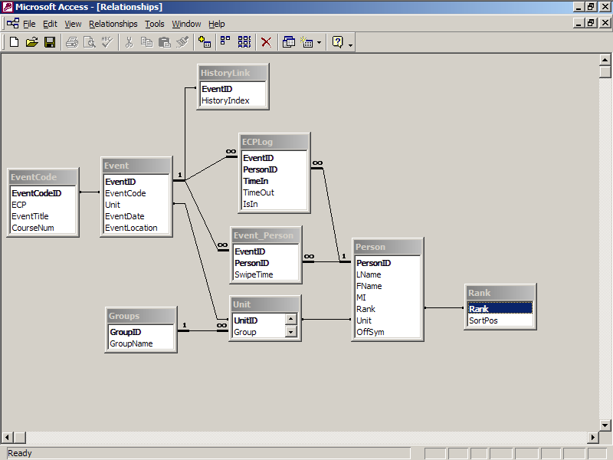
Fig. 1

Each Event record has an EventCode associated with it, as well as a Host Unit, date and location. The EventCode has a general description or type, a course number in the case of formal training courses, and can be an ECP Event. Depending on whether the application is in ECP mode or Event mode, Persons are logged into either the ECPLog table or Event_Person table. In Event_Person table, the PersonID is unique in relation to an EventID because a person can only be logged into a given Event once. In the case of the ECPLog table, a person can be logged in and out multiple times.

The HistoryLink table is used to create a History report from the Report Designer in the VB application. This table is used to temporarily link two or more events that are otherwise unrelated. This is needed for example when certain events span more than one day and are tracked as separate Events. Also, there may be times when someone desires to see a history of attendance at certain Events. The Groups, Unit, and Rank tables were added to aid in report creation due to their hierarchical nature.

3. Project Requirements

3.1 Functional Specifications

- The system must allow users to create, edit, and delete Events. In addition to the core set of Event types supplied in the database, users will be able to create their own Event types.

- Users must be able to log personnel in and out by scanning the barcodes on ID cards or by manually entering Social Security numbers.

- Users must be able to add personnel not in the database.

- The system must accommodate two modes: Event Mode which allows users to log personnel into an Event, and ECP Mode which allows users to log personnel in and out of an Entry Control Point (ECP).

- The system must allow users to create Event Reports that display attendees ordered by name, group, and/or unit.

- The system must allow users to create ECP Reports showing current location occupants, as well as activity within a specified time range.

3.2 System Specifications

The system must be constructed using Visual Basic 6.0 running Windows 2000 or Windows XP. The resulting executable must also run using Windows 2000 or Windows XP but the end-user system might not have Visual Basic installed. The system must be designed to display properly at a resolution of 800 X 600 pixels. This will allow proper display at higher resolutions.

4. Analysis and Design

This would be my first experience with Visual Basic, and fortunately, I was given a basic prototype to start from. This program could setup a basic event and log ID’s in. I used this code to get a feel for the syntax and semantics of VB. I then started the design process.

4.1 Use Cases

I began designing the application by drawing the use case diagram in figure 2. I wanted to make sure I captured all the operations the application would need to have.

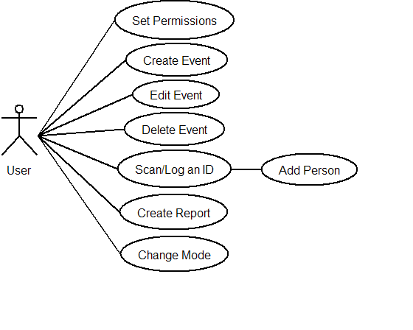
FIG 2.

The “Set Permissions” use case was dropped after discussion with Lieutenant Thompkins because of the fact that only a limited number of personnel would use the application and they would not be able to access critical data in the database. (It is important to note here that database security was not my responsibility. The plan was to password protect the database and hardcode the password into the VB code.)

4.2 System Architecture

I decomposed the system as shown in Fig 3.

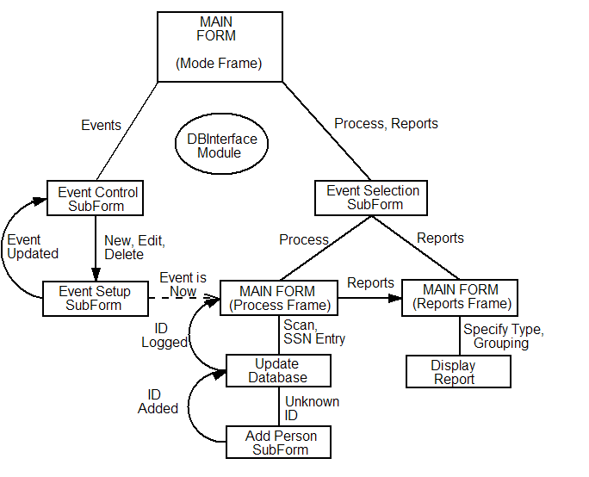
Fig 3.

The application starts in Event Mode with the Mode Frame of the Main Form displayed. The user can change modes at any point by selecting the Mode Label at the top of the Main Form. If the Events Label is selected, a sub form is displayed where the user can create new Events, or Edit and Delete existing Events, which is done through another sub form that contains controls to get the needed data. When an Event is added, updated, or deleted, a call to database manipulation routines in the DBInterface module is made. If the Event is scheduled for the current day, an option to go directly to processing it is provided.

If the user clicks the Process or Reports Labels, an Event Selection sub form is shown. After selecting the appropriate Event, the Main Form will show either the Process Frame or Reports Frame. If the Reports Label is clicked while processing an Event, the Main Form shows the Reports Frame with the current Event loaded. The user can select another Event if desired. While processing an Event, an ID card is scanned or a person’s SSAN is entered. If the person is not in the database, an option to add the person is provided. If accepted, an AddPerson sub form is displayed to collect the needed data. After successfully adding the person, the ID is logged in.

If the person’s ID is in the database and not logged into the Event, their name and rank are displayed indicating a successful login. A message will be displayed if the person is already logged in. If in ECP Mode, the person will be logged In or Out, as appropriate. In all cases, the appropriate calls are made to the DBInterface module to interact with the database.

In the case of creating user Reports, the Event selected from the Event Selection sub form is loaded into the Reports Frame of the Main Form. The user can then select the report type and grouping levels if in Event Mode, or report type and time range for ECP reports. All reports are created via the Data Environment Designer. Reports can be printed and/or exported to MS Excel.

4.3 User Interface

I used MS Excel to design a visual model of the GUI. Lt Thompkins outlined a basic visual design that he wanted. Figure 4 shows one of the screens from the Excel design.

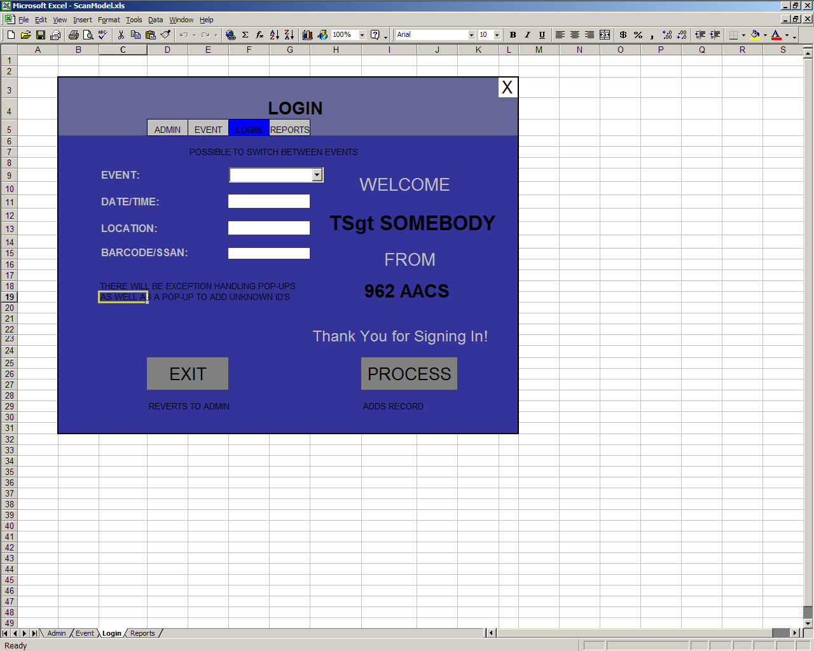
Fig. 2

In this design, tabs at the top are used to navigate through the different pages and pop-up windows are used to handle certain operations requiring user input.

5. Software Development

Once the visual model was complete, I began the coding process. I used a three-phase approach. First, I created the forms and controls needed for the functionality required. Then I wrote the code to implement the various operations. Finally, I created the reports that would be useful to the user.

5.1 Forms and Controls

I realized after some trial and error the difficulty of creating a “multi-page” application that appeared to be seamless as the user switched between the different pages. I decided to use a single ‘main’ form with Frame objects to present the pages. I stacked the frames so that only one would be visible at a time and when the user caused the application to switch to another page, the transition would be smooth. I used sub-forms to create the popup windows where needed.

I considered using an MDI Form with child forms, but this would have created problems because the child forms behaved unexpectedly when they were hidden and then shown again. The frames worked well until I included the picture background for the application and realized they could not be made transparent. So in the final design, I had to create a user control that behaves like a frame object and has a picture set as its background.

Another problem I encountered was trying to implement the tabs at the top. Although VB has some tabbed controls, the ones I found did not allow the tabs to be colored. Therefore, I decided instead to use buttons that would always be visible regardless of the current frame displayed. I later changed the design to use clickable labels so the application would conform more to the standard design look the office uses.

5.2 Coding

As mentioned earlier, the application has a single main form that serves as the control center. Interaction between the application and the database is accomplished through Active Data Objects in the case of data manipulation and filling the controls with data, and a VB DataEnvironment Designer object in the case of the reports. I used the two different methods because each has its owns benefits in relation to what they are used to accomplish. I put all the database manipulation functions and common operations in a single module. To implement both the Event and ECP functionality, I found it logical to use a state variable that determines how the application behaves.

I used a gradual approach to writing the code for this application, going in a logical order. I implemented one piece at a time, completing each use case one at a time. I had to be able to create Events before I could process them, and likewise, process before creating a report. Implementing the Mode functionality was fairly simple because the operations were almost identical.

After all operations seemed to function correctly, I tested and debugged. I then added ease-of-use aspects such as tabbing order, Return key functionality, etc. I periodically showed my progress to Lt Thompkins to receive feedback on areas to enhance. Throughout the process, he gave me a few additional requirements of which none proved to be too difficult to implement.

5.3 Reports

Creating reports proved to be the most difficult part of the project. This was mainly because I was unfamiliar with Active Data Objects. I found the easiest way to accomplish this task was to create a Data Environment Designer and Data Reports. I tested the SQL in access and then created a Data Environment Command for each type of report. I then designed a Data Report for each Command and uniformly formatted them.

6. Summary and Conclusion

IDScan was designed to allow users to track personnel attendance at certain events, as well as provide a means of tracking the activity at an ECP. During the course of this project, I learned Visual Basic and how to create an event-based application. I also learned how to work with MS Access through Active Data Objects. I enjoyed working on a real-world application with practical uses.

The customer seemed very satisfied with the final product. I was told that in the future, they were planning on using similar barcode-scanning devices installed in facility doors to enhance security and track personnel entry and exit. Additionally, the database used with this application will be used to update a personnel training database to provide a record of training for those courses that have a formal course number. This will eliminate the need for administrative workers to manually enter the data in the other database.

APPENDIX A: User Manual

This application is a Graphical User Interface (GUI) to a Microsoft Access Database. It allows the user to track attendance at events such as Commander’s Calls and Unit Training, as well as track personnel entering and leaving a specified location as in an Entry Control Point.
Personnel are tracked either by scanning their individual ID cards, or by manually entering their Social Security Account numbers. The application also allows adding personnel to the local database who are not yet in the Wing database.

SELECTING THE MODE

The application works in two modes: Event Mode or ECP Mode. A small caption near the top of the window indicates the mode the program is in. At any time you can switch between the two modes by clicking “Mode” on the top bar, and then select the mode you want to work in.

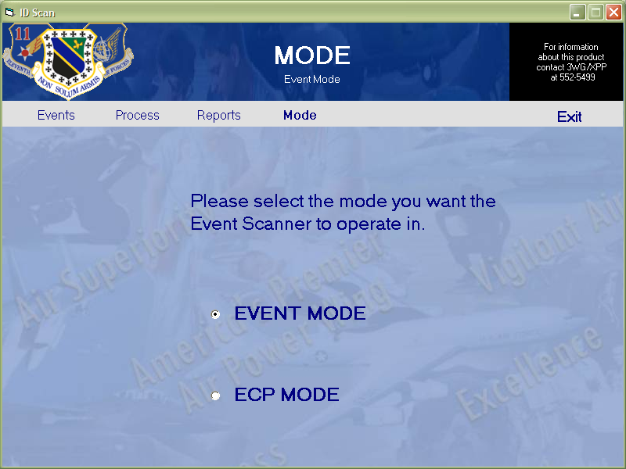

EVENT MODE

The Events
An Event can be any activity that necessitates tracking attendance. The local database is pre-loaded with several common Event Titles that can be selected from. User defined Events can also be created. To schedule an Event to Process, first ensure the application is in Event Mode as described above.
Next, click “Events” on the top bar. A new window now shows all scheduled Events, if any, in the database.
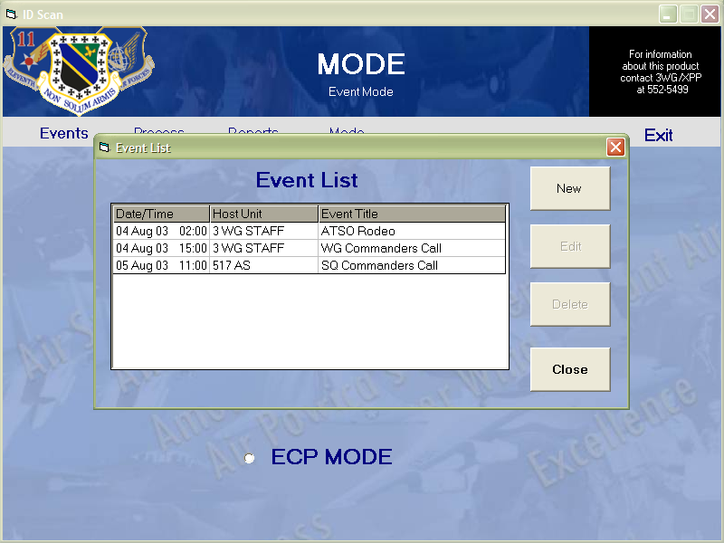

From this window, you can Create new Events, as well as Edit and Delete existing Events.
Since we are creating a new Event, click “New”. This brings up a dialog box where you will enter the necessary information to schedule an Event.

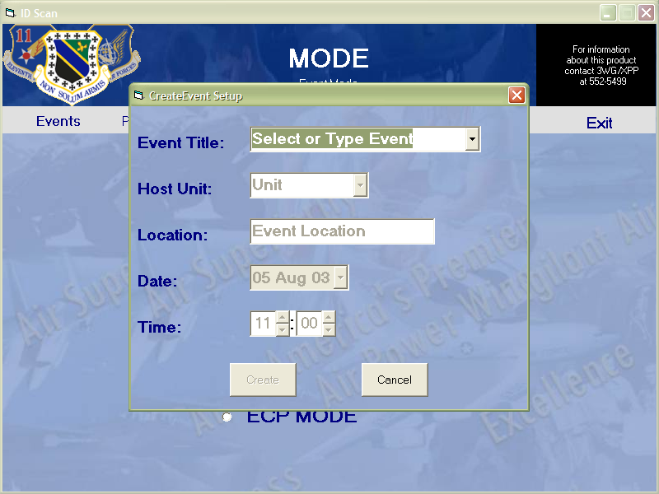

As you will notice, an Event Title must be specified first. To select from the pre-loaded Event Titles, click the down arrow to expand the combo box and see the selections. If none of the pre-loaded titles accurately describe the Event you wish to process, simply type in an accurate title or description.
Now the rest of the form is active and can be used to further identify the Event. The next information is the Host Unit. Select the unit that best identifies the organizer of this Event. Next, enter the Location where this Event will take place. Finally, specify the date and time of this Event. You can either type in the date and time information, or use the graphical controls.
After you verify all the information about this Event, click on the “Create” button at the bottom. If this is a new Event Title, you will be asked if you wish to create this new Event. Click “Yes” to confirm or “No” to go back and select one of the choices available. Next, a message will let you know that the Event is scheduled. If the Event is scheduled for today, you will be given the option to go straight to the Processing screen.
Editing and deleting Events is also easily accomplished. Just select the Event and click the appropriate button. If you are editing an Event, the same screen used to create a new Event will pop up and will contain all the information about the Event you are editing. Simply make the appropriate changes and click the “Edit” button.
NOTE: You cannot create or edit an Event if the Date, Title, Unit, and Location of the new Event exactly match one of the Events already listed.
NOTE: You cannot backdate New Events. If you absolutely must create an Event with an earlier date than today, create it with today’s date and then edit it.

To Process an Event:
To get to the Event Processing screen, first ensure the application is in Event Mode as described earlier. Then click “Process” on the top bar. This will bring up a new window that shows all the Events loaded in the database.
NOTE: If an Event was previously being processed, clicking “Process” takes you straight back to the Event Processing screen with that Event. This allows you to pause processing and accomplish other tasks, such as interim reports.

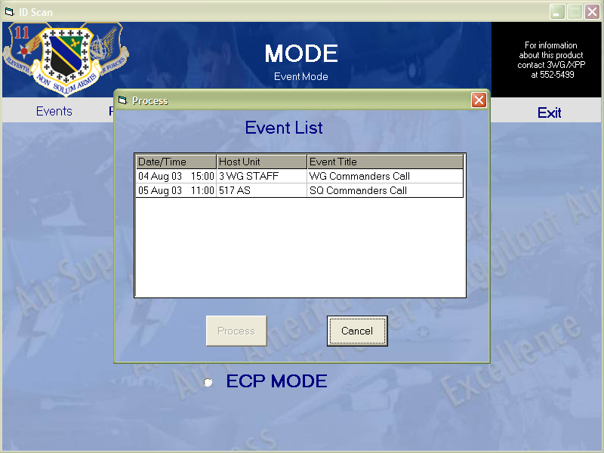

If no Events are in the list, you must setup a new Event as described in the previous section.
To begin processing an Event, either double-click the Event you wish to process, or click the Event and then click the “Process” button at the bottom of the Event List window. The Event Processing screen is now visible.
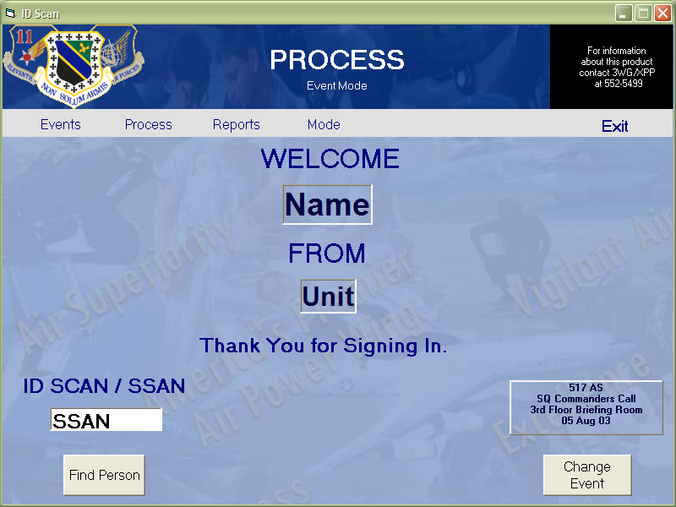

If you enter the Event Processing screen and notice the Event listed is not the Event you wanted to process, simply click the “Change Event” button on the right side of the Event Processing screen. This will bring up the Event List window again.
You may now begin processing the Event. To log a person into the Event, simply scan the person’s ID card through the scanner. Ensure the barcode on the ID card is down and toward the large part of the scanner. If the card does not scan properly, or not is available, you may manually enter the person’s Social Security Number in the text box, followed by the Enter key. If the person is in the database, the screen will show the person’s name and unit.

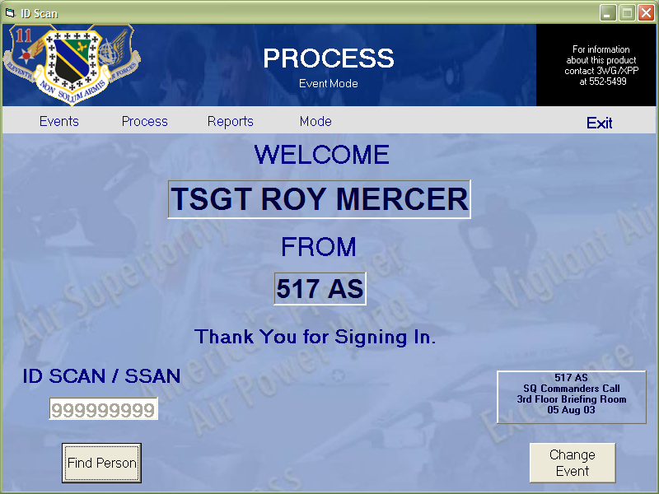

If the person is not in the database, a message will prompt you with the option to add the person to the database. After clicking “Yes”, a new window will appear with controls to enter the person’s information. As a minimum, you must provide the SSAN, last name, first name, and unit. You may change the SSAN on this screen if necessary. You may also enter a rank not listed, as well as a unit not listed.
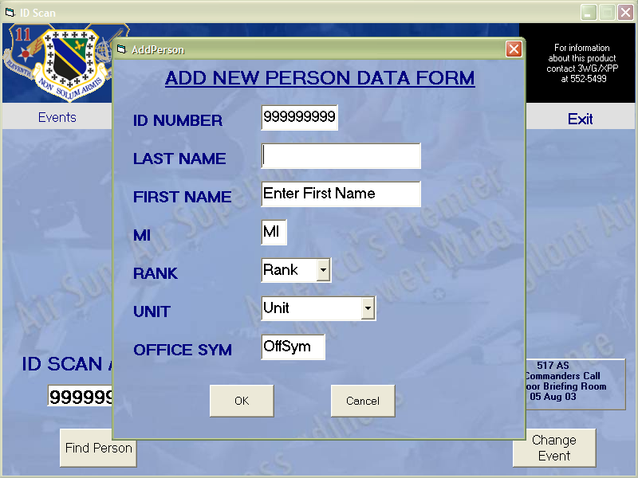

After entering the appropriate information and clicking “OK”, a message will tell you that the SSAN was successfully added. The newly added person will then be automatically logged into the Event.
Another interesting feature on the Event Processing screen is the Find Person function. This is used to find out whether or not a particular individual has signed into this Event. Simply click the “Find Person” button below the SSAN entry text box. This will bring up a new window. Type the person’s Last Name into the text box. As you type the name, any names matching the letters you type will be shown in the list box below.

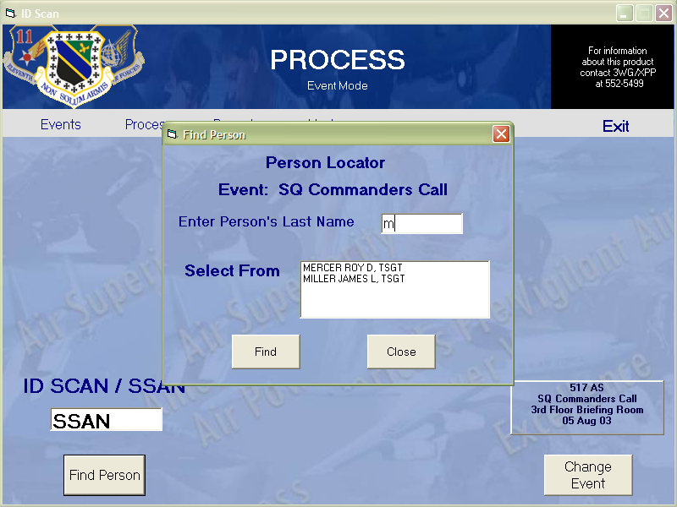

If the name you are searching for is not listed, the person has not signed in.

To create a Report:
If you wish to create a report on the Event you are currently processing, click “Reports” on the top bar. This will bring up the Event Report screen.
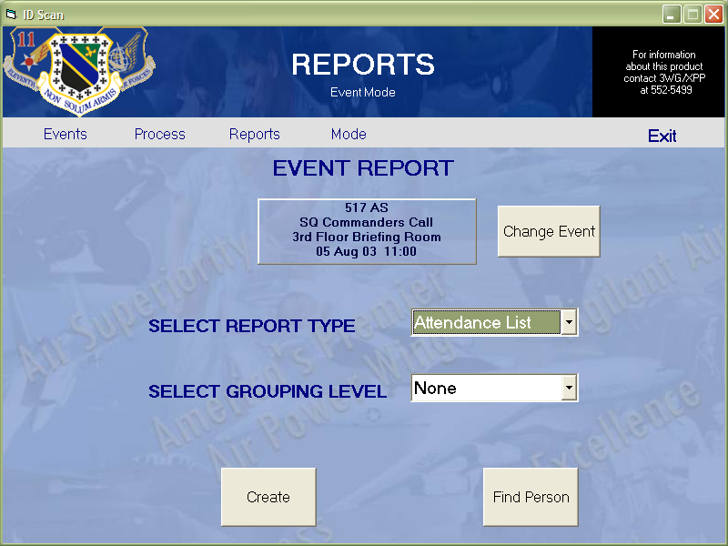

The Event you were processing is automatically loaded. If no processing is taking place when “Reports” on the top bar is clicked, the Event List window will be shown. If the Event listed on the Reports screen is not the Event you wish to create a report on, click the “Change Event” button to the right of the Event box. This will bring up the Event List window again. Select the Event you wish to report on and click “Report”.
The “Find Person” function is also available on the Event Report screen and works just like the one on the Processing screen. Again, this is used to find a particular person by name.

You can create several different types of reports:
Report Type | Grouping Level | Report Description
Attendance List | None | Listing of personnel by name
Attendance List | Squadron | Listing of personnel grouped by unit
Attendance List | Group | Listing of personnel grouped by Group
Summary Report | Squadron | Number of personnel by unit
Summary Report | Group | Number of personnel by Group
History Report | N/A | Total number of personnel by Event for multiple Events
NOTE: All reports show number of personnel (by grouping level, if grouped), as well as Grand Total.

Select the type of report you wish to create from the drop down box, and then select the grouping level, if applicable. Finally, click “Create”. A print preview of the report will now be visible. To print the report, click the printer icon at the top left of the window.
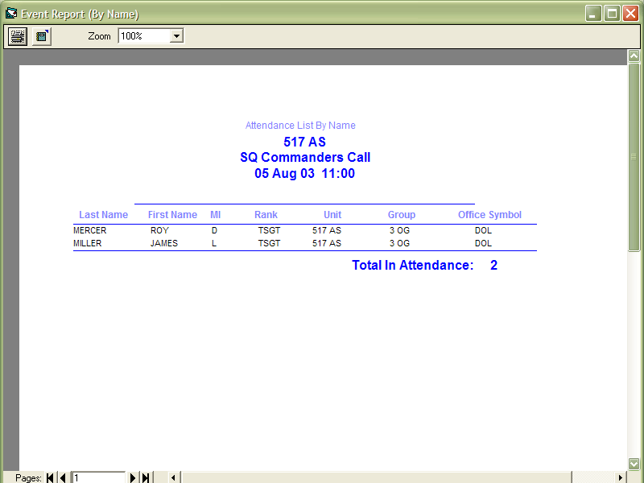

You may also Export the report to HTML and/or Text format, if desired. To export, click the Export button to the right of the printer button at the top and specify a format and filename.

ECP MODE

To Create an ECP:
To create an ECP to process, you must first switch the application into ECP Mode. If the Mode screen is not visible, click “Mode” on the top bar. Next, select the “ECP Mode” option button. Now click “Events” on the top bar. The Events window will now be visible. Any ECP Events currently loaded will be listed.

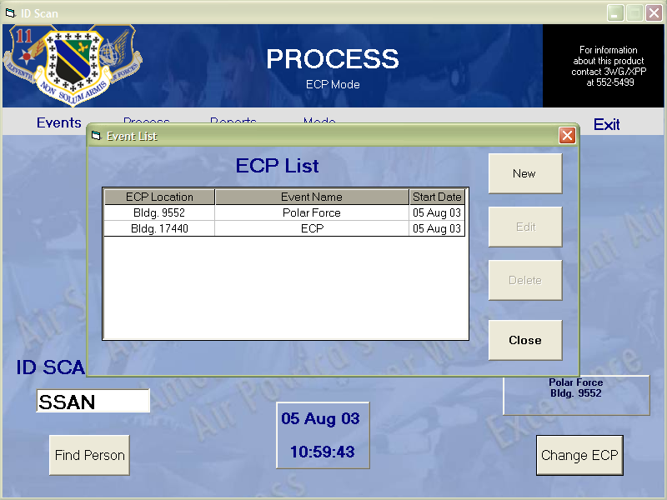

To create a new ECP Event, click the “New” button on the right side. Now the New Event window will be visible and you can specify the details of the ECP.

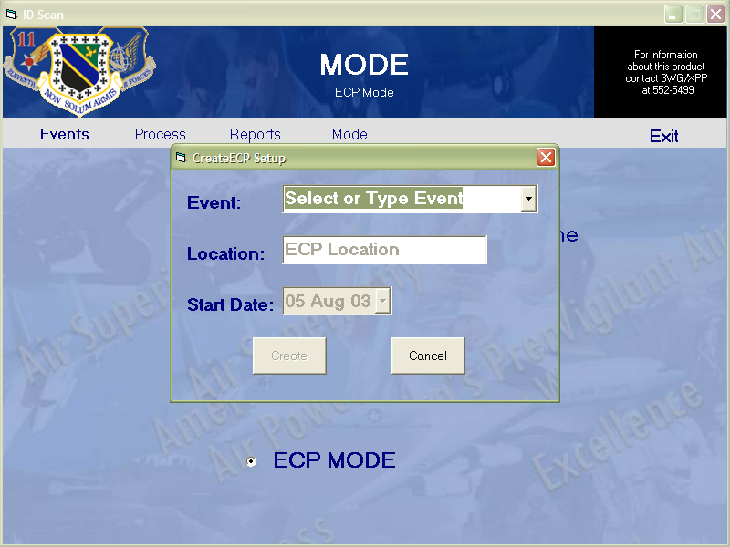

Either select or type a name for the Event the ECP is being used, such as the Exercise name. Next, type the location of the ECP. Your building number is a good choice. Finally, select the start date of the Exercise or Event. Don’t worry about accuracy for the date. It is only used to help you identify the Event for processing and reporting. After verifying the details of the new Event, click “Create”.
NOTE: You cannot create or edit an Event if the Date, Title, Unit, and Location of the new Event exactly match one of the Events already listed.
NOTE: You cannot backdate New Events. If you absolutely must create an Event with an earlier date than today, create it with today’s date and then edit it.

To Process an ECP:
To get to the ECP Processing screen, first ensure the application is in ECP Mode as described earlier. Then click “Process” on the top bar. This will bring up a new window that shows all the ECP Events loaded in the database.
NOTE: If an Event was previously being processed, clicking “Process” takes you straight back to the Event Processing screen with that Event. This allows you to pause processing and accomplish other tasks, such as interim reports.
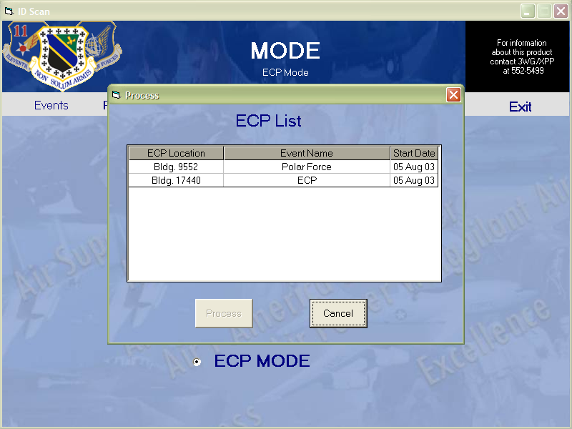

Next, either double-click the ECP you wish to process or select the ECP and click “Process”. This will take you to the ECP Processing screen.

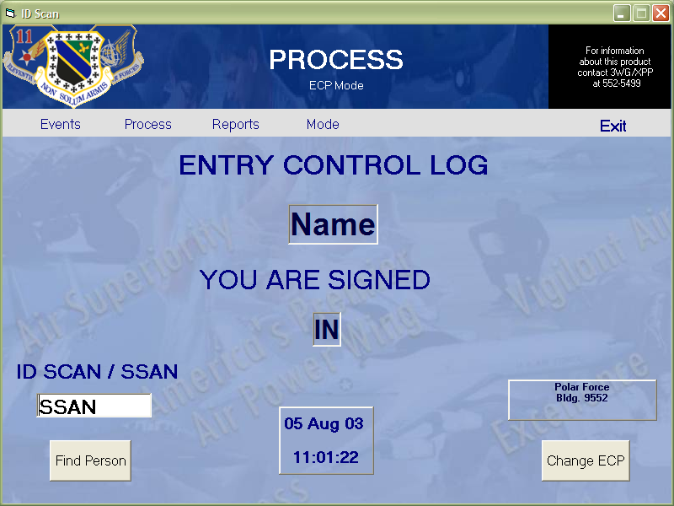

If you enter the ECP Processing screen and notice the ECP listed is not the ECP you wanted to process, simply click the “Change ECP” button on the right side of the ECP Processing screen. This will bring up the ECP List window again.
You may now begin processing the ECP. To log a person into the ECP, simply scan the person’s ID card through the scanner. Ensure the barcode on the ID card is down and toward the large part of the scanner. If the card does not scan properly, or is not available, you may manually enter the person’s Social Security Number in the text box, followed by the Enter key. If the person is in the database, the screen will show the person’s name and either “In” or “Out”. If the person is not in the database, the same process as described previously for adding them to the database will occur.
This is how it works: If the person has not been logged in or out through that ECP before, then the person is logged “In”. Successive entries are then just the opposite of the previous entry. So the second time the person’s ID is scanned, the person is logged “Out”.
The Find Person function described in the Events section is also available. To find a specific person, click “Find Person”. In the new window, type the person’s Last Name in the text box. If the person has logged in or out of this ECP, the name and rank will appear in the list box. Double-clicking the name in the list box will show a message with the last time the person logged in or out.

To Create an ECP Report:
First ensure you are in ECP Mode. Then click “Reports” on the top bar. This will bring up the ECP List window. Select the ECP you wish to report on and click “Report”, or you can double-click the ECP. The ECP Report screen is now visible.

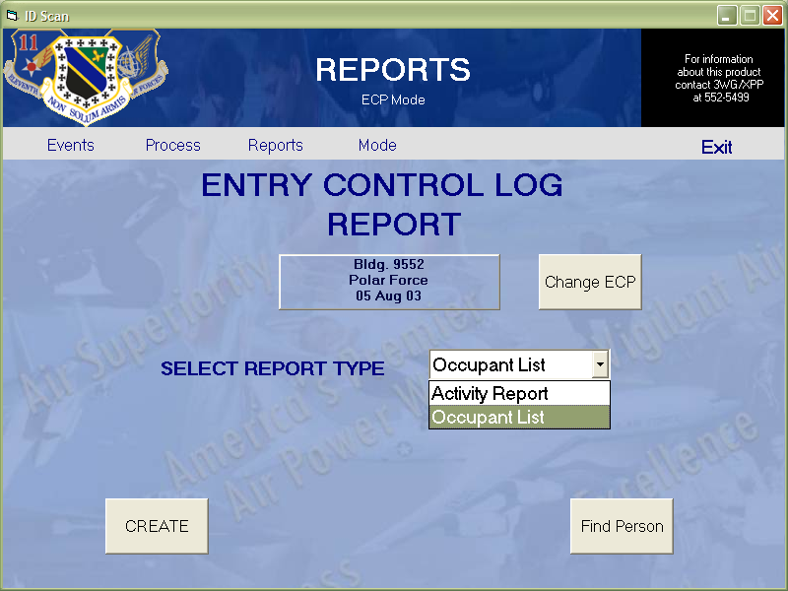

If the ECP listed is not the ECP you wish to create a report on, click the “Change ECP” button. This will again bring up the ECP List.

There are three types of ECP reports to choose from:
Report Type | Range | Report Description
Occupant List | N/A | Names of personnel currently “In” the ECP Location
Activity Report | Last 24 Hours | Sequential account of all ECP activity in the last 24 hours ordered by date/time processed
Activity Report | Specified Range | Sequential account of all ECP activity that occurred between the specified date/time range, ordered by date/time processed

Select the type of report, along with the report range, if applicable, and click “Create”. The report is shown and has the same options as the Event Reports.
NOTE: The Range options are not visible unless “Activity Report” is selected.

The Find Person function is also available on the ECP Report screen and works the same as the one on the ECP Processing screen.

APPENDIX B: Code Listing

See IDScan.vbp file for complete code listing.

APPENDIX C: Evaluation

See Email message from Lt. John Thompkins sent to Dr. Kenrick Mock.

