Outlook Categorizer Add-In
v0.1

Kenrick Mock
kenrick@acm.org
9/1/2001

DISCLAIMER

This software is an experimental system. The author assumes no responsibility whatsoever for its use by other parties, and makes no guarantees, expressed or implied, about its quality, reliability, or any other characteristic. We would appreciate acknowledgement if the software is used.

This software can be redistributed and/or modified freely provided that any derivative works bear some notice that they are derived from it, and any modified versions bear some notice that they have been modified.

PURPOSE

Many problems are difficult to adequately explore until a prototype exists in order to elicit user feedback. One such problem is a system that automatically categorizes and manages email. Due to a myriad of user interface issues, a prototype is necessary to determine what techniques and technologies are effective in the email domain. This project comprises the implementation of an add-in for Microsoft Outlook 2000 TM that intends to address two problems with email: 1) help manage the inbox by automatically classifying email based on user folders, and 2) to aid in search and retrieval by providing a list of email relevant to the selected item. This add-in represents a first step in an experimental system for the study of other issues related to information management. The system has been set up to allow experimentation with other classification algorithms and the source code is available online in an effort to promote further experimentation.

See the associated papers for more information regarding the problem and proposed architecture.

COMPATIBILITY

This software has only been tested with Outlook 2000 and Windows 2000. Other combinations may not work. The software will definitely not work with older versions of Outlook.

INSTALLATION

See the README.TXT file in the BinaryDist or Source Code directories for installation or removal instructions.

PROGRAM OPERATION

1. STARTUP

Once the program has been installed you should see the add-in scan through all folder messages:
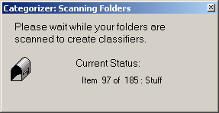
Currently, the scanning process is performed only once upon startup. This process automatically creates a category out of every folder you have created. The messages in the folder are then associated with that category. Since this is only done during startup, currently any new folders that are created or messages that may be moved between folders while Outlook is running will not be noticed by the add-in. This information will only be used when Outlook is shut down and restarted.

Note: The trash and sent-items folders are ignored.

While the scanning process may be somewhat lengthy, for prototype purposes it is easier to rescan every time than to try and retain the state information from previous scans while ensuring data integrity (e.g. a crash while the program is scanning).

2. CUSTOMIZING VIEWS

The add-in is designed to attach a category to each incoming email in your inbox. Each category is automatically created based upon what folders you have. The email messagse that you place into the folder determines what each category is about. Only one category may be associated with a particular email message at this time (although there is the capability for an email message to support multiply tagged categories).

The easiest way to visualize your inbox by category is to add this field to your view. You can do this by taking the following steps:
- Right-click on the subject header in your inbox view
- Select "Customize Current View"
- Select "Fields"
- Add "Category" to the list of selected fields.

The following is an example of the result. Note the “Categories” field which corresponds to folders that have already been set up. Inbox messages in this case have already been classified into one of these folders.

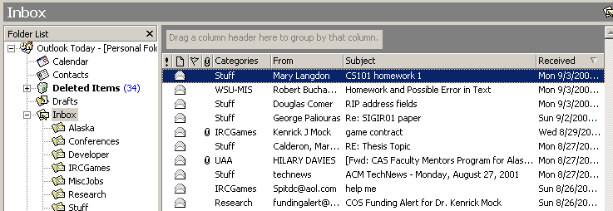

You may also select to view by groups if you wish, where the group is the Categories field. To do this, right-click on the “Categories” column and select “Group By This Field”. The following is an example:

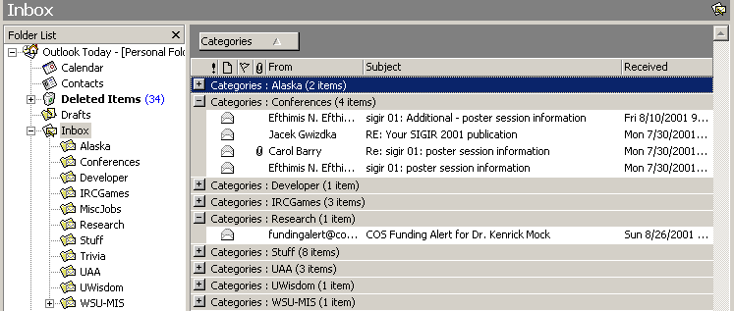

3. CLASSIFICATION

When the add-in is active and you receive a new email, it will automatically be classified into one of the known categories and tagged in your inbox. The hope is that this will be accurate enough to help users more effectively sort and manage their email.
Unfortunately, there are bound to be errors in the classification process. Currently, only a simple nearest neighbor classifier is implemented in this prototype. It is anticipated that many other classifiers will be explored in the future for this domain (and is one of the directions that we would like to pursue).

When the classifier incorrectly attaches a category to an email message, the best course of action is to move the email to the proper folder that it actually belongs to. Upon startup, this information will be read by the classifier and it should incrementally learn the proper category for this type of content.

You may also manually set a category by right-clicking on a message and choosing “Categories”.

4. FINDING RELEVANT EMAIL

The other feature that has been implemented in this prototype is the ability to find email relevant to the currently selected email. This is currently implemented by scanning through all indexed emails, applying a simple similarity metric (in this case, term intersection), and then displaying the results in a dialog box. This is useful if you have a particular email and wish to find other messages related or similar to it, based on content rather than the Reply/Forward headers.

To use this feature, select a message by either opening it or highlighting it in the folder. The click on the “Similar Messages” button on the menu bar:

In the example above, we will be finding messages similar to the selected message (sigir 01 poster session information).
The results are shown in a separate window:

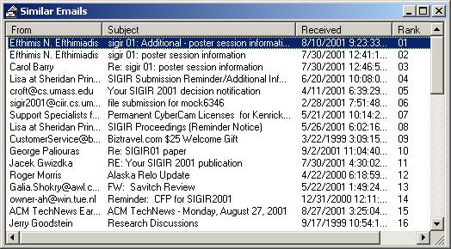
The top 50 results are displayed. These messages may be located in any folders that were scanned (not including trash and sent items). The user may then click on any of these messages to open them.

KNOWN ISSUES

The nearest neighbor classifier performs best with at least a dozen or so messages in a folder. Some occasional maintenance of putting properly representative messages in folders appears helpful.

Junk/spam messages are a bit problematic especially since the Trash folder is not scanned (this would incur some significant overhead, but it may be worth experimenting with). One solution is to keep a separate “Junk Mail” folder that contains some selected emails that you consider junk mail. The classifier can then attach this as a category to incoming messages.

