While Loop

Last time we looked at how to use if-then statements to control the flow of a program. In this section we will look at different ways to repeat blocks of statements. Such repetitions are called loops and are a powerful way to perform some task over and over again that would typically be too much work to do by hand. There are several ways to construct loops. We will examine the while loop construct here.

The while loop allows you to direct the computer to execute the statement in the body of the loop as long as the expression within the parentheses evaluates to true. The format for the while loop is:

while (boolean_expression)
{
statement1;
…
statement N;
}

As long as the Boolean expression evaluates to true, statements 1 through N will continue to be executed. Generally one of these statements will eventually make the Boolean expression become false, and the loop will exit.

In terms of a flowchart, the while loop behaves as follows:

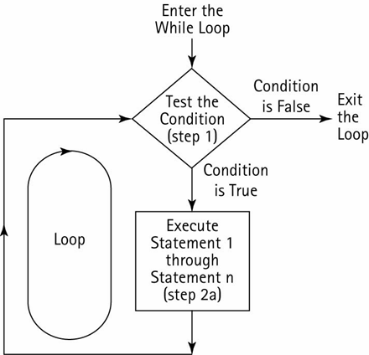

Tip: You can type “while” and then two tabs to generate a while loop template.

Here is an example of a while loop that prints the numbers from 1 to 10:

int i = 0;
while (i <= 10)
{
Console.WriteLine(i);
i=i+1;
}

If we wanted to print out 1,000,000 numbers we could easily do so by changing the loop! Without the while loop, we would need 1,000,000 different WriteLine statements, certainly an unpleasant task for a programmer. Similarly, you might recall an earlier example where we scored a quiz. If there were hundreds of questions in the quiz, it would be much better to score everything using a loop.

What is wrong with the following code? Hint: It results in what is called an infinite loop.

int x = 1
int y = 1

while (x<=10)
{
Console.WriteLine(y) ;
y=y+1 ;
}

Example: Write a program that outputs all 99 stanzas of the “99 bottles of beer on the wall” song.

For example, the song will initially start as:

99 bottles of beer on the wall, 99 bottles of beer,
take one down, pass it around,
98 bottles of beer on the wall.

Write a loop so that we can output the entire song, starting from ninety-nine and counting down to zero.

It is also possible to put a loop inside a loop. You really have no restrictions about the type of statements that can go in a loop! This type of construct is called a nested loop. The inner loop must be fully contained inside the outer loop:

Example: What is the output of this code?

int i = 0;
while (i < 6)
{
j = 0;
while (j < i)
{
Console.Write("*");
j = j + 1;
}
Console.WriteLine();
i = i + 1;
}

Nested loops are quite common, especially for processing tables of data.

ListBox Control

The listbox control lets you create a list of selectable items from a scrollable list. To use it, drag the listbox control to your form. To manually add items to the listbox click on the “. . . “ under the “Items” property. A window will appear where you can type in your list of items.

In the example below I entered the names of trees:

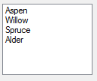

The Items property is a collection that you can access programmatically. To add items, use the Add method:

private void btnAdd_Click(object sender, EventArgs e)
{
listBox1.Items.Add("Cottonwood");
listBox1.Items.Add("Hemlock");
}

Clicking the button adds two more trees at the end:

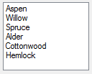
To see what item is selected, there is a SelectedItem property. The code below will output the item the user has clicked on.

MessageBox.Show(listBox1.SelectedItem.ToString());

There is also a SelectedIndex property. This returns back the number of the selected item. The first item in the list is at index 0. The second item is at index 1, and so forth. If no item is selected then the SelectedIndex is -1.

You can also insert items as specified positions. The first item in the list is at position 0, the second item is at position 1, and so forth. The following inserts after the first item and before the second:

listBox1.Items.Insert(1, "Christmas");

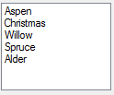

To remove items you can either specify the text of the item to remove or the index of the item to remove. To specify the text:

listBox1.Items.Remove("Spruce");

Removes “Spruce” from the listbox. If there are multiple “Spruce” entries then only the first one is removed.

To specify the index:

listBox1.Items.RemoveAt(2);

This removes the third item from the list (at index 2, remember we start at index 0).

To remove everything from the listbox, use the Clear method:

listBox1.Items.Clear();

Iterating through a listbox

We can iterate through the items in a listbox using a loop. The Count property tells us how many items are in the listbox and then we can use square brackets with the index to retrieve the item at a particular index.

For example, the following will output what is at index 0 and index 2 of the listbox:
Console.WriteLine(listBox1.Items[0]);
Console.WriteLine(listBox1.Items[2]);

We can change items at a specific index as well:

listBox1.Items[2] = "Christmas";

This changes the third entry in the list to “Christmas”.

The following outputs how many items are in the listbox in total:

Console.WriteLine(listBox1.Items.Count);

Note that this gives the total number of items, not the last index. For example, if there are 4 items at indices 0,1,2, and 3 then Count will output 4, not 3.

We can put these two constructs together to process everything in the list. In this case we just output everything:

int i = 0;
while (i < listBox1.Items.Count)
{
Console.WriteLine(listBox1.Items[i]);
i++;
}

In our original list of trees this would output:

Aspen
Willow
Spruce
Alder

It is a common operation to scan through every item in a list and do something to each one (e.g. print them out) or to scan through every item in a list and do something to a specific item (i.e. search and select).

