The For Loop

The for loop is a compact way to initialize variables, execute the body of a loop, and change the contents of variables. It consists of three expressions that are separated by semicolons and enclosed within parentheses:

for (expression1; expression2; expression3)
statement;

Where, statement might include a { block } of statements:

for (expression1; expression2; expression3)
{
Statement;
…
}
All of the expression statements are optional!

Expression1 is used to set initial values, and can set multiple values separated by a
comma.
Expression2 is the condition for the loop to continue (while this is true).
Expression3 contains any operations you’d like to do at the end of each iteration.
Separate different instructions with a comma.

The for loop can be written in the following equivalent while-loop format:

expression1;
while (expression2) {
statement; …
expression3;
}

Here are some examples of for-loops:

int i;
for (i=0; i<10; i++) {
Console.WriteLine(i);
}
This outputs the numbers from 0 to 9.

int sum, i, value;
for (i=0, sum=0; i<10; i++) {
sum = sum + i;
}
This snippet loops from 0 to 9 and keeps a sum of each value (i.e. 0 + 1 + 2 + 3 + 4 + 5 + 6 + 7 + 8 + 9) in variable sum.

We could do the same thing but count backwards from 9:

for (i=9, sum=0; i>=0; i--) {
sum = sum + value;
}

This loop ends when i= -1.
Note that sometimes we can use a for loop to do work without any body at all!

for (i=2; i<=1000; i=i*2);

This snippet of code produces the first power of 2 larger than 1000. Note where the
semicolon is placed to avoid any body at all. All the work is done in the loop heading.

However, normally when there is a semicolon at the end of the loop statement, it is a bug. Consider the following:

int product=1, num;
for (num = 1; num <=5; num++);
{
product = product * num;
}
Console.WriteLine(num);

You might expect this to print out 5*4*3*2*1, or 120. Instead, it prints out 6. Why? Because of the semicolon at the end of the for loop:

for (num = 1; num <=5; num++);

The semicolon terminates the loop, so there is no loop body executed for each iteration. Product is then set to product * num, which is now 6. To fix this bug, we should remove the semicolon from the for loop statement:

int product=1, num;
for (num = 1; num <=5; num++)
{
product = product * num;
}
Console.WriteLine(num);

You can also declare variables that have scope limited to the loop itself. For example:

for (int i=0; i < 5; i++) {
… // variable i only exists within these curly braces
}
Tip: Just like the while loop, you can type “for” and then two tabs to generate a for loop template.

In-Class Example: Convert this code to use for loops instead of while loops

int i = 0;
while (i < 6)
{
j = 0;
while (j < i)
{
Console.Write("*");
j = j + 1;
}
Console.WriteLine();
i = i + 1;
}

Working with Images

Images provide a nice visual way to see loops in action. We’ll use nested loops to process images to do things you might normally run in a paint program.

First, create a project and add a PictureBox control and a Button to it. Set the text of the button to “Test”. Load an image into the PictureBox. In this example I picked the following image:



Let’s show how we can access individual colors of the image. Add the following code to the Button Click event of the “Test” button:

private void btnTest_Click(object sender, EventArgs e)
{
// Get bitmap of the image
Bitmap bmp = new Bitmap(pictureBox1.Image);
Color c;
int x;

// Get color values for the first line
for (x=0; x < bmp.Width; x++)
{
c = bmp.GetPixel(x, 0);
Console.WriteLine("Red=" + c.R + " Green=" + c.G +
" Blue=" + c.B);
}
}

This code will output the Red, Green, and Blue values of each pixel on the first horizontal line of the image when we click the button. The output will show up in the Output window. Here is a sample of the output:

Red=106 Green=127 Blue=58
Red=119 Green=162 Blue=47
Red=66 Green=106 Blue=9
…

We can also set the color of pixels if we like. Consider the following code:

private void btnTest_Click(object sender, EventArgs e)
{
// Get bitmap of the image
Bitmap bmp = new Bitmap(pictureBox1.Image);
Color c;
int x;

// Get color values for the first line
for (x=0; x < bmp.Width; x++)
{
// Set color of pixel at coordinate (x, 0) to Red
bmp.SetPixel(x, 0, Color.FromArgb(255, 0, 0));
}
pictureBox1.Image = bmp;
}

This code loops through each pixel on the top row and sets its color to red (255 red, 0 green, 0 blue). Note that we must reset the Image property to our bitmap at the end for the changes to take effect. This is shown below (the top line is turned to red).

Image Brightness

If we wanted to set every pixel to red, we would just need a nested loop so that we process every row in addition to the columns. An example is shown below. However, it doesn’t turn every pixel to red – can you guess what it will do?

private void btnTest_Click(object sender, EventArgs e)
{
// Get bitmap of the image
Bitmap bmp = new Bitmap(pictureBox1.Image);
Color c;
int x, y;

for (x = 0; x < bmp.Width; x++)
{
for (y = 0; y < bmp.Height; y++)
{
c = bmp.GetPixel(x, y);
int red, green, blue;
red = (int) (c.R / 1.2);
green = (int) (c.G / 1.2);
blue = (int) (c.B / 1.2);
c = Color.FromArgb(red, green, blue);
bmp.SetPixel(x, y, c);
}
}
pictureBox1.Image = bmp;
}

In this case we decrease the red, green, and blue components by 1.2 every time we click the button. This darkens the entire image until it becomes black.

If we wanted to brighten the image, we might try changing the code so we multiply 1.2 instead of dividing by 1.2:

red = (int) (c.R * 1.2);
green = (int) (c.G * 1.2);
blue = (int) (c.B * 1.2);

However, this results in an error message:

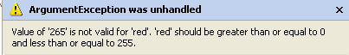
A color value cannot be larger than 255. We can compensate for this by limiting the maximum value of a color to 255:

red = (int) (c.R * 1.2);
if (red > 255)
red = 255;
green = (int) (c.G * 1.2);
if (green > 255)
green = 255;
blue = (int) (c.B * 1.2);
if (blue > 255)
blue = 255;

Every time the button is clicked the image will get brighter, until everything is washed out and eventually becomes white (except for values that started at 0, in which case multiplying by 1.2 still results in 0).

Changing Color Values - Grayscale

We can also use our basic nested loop to easily convert an image to grayscale. A color of gray is one in which the red = green = blue. Large values are white and small values are black. An easy way to make an grayscale image out of color is to set each color value to the average of all three:

Gray = (Red + Green + Blue) / 3
Red = Gray
Green = Gray
Blue = Gray

Here is an example:

private void btnTest_Click(object sender, EventArgs e)
{
// Get bitmap of the image
Bitmap bmp = new Bitmap(pictureBox1.Image);
Color c;
int x, y;
for (x = 0; x < bmp.Width; x++)
{
for (y = 0; y < bmp.Height; y++)
{
c = bmp.GetPixel(x, y);
int red, green, blue;
red = c.R;
green = c.G;
blue = c.B;
int gray = (red + green + blue) / 3;
c = Color.FromArgb(gray, gray, gray);
bmp.SetPixel(x, y, c);
}
}
pictureBox1.Image = bmp;
}

The image with the kids becomes this:

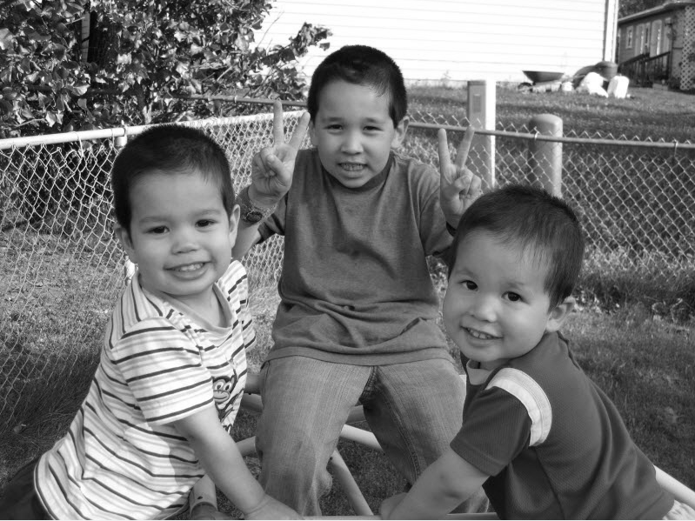

Selective Color Changes

Let’s say that red is no longer our favorite color and we would like to turn the color of the red on the shirt to green.



Using a paint program we can examine the range of pixel values for the red shirt. Alternately, we can modify the Mouse_Click event of the picturebox so that when we click it outputs the coordinate and color of the pixel we clicked on:

private void pictureBox1_MouseClick(object sender, MouseEventArgs e)
{
Console.WriteLine("Coordinates: " + e.X + " " + e.Y);
Bitmap bmp = new Bitmap(pictureBox1.Image);
Color c;
c = bmp.GetPixel(e.X, e.Y);
Console.WriteLine("Red = " + c.R + " Green = " + c.G + " Blue = " + c.B);
}

Coordinates: 642 477
Red = 165 Green = 24 Blue = 40
Coordinates: 666 502
Red = 176 Green = 24 Blue = 47
Coordinates: 688 491
Red = 210 Green = 42 Blue = 68
…
Using this we can see that the red is almost always twice as big as the green and almost always twice as big as the blue.

If we loop over the image and find all pixels in this range, we can make them much greener by decreasing the amount of red and increasing the amount of green:

private void btnTest_Click(object sender, EventArgs e)
{
Bitmap bmp = new Bitmap(pictureBox1.Image);
Color c;
int x, y;
for (x = 0; x < bmp.Width; x++)
{
for (y = 0; y < bmp.Height; y++)
{
c = bmp.GetPixel(x, y);
int red, green, blue;
red = c.R;
green = c.G;
blue = c.B;
if ((red > 2*green) && (red > 2*blue))
{
red = red / 3;
green = green * 3;
if (green > 255)
green = 255;
}
c = Color.FromArgb(red, green, blue);
bmp.SetPixel(x, y, c);
}
}
pictureBox1.Image = bmp;
}

The result is close, but not quite there! We change the color on most of the shirt, but some of the lip and ear is inadvertently changed as well. We could increase our threshold and get less flesh tones, but then fewer pixels on the shirts would be changed.



One way out of this problem would be to make separate loops that apply only to a small area instead of the entire image. For example we could make a loop that only changes pixels in the general area of the red shirt, in this case from X=512 to the width of the image, and Y=385 to the height of the image.

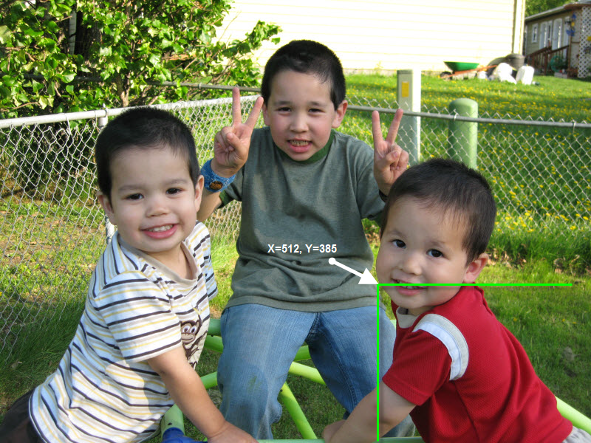
private void btnTest_Click(object sender, EventArgs e)
{
Bitmap bmp = new Bitmap(pictureBox1.Image);
Color c;
int x, y;

for (x = 512; x < bmp.Width; x++)
{
for (y = 385; y < bmp.Height; y++)
{
c = bmp.GetPixel(x, y);
int red, green, blue;
red = c.R;
green = c.G;
blue = c.B;
if ((red > 2*green) &&
(red > 2*blue))
{
red = red / 3;
green = green * 3;
if (green > 255)
green = 255;
}
c = Color.FromArgb(red, green, blue);
bmp.SetPixel(x, y, c);
}
}
pictureBox1.Image = bmp;
}

We still get a little bit of the cheek but miss the ear and lips. If we used separate loops or addition if statements to skip the cheek pixels then we could perfect the color change.



A very similar process is done when performing red-eye reduction on an image in a photo editing program. The user typically selects the eye region (so the program knows what area to look for) and changes any reddish pixels in that area to dark pixels.

